ELECTROPHORETIC SEED ALBUMIN PATTERNS IN PISUM
Przybylska, J., Z. Zimniak-Przybylska Institute of Plant Genetics
and E. Kozubek Polish Academy of Sciences, Poznan, Poland
Bllxt, S. Weibullsholm Plant Breeding Institute
Landskrona, Sweden

In an investigation performed in 1973 two electrophoretic seed al-
bumin patterns, designated A and B, were found to occur in cultivars and
breeding lines of P. sativum (3). After extending the study to include
other forms or Pisum five patterns were found, designated EP I - EP V,
EP I corresponding to previous pattern B (2). The distribution of these
EP patterns indicated possible differences between Pisum taxa at the
species-ecotype level. Analysis of seed albumins by means of gel
filtration and electrophoretic analysis of the main protein peaks showed
the fraction with MW of about 40,000 to be responsible for the observed
differentiation of total albumin patterns (1). This report presents
further data on variation in electrophoretic seed albumin patterns in
peas.
To date, 251 Pisum accessions have been screened for EP patterns as
previously described, using crude protein extracts with large propor-
tions of albumins (2). P. sativum was represented by 241 accessions.
Of the remaining ten accessions, two represented P. elatius, one
P. humile and seven P. abyssinicum. The lines we examined were obtained
from the collections at Weibullsholm (Sweden), Gatersleben (GDR) and
VIR-Leningrad (USSR).
In this material the following EP patterns were detected:
EP I - EP IV, patterns A, now designated as EP VI, and three "new" pat-
terns designated EP VII - EP IX. These patterns, together with
EP V reported previously for several P. fulvum forms, are presented in
Fig. 1A; the characteristic bands, a-f, are indicated.
Albumins of Pisum forms representing the EP VI - EP IX patterns
have now been fractionated by gel filtration on Sephadex and the peak
fractions have been analyzed electrophoretically as described earlier
for EP I - EP V (1) . As in the case of EP I - EP V, EP VII - EP IX
could be distinguished by the patterns produced by the 40,000 MW
fraction. In contrast, no peak corresponding to MW of about 40,0 00 was
observed in the gel filtration profile of albumins from the Pisum form
showing EP VI. Electrophoretic patterns produced by the Sephadex al-
bumin fractions with an MW about 40,000 are presented in Fig. 1B. It

Cooperative investigation performed under an Agreement between the
Royal Swedish Academy of Sciences and the Polish Academy of
Sciences. The project involves cooperation with Dr. Ch. Lehmann
from "Zentralinstitut fur Genetik und Kulturpflanzenforschung" of
Germany Academy of Sciences, Gatersleben, GDR. Special thanks are
due to Prof. R. Kh. Makasheva (N. I. Vavilov All-Union Research
Institute of Plant Industry, VIR, Leningrad, USSR) for supplying
plant material and for fruitful discussions.

iilWpiiiipiiiii.i'i*

may be noticed that the positions of the bands in EP VII - EP IX pat-
terns were similar to those in EP I - EP V; the additional variation is
due to differences in number and combination of the previously distin-
guished bands.
Regarding the distribution of electrophoretic seed albumin pat-
terns, EP I proved to be the one commonly occurring in P. sativum (183
accessions), which is consistent with the earlier data. Other EP pat-
terns found in accessions classified as P. sativum were EP II, EP III,
EP VI and EP VII. EP III, previously reported only for a single line
called P. cinereum W 1490, has now been found in seven other accessions,
all from the Saratov region. EP VII was observed in 59 accesaions
originating from Caucasia. The P. abyssinicum accessions all showed
EP IV, a pattern not found in other Pisum forms, indicating that this
pattern might be specific for P. abysslnicum. EP VIII and EP IX have
been found in single lines, P. humile VIR 2521 and P. elatius Gat. 255,
respectively.

1. Jakubek, M., Przybylska, J. 1979. Genetica Polonica 20:369-380.
2. Przybylska, J., S. Blixt, J. Hurich, Z. Zimniak-Przybylska. 1977-
Genetica Polonica 18:27-38.
3. Przybylska, J., J. Mikolajczyk, Z. Zimniak-Przybylska. 1 97 3.
Gentica Polonica 14:383-388.
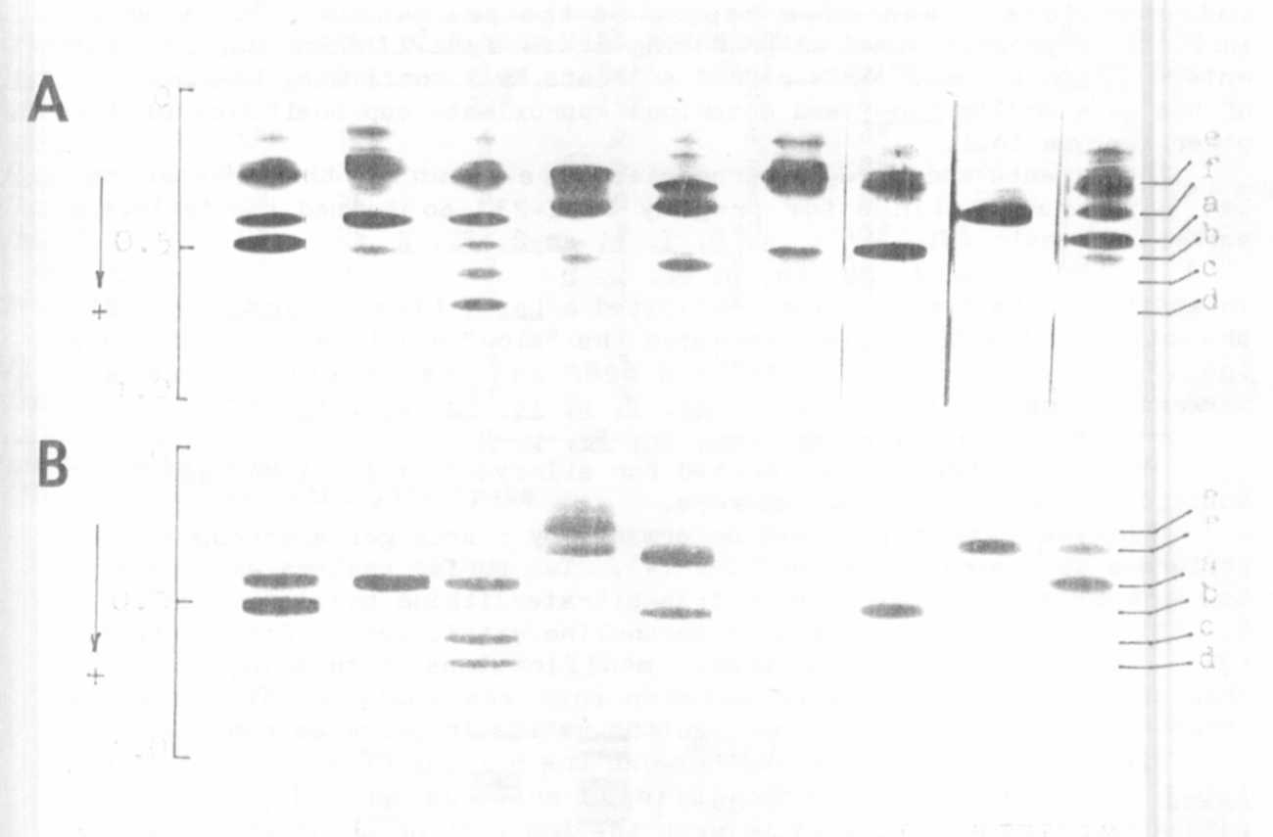

Fig. 1. Disc gel showing variation in electrophoretic seed albumin pat-
terns in Pisum. A - Crude protein extracts; B - Sephadex
fractions with an MW about 40,000. The given patterns are
produced by the following accessions: I - WL 110, P. sativum:
II - WL 936, P. humile: III - WL 1490, P. sativum: IV - WL 808,
P. abvssinicum ; V - WL 1256 , P. fulvum ; VI - WL 1973,
P. sativum : VII - VIR 1987, P. sativum: VIII - VIR 2521,
P.. humile: IX - Gat. 255, P. elatius. Characteristic bands:
a-f.

