VARIATIONS IN THE PHOTOENVIRONMENT WITHIN FRUITS OF A Pu Pur AND gp PEAS

Price, D. N., J. E. Hayward, and C. M. Smith
Plymouth Polytechnic, Plymouth, U. K.

Several well defined genes specifically alter pod characters,
including color. Recessive gp plants produce yellow pods which lack
normally developed chloroplasts in the typically green mesocarp. Pu Pur
in an A background give purple pods due to the production of high levels
of anthocyanin within the exo- and outer mesocarp. Such dramatic
characters are bound to profoundly alter the normally important
photosynthetic function of pods and could also have a more direct
photomorphogenetic effect on the developing seeds. We have measured the
percent transmission through various pod layers in a range of genotypes
as part of a wider investigation into variation in the photosynthetic
machinery in pea fruits.
Fig. 1 shows the percent transmission through the outer layers
(exocarp, mesocarp and sclerenchyma) of normal green (JI 141), purple
(JI 755) and yellow (JI 73) pods. This is therefore equivalent to the
light received by the inner endocarp and similar to that penetrating to
the seeds. Measurements were made on 20-day-old pods (from anthesis),
using a modified Ulbricht Sphere in a Unicam SP8-100 spectrophotometer.
The spectra are typical for these three pod types, additional variation
in other genotypes being swamped by the operation of these pod color
genes.
The spectrum for the green pod (Gp) shows distinct transmission
troughs in the blue and particularly red (685 nm) regions. These can be
shown to be largely due to the specific absorption by photosynthetic
pigments located within the chloroplasts of the extensive mesocarp and
associated with RuBP carboxylase activity (1). It is photosynthesis
within this layer which produces most of the (approx) 25% contribution
that green pods make to the carbon economy of the developing seeds.
In purple pods (A Pu. Pur) light penetration beyond the exo- and
outer mesocarp is very restricted, being appreciable only in the red.
The small trough at 680 nm indicates some specific absorption by
chlorophyll and we have observed some moderately developed chloroplasts
even in the inner mesocarp. However, they must all be operating in a
heavily shaded environment and their photosynthetic contribution can be
no more than minimal.
Yellow pods (gp) exhibit the opposite extreme. Here the exo- and
mesocarp are far more translucent, again with evidence of little
specific absorption by chlorophyll. The decline in transmission towards
400 nm is not due to specific absorption by photosynthetic pigments to
any extent. However, although little light is usefully absorbed by the
mesocarp, more penetrates to the inner endocarp (and seeds). This
region of parenchyra is thin but is particularly well endowed with fully
developed chloroplasts and associated biochemical machinery (1) and ex-
posed to the elevated levels of CO₂ of the pod space. The endocarp in
yellow pods is therefore a very favorable photosynthetic environment and
we have estimated that in this line 251 of the 680 nm light incident on
this layer is specifically absorbed. This could not only make a sig-
nificant contribution to the photosynthate for seed growth, but also
affect the O₂/CO₂ regime surrounding the seeds.
Similar endocarpic effects can operate in green pods but in the A.
Pu Pur lines they are very minor. A study of the orange pods of the orp
lines described recently (2) would be interesting since here the addi-
tional pigmentation is within the sclerenchyma and should therefore only
affect light availability to the inner endocarp and seeds.

1. Price, D. N. and C. L. Hedley. 1980. Ann. Bot. 45:283-294.
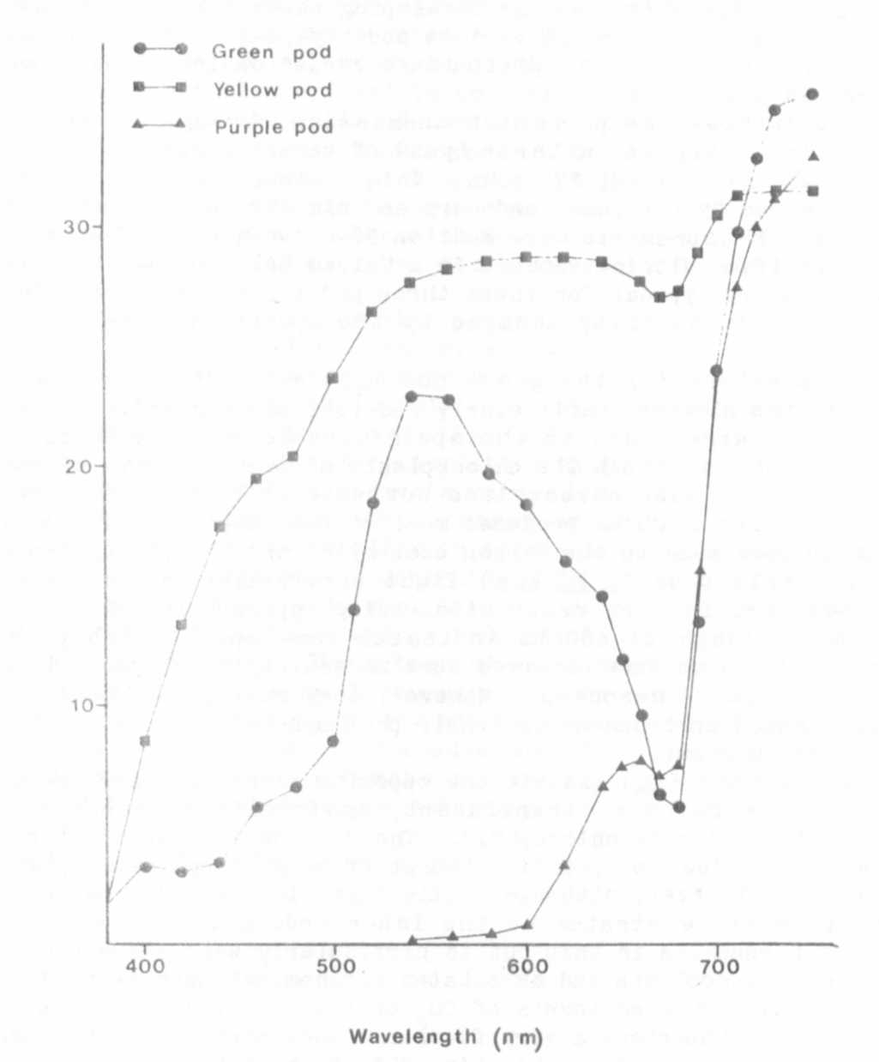
2. Swiecicki, W. K. 1981. PNL 14:65-66.
Fig. 1. Percent transmission through the outer layers (exocarp,
mesocarp, and sclerenthyma) of green, purple (A Pu Pur) and
yellow (gp) pods.

