SUPPLEMENTAL LINKAGE DATA INVOLVING MARKERS ON CHROMOSOMES 3 AND 5

Marx, G. A.
NYS Agricultural Experiment Station, Geneva, NY USA

The results of two multi-point tests, hitherto unreported, seem
worth placing on record.
Table 1 presents the analysis of a three-point cross involving st,
wel and b on chromosome 3- The data, collected in 1971 from a cross
wel St b x Wel st B. are noteworthy primarily because they provide an
exception to results I have reported previously (1). In the present
case the order of the three genes appears to be st-wel-b whereas in all
previous instances the order was indicated as wel-st-b. There is noth-
ing to indicate that the populations segregated for semi-sterility. It
is evident, however, that there was a statistically significant
deficiency in wel segregants.
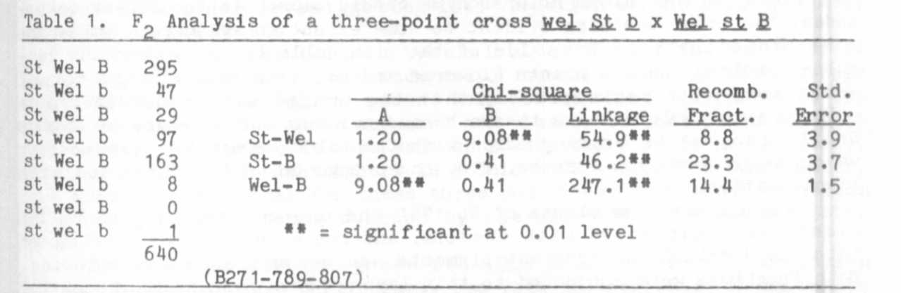
An analysis of a cross involving markers on chromosome 5 is given
in Table 2. The cross was performed in 1970 to check the possibility
that wex is situated on chromosome 5. No definite linkage was indicated
between wex and the markers scored but the cross represents a three-
point cross verifying the order of gp, .cp and fs. as given in the most
recent map (Blixt 1972). The estimated recombination fractions are:
gp 10 cr 29 fs
For other reports in the literature concerning linkage among these and
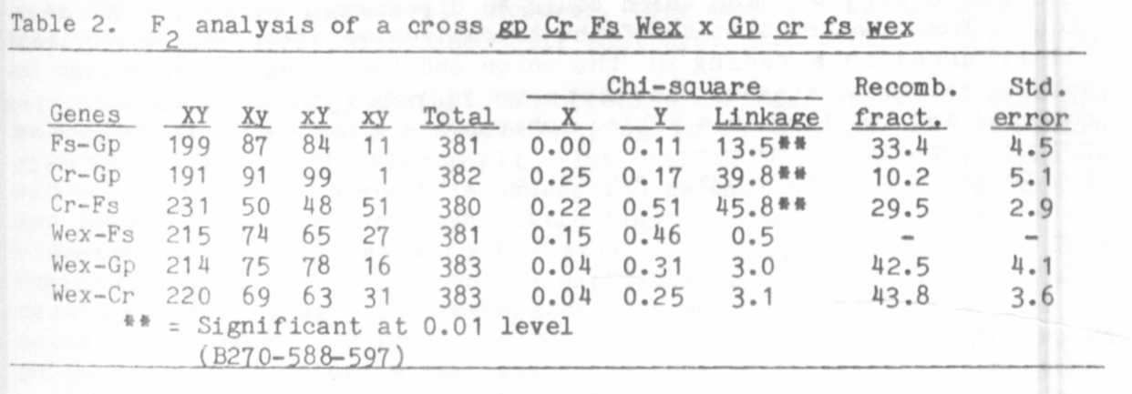
other markers on chromosome 5, see Yarnell (2).
1. Marx, G. A. 1982. PNL 14:43-46.
2. Yarnell, S. H. 1962. Botanical Review 28(4):465-537.

