CROSS-FERTILIZATION IN PEAS

Lonnig, W.-E.

Institute of Genetics, University of Bonn
Federal Republic of Germany

A simple method to determine the frequency of cross-fertilization
occurring in cultivated peas is to grow control groups homozygous for
gene i (green seeds) or gene r (wrinkled seeds) among a majority of
plants with I. and R. (yellow and round seeds). Through the phenomenon of
xenia, contamination of pollen carrying I or R or both is immediately
apparent in the seeds of the control plants.
We used the following two lines for our investigations:
a) WL 6040: green, round seeds, linearly fasciated (derived
by Vasileva from the variety 'Virtus'); provided by Dr.
Blixt, Weibullsholm, Sweden.
b) Variety 'Gribowo Kronenerbse' : green, wrinkled seeds,
strongly fasciated; provided by Zentralinstitut fur
Genetik und Kulturpflanzenforschung, Gatersleben, DDR.
These lines were among several thousand plants with yellow, round
seeds. The percentage of cross-fertilization is given in Fig. 1. In
detail, 27 plants of WL 6040 produced 1422 seeds, 34 of which could be
clearly distinguished as yellow (2.39$), and 26 plants of 'Gribowo
Kronenerbse' with 831 seeds showed 10 seeds which were yellow and round
(1.20?). In the former ease 20 out of 27 plants (74%) showed at least
one cross-fertilization, and in the latter the ratio was 6 out of 26
plants (23%). Bumble bees (Bombus spp.) were the chief cause for the
pollen transfer. Bees were present in large numbers and they actively
visited the blossoms. As fasciated plants tend to have more flowers
open at one time than normal plants, the percentage may be higher in
them than in normal plants.
Varying results have been obtained with respect to the amount of
cross-pollination in the pea (1). More material of different normal and
mutant lines under different ecological conditions are needed for a
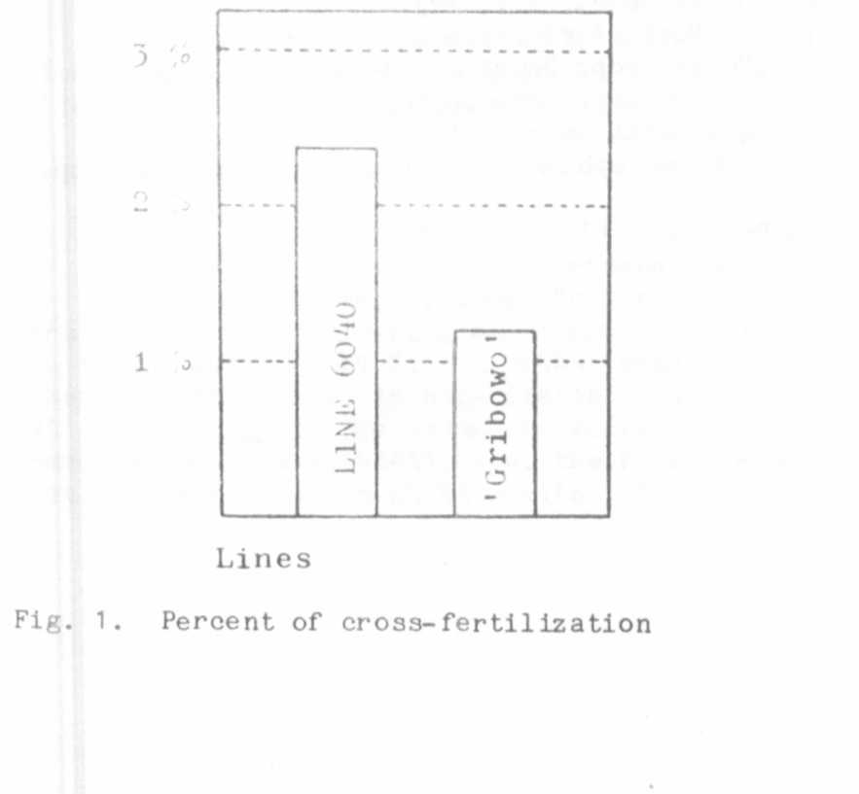
general statement.

1. Blixt, S. 1972. Agri Hort. Genet. 30:1-293-

