RESEARCH REPORTS
PNL Volume 15
38
1983

LOCUS IDENTITY TEST CROSSES FOR DIFFERENT FASCIATA LINES

Loennig, W. -E. Institute of Genetics, University of Bonn
Federal Republic of Germany

Spontaneous and induced fasciated mutants have been obtained inde-
pendently by several investigators [for review see Blixt (1)]. The
symbol Fa was proposed by White (7) after segregation ratio of 651 nor-
mal : 207 fasciated plants. Lamprecht got several 15:1 segregations
after crossing his lines 490 x 794 (5,6) and proposed the symbol Fas for
the second gene. He also records a 15:1 segregation after crossing two
normal lines (Fa fas x fa Fas) (6). Several locus identity test crosses
of different lines were performed by Gottschalk (2,3). The lines tested
in the present study are given in Table 1.
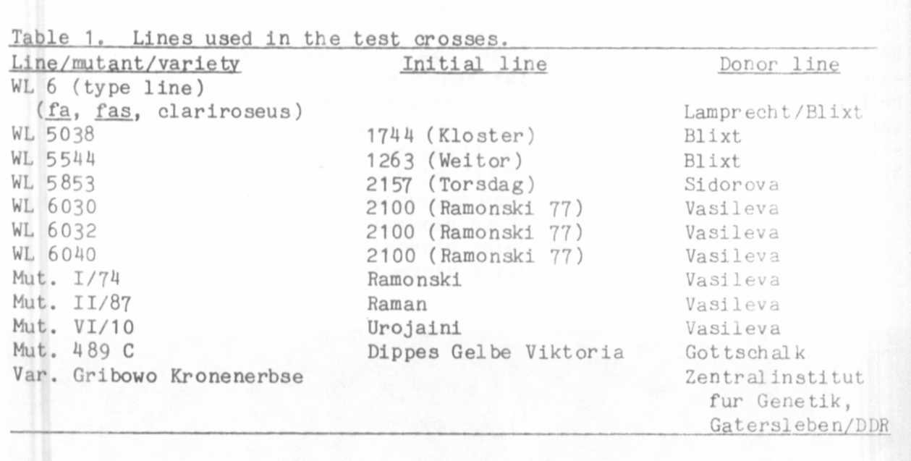

The test crosses show that WL 6 and mutant 489 C have either iden-
tically mutated at their fasciated loci or (more probably) have multiple
alleles (Table 2). The following hybrids:
WL 5038 x 489 C
WL 6 x WL 5038
489 C x WL 6040
WL 6 x WL 6040
Var. Gribowo Kronenerbse x 489 C40
Var. Gribowo Kronenerbse x WL 6
are all fasciated, leaving no doubt concerning the locus identity of
WL 6 and mutant 489 6. WL 5544 (weakly fasciated and bifurcated with
unstable penetrance) is non-allelic to 489 C and thus to the type-line
WL 6 (fa, fas). The same was found for our mutant 1201 A (having the
same features as WL 5544), i.e. the F1 was non-fasciated. We have not
yet, however, crossed WL 5544 with 1201 A for locus identity.

RESEARCH REPORTS 39
PNL Volume 15 1983

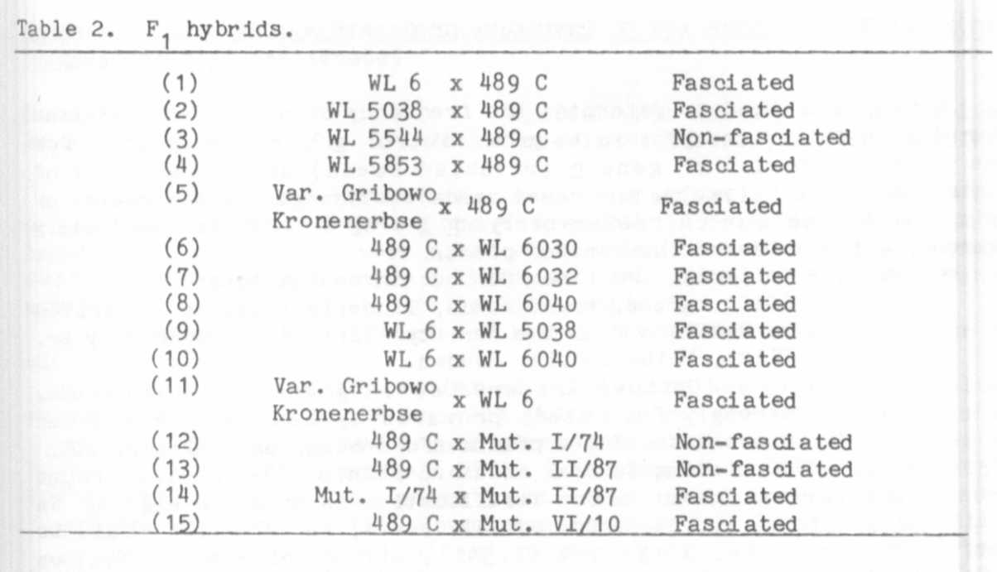
In connection with the bifurcated lines we have found the following
unusual phenomenon: F₁ 4 89 C x Recombinant 177 (derived from
489 C x 1201 A, - small seeds and stable penetrance of bifurcation) was
fasciated. The hybrids 489 C x 1201 A were definitely non-fasciated,
but all the plants of F 101 A x R 177 were again weakly fasciated and
bifurcated. The problem remains unsolved (4). Mt. 1/74 and Mut. 11/87
were "identical" with each other, but not identical with 489 C.
F2 segregation of (12) and (13) was:
(12) 113 normal:98 fasciated plants (1.15:1)
(13) 97 normal:76 fasciated plants (1.21:1).
According to 9:7 segregation (1.26:1), the mutants differ from the type
line at one locus (gene fa-2).

1. Blixt, S. 1972. Agri Hort. Genet. 30:1-293.
2. Gottschalk, W. 1977. J. Nucl. Agric. Biol. 6:27-33.
3. Gottschalk, W. 1981. Pulse Crops Newsl. 1 :54-55.
4. Hartmann, K. 1981. Ph.D. Thesis, Bonn University.
5. Lamprecht, H. 1952. Agri Hort. Genet. 10:158-168.
6. Lamprecht, H. 1 974. Monographie der Gattung Pisum. Graz. pp.
333-335.
7. White, 0. E. 1917. Proc. Am. Phil. Soc. 56:487-558.

