RESEARCH REPORTS
PNL Volume 15
1983
36

STREPTOMYCIN BLOCKS CHLOROPHYLL SYNTHESIS IN PEA-SEEDLINGS

Loennig, W.-E.
Institute of Genetics, University of Bonn
Federal Republic of Germany

During tests for mutagenicity of different antibiotics, strep-
tomycin proved to be a blocker of chlorophyll synthesis in M1 (Fig. 1).
(According to some medical authorities streptomycin appears to be
mutagenic.) Air-dried pea seeds of the variety 'Dippes Gelbe Viktoria'
were treated as follows:
1) 100 seeds in 0.25% streptomycin solution for 14 hours.
2) 100 seeds in 0.50% streptomycin solution for 14 hours
3) 300 seeds in 1.00% streptomycin solution for 14 hours
The figure shows several differently affected plants of the third
group. The control plants were about twice as long as the plant on the
extreme left, were of normal green color, and had a strong root system.
All the plants of the third group including the controls were grown in a
growth chamber. The conditions were as follows: light, 100 lux of
fluorescent tubes (equivalent to 6000 lux for plant growth); 16-hour
photoperiod; temperature 21C; age, 15 days, including time for soaking
in streptomycin solution. The first two groups were grown on an ex-
perimental field at Bonn. All three groups had the following features
in common: development of the affected plants was slowed down (stem,
leaves and roots), and chlorophyll synthesis was blocked and/or dis-
turbed to a different extent in different plants. Percentages of
affected plants for the three groups were as follows:
1) 23.1$ (0.25% streptomycin solution)
2) 39.6$ (0.50% streptomycin solution)
3) 94.3$ (1.00% streptomycin solution)
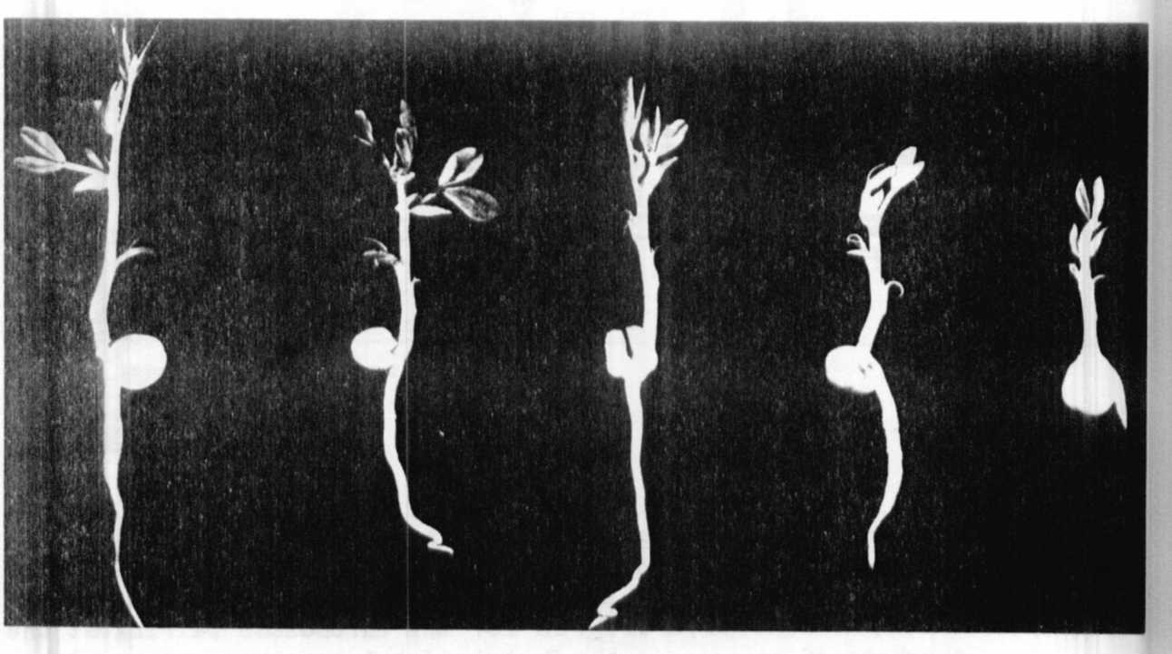

Fig. 1. Pea seedlings showing varying effects of treatment with
streptomycin. All the stems are white, and most of the leaves are green
in the center and white along the edges. The leaves of the fourth plant
from the left are entirely white.

The extent to which the different plants were affected varied from
an entirely white stem extending to the first normal leaf (so that this
and the primary leaves were white) to different degrees of spotted and
light green leaves. Most of the affected plants of the first two groups
survived this "white stage" and further development of the plants was
normal. In the third group, however, many of the seedlings did not sur-
vive and the few that did had spots on upper leaves. Biochemical
studies could show whether there is interference with membrane
transport, RNA-synthesis, and respiration as is the case with another
antibiotic (1). The M2 will show whether there is also an interference
with DNA-synthesis.

1. Galling, G. 1982. In: Encyclopedia of Plant Physiology. Vol.
14 B. B. Parthier and D. Boulter, eds. Springer.

