CYTOLOGICAL STUDIES OF L-108. NILSSON'S N II

Lamm, R. L. The Swedish University of Agricultural Sciences
Alnarp, Sweden

In his Botanical Review article of 1962, S. W. Yarnell presented
data and references concerning the then current status of translocation
lines in Pisum (4). The G-line of his survey corresponds to my L-108,
Nilsson's N II, T(2-6)a. I have completed the investigations published
earlier by a study of the karyotype of L-108 and by linkage determina-
tions between the T-point of this line and six marker genes of the
chromosomes involved.
W. Gottschalk states, after a study of 24 translocation lines in
Pisum, that in mitotic metaphase plates only relatively drastic inter-
changes can be reliably discerned (1). In L-108 at least one of the
interchanged cnromosomes is very easy to recognize by its small size and
by a submedian primary constriction. The shortest chromosomes of the
standard karyotype, viz. chromosomes 1 and 2, have about the same length
and yet cannot be confused with the still shorter 6² interchange
chromosome. For a reliable recognition of the 2⁶ chromosome, however,
measurements are desirable since it might otherwise be confused with
chromosome 6 of the standard type. The structure of the interchange
characterizing L-108 is explained by the drawings in Fig. 1. These
drawings are founded on measurements of eleven good mitotic metaphase
plates of L-108.
An account of the linkage studies performed with L-108 in crosses
with lines of the standard structural type is given in Tables 1 and 2.
The results of cross Nos. 2 and 7 have been published earlier (3). Data
concerning the backcross Nos. 3, 6 and 8 have been kindly put at my dis-
posal by Dr. E. Nilsson. In future investigations it would be desirable
to include at least three other genes, viz. .ar, mifo and i. Apart from
the incompleteness and somewhat vague results of the present linkage
studies, I have marked the approximative sites of the genes of Table 2
in the tentative diagram for the pairing at the prophase of meiosis in
Fig. 1. As regards the genes of chromosome 6, the suggested localiza-
tions are supported by the results of other investigations (2). At the
first metaphase of meiosis in the translocation heterozygote, chiasmata
never occur in the interstitial segments indicating that the T-point
must be proximal to the centromeres of the chromosomes forming a ring of
four (cf. Fig. 1).
Finally, it should be mentioned that trisomic plants have been ob-
served in the progenies of crosses between L-108 and lines of standard
structural type. A cytogenetical analysis, however, has not been
performed. The leaflets of these trisomies were broad and of the same
type as those described from crosses with L-114, Nilsson's N I, T(4 6)a
(2).

1. Gottschalk, W. 1978. The Nucleus 21:29-3*».
2. Lamm, R. 1982. PNL 14:32-35.
3. Lamm, R. and R. J. Miravalle. 1959. Hereditas 45:417-440.
4. Yarnell, S. H. 1962. The Bot. Review 28:465-537.

34 PNL Volume 15 1983
RESEARCH REPORTS

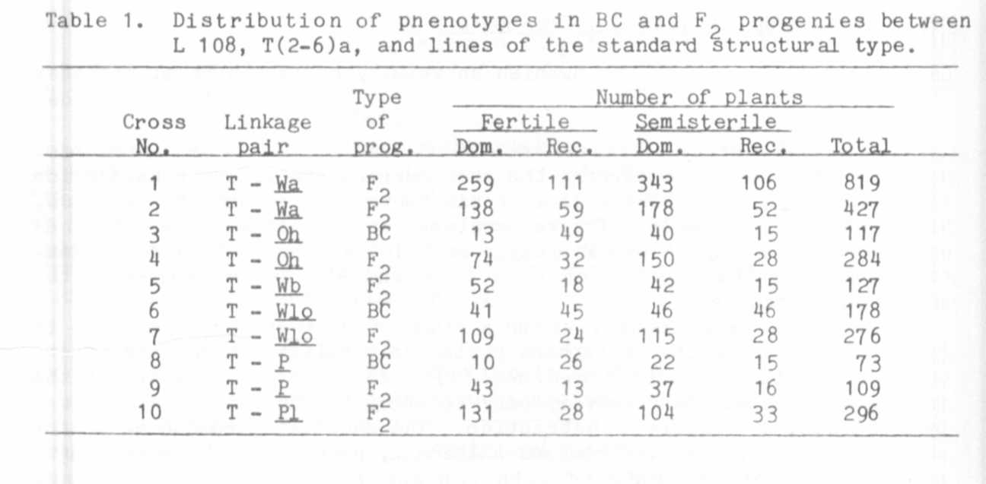
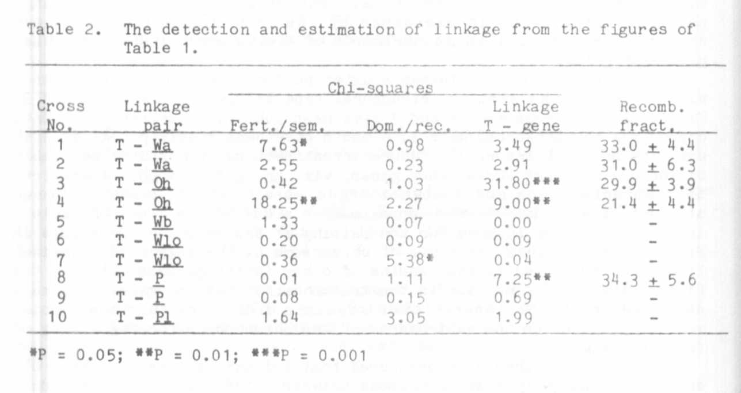

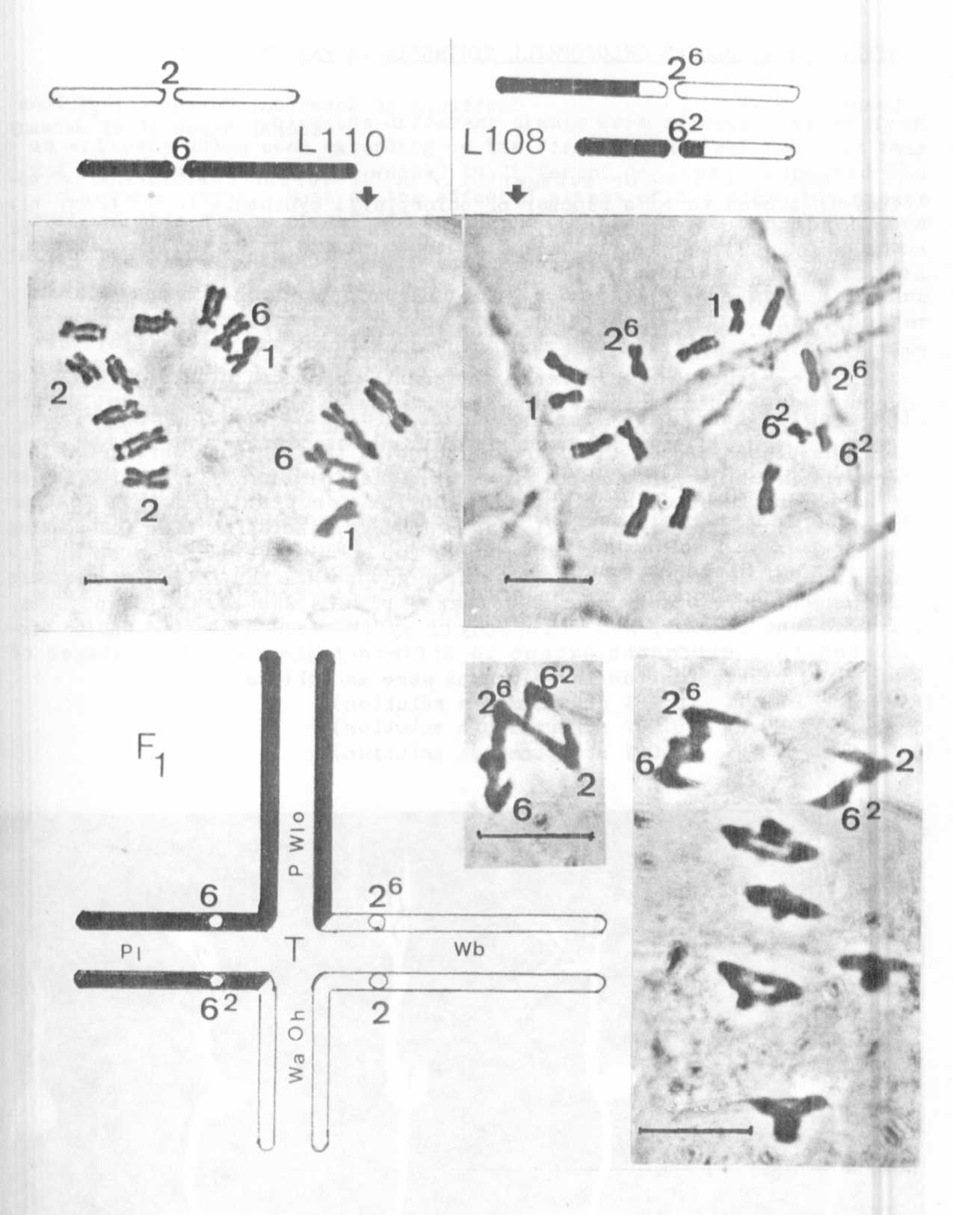
Fig. 1. Interpretative drawings of the reciprocal translocation charac-
teristic of L-108 and illustrations of mitosis in root tips of
L-110 (the standard structural type) and L-108, T(2-6)a.
Below, a tentative diagram for the chromosome pairing at the
prophase of meiosis in the F1 hybrid between these lines with a
very approximative location of six marker genes together with
illustrations of the ring of four at the first metaphase of
meiosis. Bars represent 10 mkm
t ...»

