A MUTANT SHOWING EFFICIENT NODULATION IN THE PRESENCE OF NITRATE
Jacobsen, E. and H. Nijdam
University of Groningen, Dept. of Genetics, Haren, The Netherlands

In legumes, symbiotic N₂-fixation is an important source of
nitrogen for the plant. However, nitrate, administered at the moment of
sowing, inhibits nodulation (8), and when added after nodulation
inhibits N -fixation (5). Using a nitrate reductase (NaR) mutant which
also is nitrate accumulating, we ascertained that nitrate itself, when
present in the plant, inhibits nodule initiation (6), and that the
decrease in N -fixation is brought about by the reduction of nitrate
(3). In the literature ineffective nodulation (7), resistance to
nodulation (7), and high nodulation (4) are described as genetically
determined variation in nodulation behavior of pea but, to our
knowledge, no data are available regarding variation in the reaction to
nitrate. We therefore searched for EMS-induced mutants that showed
nodulation in the presence of nitrate. M2, seedlings were screened for
nodulation on aerated liquid standard mineral solution (SMS, 2) supple-
mented with 15 mM KNO₃ and Rhizobium leguminosarum strain PF . Under
these conditions nodulation of cv 'Rondo' is strongly inhibited. The
seeds were from the same M2families as used for the selection of an
NaR-deficient mutant (2). Among 222 M2families, one distinct nodulat-
ing mutant was found.
In the M3 M4 and M5progenies of that mutant only mutant
phenotypes appeared; after crossing with cv Rondo as male parent,
nodulation of the F1progeny on SMS + 15 mM KNO₃was inhibited as in the
wild type; and in the F2the mutant appeared to be monogenic and
recessive. According to the Rules of Genetic Symbols (1) its designa-
tion will be nod-3.
Preliminary nodulation data of nod-3 is given in Table 1.
Nodulation of nod-3 on nitrate-containing medium is striking and even
better than nodulation of cv Rondo on SMS. Also, on SMS nodulation of
nod-3 is much better than that of cv Rondo. In nod-3 the appearance of
nodulation is accelerated, number of nodules is much higher, and total
nodule weight and acetylene reduction per plant (Table 2) are increased,
whereas acetylene reduction of nodules per g fresh weight is lower.
Further investigations on nod-3 will include continued genetic
analysis, its behavior with other bacterial strains, the morphological
and/or physiological basis for its aberrant nodulation, and the effect
of nitrate on the level of acetylene reduction. The double mutant with
E1[NaR-deficient (2)] will be constructed, in order to study the effect
of increased nitrate levels in the plant. Mutant nod-3 is interesting
for studying the effect of efficient nodulation on yield, as Gelin and
Blixt (1) did with their high nodulating genotypes, and additionally for
studying the effect on yield of nitrate fertilization which does not in-
hibit nodulation in this mutant.

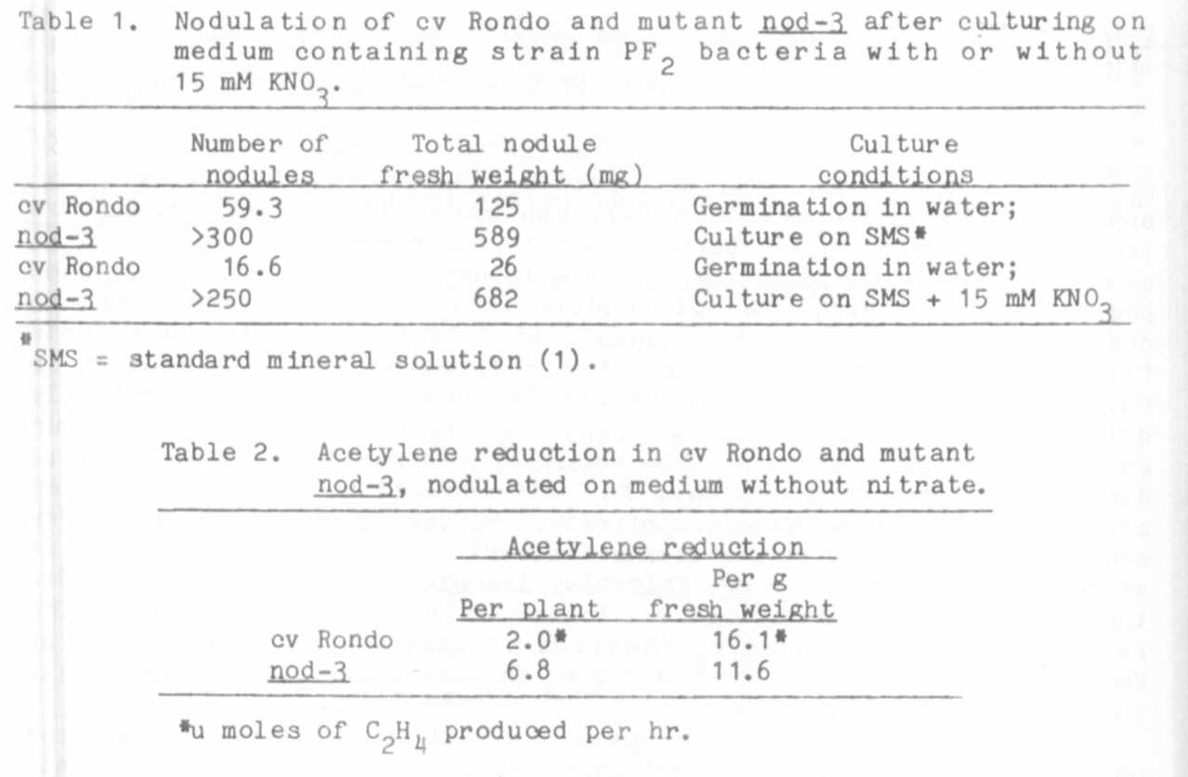

Lamm

da ta
! ines
Nil

1. Blixt, S., G. A. Marx, and I. C. Murfet. 1977. PNL 9:67-82.
2. Feenstra, W. J., and E. Jacobsen. 1980. Theor. Appl. Genet.
58:39-42.
3. Feenstra, W. J., E. Jacobsen, A. C. P. M. van Swaay, and
A. J. C. de Visser. 1982. Z. Pflanzenphysiol. 105:471-474.
4. Gelin, 0., and S. Blixt. 1964. Agri Hort. Genet. 22:149-159.
5. Harper, J. E. , and J. C. Nichols. 1978. Plant Physiol.
62:662-664.
6. Jacobsen, E., and I. van Dongen. 1982. PNL 14:23-24.
7. Lie, T. A. 1971. In.: Quispel, A. (ed). North Holland Publ.
Comp., Amsterdam, Oxford, pp. 117-127.
8. Wilson, P. W. 1935. Wis. Res. Bull. 129:1-40.

