PEA ENATION MOSAIC VIRUS: VARIATION IN RESISTANCE CONFERRED BY En

Baggett, J. R. and R. 0. Hampton Oregon State University
Corvallis, Oregon

Resistance to pea enation mosaic was reported by Schroeder and
Barton (2) to be conferred by a single dominant gene, En. They noted
that when resistant pea plants were inoculated with any of several pea
enation mosaic virus (PEMV) isolates, the plants usually became in-
fected, with only minor effects on growth. Hagedorn and Hampton (1)
demonstrated that commercial breeding lines putatively containing En
varied in degrees of PEMV-susceptibility, as indicated by symptom
severity. Even the most resistant lines, when inoculated in greenhouse
tests, either developed mild symptoms or, if affected by the virus more
severely, progressively recovered from symptoms. Follow-up field tests
confirmed that lines able to recover from PEM symptoms in the greenhouse
also manifested field resistance, corroborating the presence of the En
allele.
The data of Hagedorn and Hampton have been retabulated in descend-
ing order of susceptibility (disease indices), from greenhouse tests
(Table 1). To these data we have added a column to indicate presumptive
presence of the En allele, as deduced from greenhouse recovery data and
information provided by the breeder of the cultivar. The 45 entries in
Table 1 comprise a continuous range of PEMV responses including interm-
ediate types which, based on PFM- recovery, contain either En or en
alleles (see Line Nos. 15-25). These data suggsst that modifier genes
and perhaps cytoplasmic factors, working either independently of or
interactively with gene En, affect the type and severity of PEM
symptoms. Thus, among these intermediate lines, some with en showed a
lower disease index than some lines carrying En.
We sought to elucidate the nature of this modification by crossing
'Perfected Freezer 60' (En En) reciprocally with three susceptible
(en en) and three other resistant cultivars. F2 progenies from these
crosses were rub-inoculated in two successive "greenhouse tests, using
mechanically transmissible Wisconsin isolate (C3) of PEMV used by
Hagedorn and Hampton (1). These progenies were also field tested
Corvallis under a severe natural incidence of PEMV. Disease indices
were calculated from individual-plant symptom scores, where
visible symptoms, 1 = slight chlorotic flecking, 2 = moderate PEM
symptoms, 3 = severe PEM symptoms, and 4 = PEMV-induced plant necrosis.
To obtain a refined estimate of disease severity, we removed the p1ants
from containers at peak development of PEM symptoms and made side-by-
side visual comparison. This procedure, however, wa3 done at the
expense of greenhouse PEM-recovery data.
Symptom scores of greenhouse-grown progenies from PEMV-resistant x
susceptible parents were combined into resistant (scores 0 and 1) and
susceptible (scores 2-4) classes for computation of segregation ratios.
Most X values for 3:1 ratios were within a 0.05 level of probability,
clearly indicating conformity with and affirming single-dominant-gene
inheritance for PEMV resistance (Table 2). There were a few non-
conforming ratios. For example, control plants of 'Banff and
'Canner PL' tended to escape PEMV-infection during greenhouse inoculation,
particularly in Test #1, but were extremely susceptible in field tests
(Table 3). The cultivar 'Aurora' and the progeny of P.F.60 x Canner PL,
in Test #2, contained more than expected PEMV-susceptible plants.
Perhaps some of these plants were in the process of recovery when they
were sacrificed. Segregation ratios varied somewhat between progenies
of reciprocal crosses, with a suggestion of maternally mediated PEMV-
resistance by P.F. 60 in crosses with 'Melody' (en en), Aurora (En Ea),
and 'Tempter' (En En).
PEMV-resistance classes of naturally infected progenies (Table 3)
were derived by combining symptom scores 0-2 as resistant, and 3-4 as
susceptible. X² values for 3:1 ratios were within the 0.05 level of
probability for five of the six progenies from PEMV-resistant x suscep-
tible parents. Likewise, parental controls responded predictably to
natural PEMV infection. Maternal mediation of PEMV-resistance by
P.F. 60 was again suggested in progenies from crosses with Banff,
Aurora, and Tempter, particularly apparent in the distribution of plants
per symptom score.
Our results verify the work of Schroeder and Barton (2), but failed
to demonstrate germplasm-related modification of En. We expected
Aurora and Tempter to contribute germplasm that skewed progenies from
P.F. 60 toward greater PEMV susceptibility. Instead, these parents were
quite resistant to PEMV in our studies. Although it is tempting to at-
tribute PEMV-resistance enhancement to P.F. 60 cytoplasm, we recognize
that new approaches are likely to be required to further elucidate this
phenomenon.

1. Hagedorn, D. J. and R. 0. Hampton. 1975. Plant Dis. Reptr.
59:89 5-899.
2. Schroeder, W. T. and D. W. Barton. 1 958. Phytopathology
48:628-653.

1- From ihe data of D. J. Hagedorn and R. 0. Hampton (Plant Disease Reporter 59,
Table 1.
Ranking of pea lines and^cultivars by greenhouse indices for enation mosaic
symptom expression, 1973 .
No. Line | 2Source | Greenhouseindex | Greenhouserecovery | Fieldindex | En gene-present
1 72-1554 | 1 | 94 | none | 77 | no*
2 Exp. 331-485 | 2 | 91 | none | 62 | no
3 Exp. 326 | 2 | 86 | none | 80 | no
4 9776 | 3 | 85 | — |  | no#
5 Banff | 4 | 85 | — |  | no
6 72-626 | 1 | 85 | f ev-none | 63 | no*
7 Melody | 5 | 85 | none | 84 | no*
8 72-665 | 1 | 82 | none | 46 | no*
9 72-673 | 1 | 82 | none |  | no*
10 Can. 49 | 4 | 80 | none |  | no
11 Tonka | 2 | 78 | none | 69 | no
12 Dark Skin Perf. | - | 76 | none | 83 | no*
13 9778 | 3 | 74 | — |  | no#
14 9868 | 3 | 74 | , — |  | no#
15 Can. 69141 | 5 | 73 | excellent |  | yes*
16 Anoka | 2 | 71 | none | 37 | no
17 Exp. 306 | 2 | 69 | none |  | no
18 71-2687 | 6 | 61 | excellent-fair |  | yes*
19 Aurora | 5 | 61 | good |  | yes*
20 9867 | 3 | 59 | — |  | ?#
21 9869 | 3 | 58 | — |  | ?#
22 Tempter | 5 | 53 | good |  | yes*
23 72-3711 | 6 | 47 | good, fair |  | yes*
24 Puget | 8 | 47 | none, fair |  | no*
25 72-689 | 1 | 46
26 70C-56 | 6 | 39 | good | 11 | ves*
27 Perf. Fr. 60 | - | 38 | excellent | 6 | yes
28 71-GP106 | 6 | 36 | good |  | yes*
29 Freezer 52 | 4 | 35 | good, excellent |  | ves
30 226 C | 7 | 35 | good |  | yes
31 328 F | 7 | 34 | good |  | yes
32 70C-36 | 6 | 31 | good | 6 | yes*
3"J Trident | 8 | 31 | excellent, fair |  | yes*
~t4 Fr. 6650 | 5 | 31 | excellent | 5 | yes
35 310 F | 7 | 30 | good | 2 | yes
36 Can. 695 | 5 | 29 | excellent | 3 | yes
37 H286-1-1 | 8 | 28 | excellent | 1 | yes*
38 329 | 7 | 27 | excellent |  | ves
39 H294-5-1-1. | 8 | 24 | excellent | 0 | ves*
40 H302-2 | 8 | 24 | excel lent |  | yes*
41 203 C | 7 | 24 | good | 7 | yes
4 2 Fr. 50 | 4 | 24 | excellent | 5 | yes
43 Can. 50 | 4 | 22 | excellent |  | yes
44 H312-2-3 | 8 | 21 | excel lent | 2 | yes*
45 305 C | 7 | 21 | good | 10 | yes

No. 11, 8M5-399. 1975.)
2- Sources: (1) Anonymous, (2) Northrup King, (3) Canner Seed, (4) Pureline,
(5) Rogers, (6) Crites-Moscow, (7) Western Valley, (8) Gallatin Valley

3- Concluded frorr. test results, with emphasis on greenhouse recovery tendency.
* indicates the breeder confirms conclusion. # indicates that one parent was
enation mosaic resistant but progenies were not selected for resistance.
6 PNL Volume 15 1983 RESEARCH REPORTS

Table ft Ratios of resistant:susceptible plants and disease indices, sreenhouse tests, 1978.
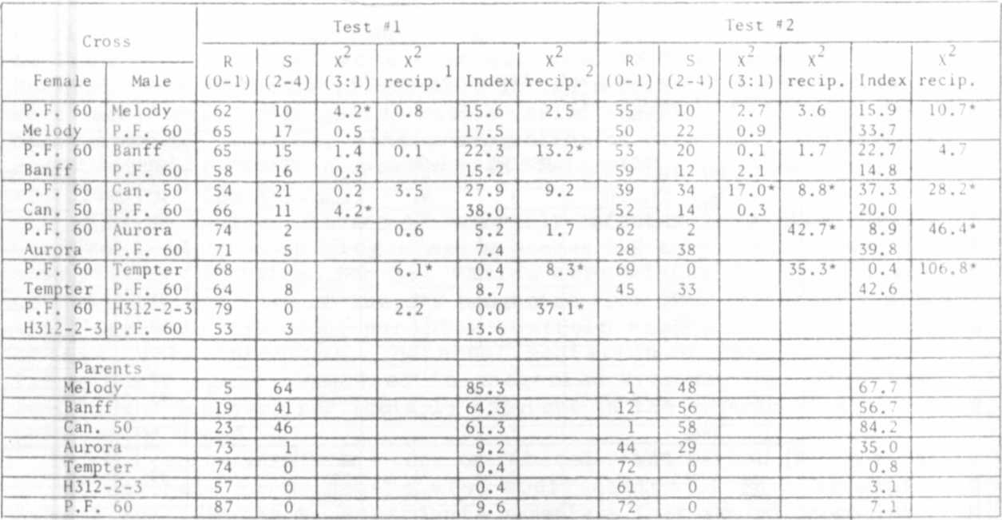
•Significant at 5% level.
,Ratios of R:S for reciprocals compared by contingency table test.
'Complete distribution of reciprocals in disease classes 0-4 compared by contingency table test.

Table 3. Ratios of resistant:susceptible plants, and disease indices, field test, 1978.
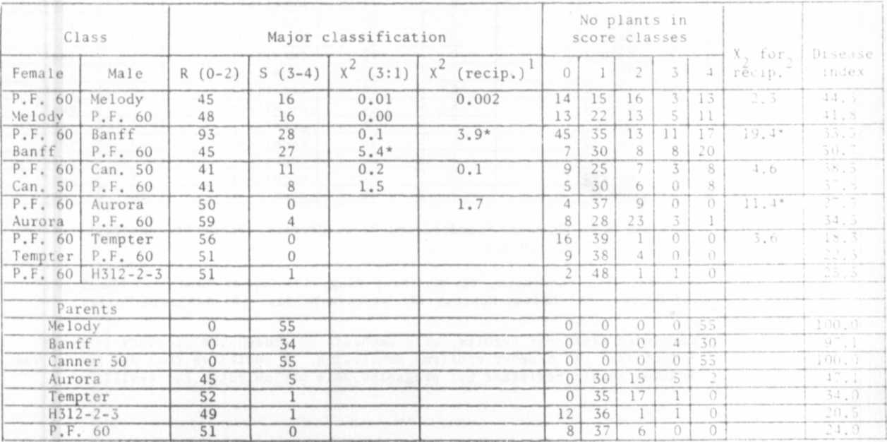
"Significant at the 5% level.
,Ratios of R:S for reciprocals compared by contingency table test.
"Score distribution for reciprocals compared by contingency table test.

