RESEARCH REPORTS 29
PNL Volume 15
1983

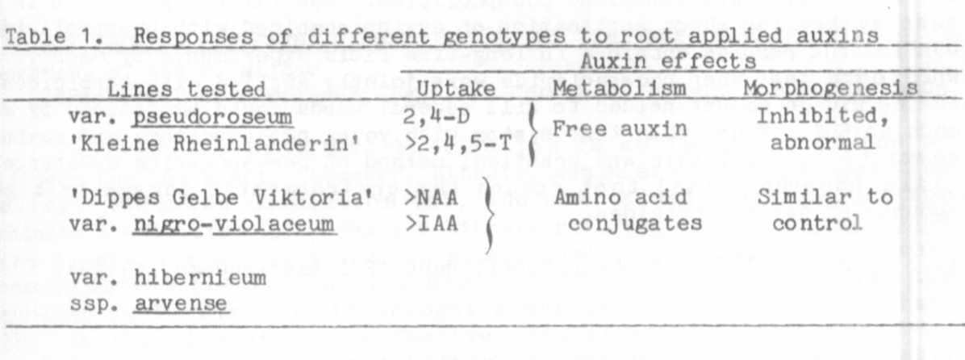
1. Ingensiep, H. W. , M. Hertl, and H. L. Jacobsen. 1981.
PNL 13:21-23.
2. Ingensiep, H. W. 1982. PNL 14:19-20.

A TEST SYSTEM FOR SHOOT APPLICATION OF AUXINS COMBINED WITH
PHOSPHOLIPIDS USING SEEDLINGS OF PISUM SATIVUM

Ingensiep, H. W. Institute of Genetics, University of Bonn
Federal Republic of Germany

A test system is described which allows us to characterize the
auxin-sensitivity and effects of phospholipids in auxin solutions
following application to the shoots of young pea seedlings. Co-applied
phospholipids may be useful to reduce the amount of herbicides as has
been demonstrated previously in field experiments by Maas (1). Simple
test systems as introduced here may be a practical means of screening
for substances which reduce the amount of auxin-herbicides or of
identifying mutants of Pisum with abnormal auxin-sensitivity.
The test system is schematically summarized in Fig. 1. One-week-
old etiolated seedlings cultivated on moist vermiculite were further
cultivated for two days under a light/dark rhythm of 16 hr/8 hr to
induce light dependent morphogenesis. Then the auxins were applied to
the shoots by dipping the top of the epicotyl in aqueous auxin solutions
(10⁻⁴ M) with and without phospholipids (0.02%). As typical
auxin-herbicides we used ¹⁴C-labelled 2,4-D, 2,4,5-T, and MCPA. After
this treatment the seedlings were again cultivated on moist vermiculite
and the uptake or radioactivity was measured during the following 24
hours. At each measuring point the seedlings were dipped in ethanol to
remove the surface-associated auxin and after that the shoot tissue was
extracted by an ethanol procedure. Auxin-radioactivity on the shoot and
in the shoot were obtained and measured by a liquid scintillation
counter. The distribution of radioactivity one week after the shoot
application was also measured by autoradiography of the whole seedlings
on X-ray films.
These experiments showed that the presence of phospholipids in the
aqueous auxin solutions enhanced the detectable auxin-radioactivity on
the shoot surface up to three times and in the shoot tissue up to two
times compared with solutions containing only the auxins. Moreover, the
analysis by autoradiography showed broader spots of radioactivity on the
leaves if phospholipids were present in the solutions. Also the typical

morphogenetic response during further cultivation was more drastic if
the auxin solutions contained phospholipids. Our first experiments in a
test system for shoot application of auxins combined with phospholipids
confirm the results obtained in long-time field experiments by Maas (1),
who found that when phospholipids were jointly applied with herbicides,
the herbicide amount needed to kill several weed3 could be reduced by as
much as 50$. Thus, this test system with young pea seedlings and auxins
seems to be a reliable and practical method of pre-screening substances
(like phospholipids) that reduce the environmental damage by high
amounts of auxin-herbicides.
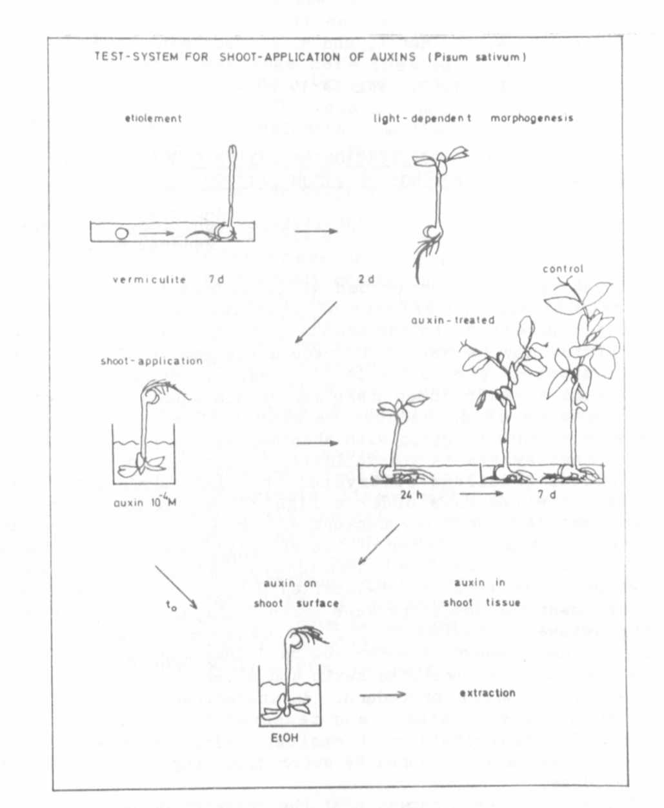
Fig. 1. Test system for shoot-application of auxins (Pisum sativum).
1. Maas, G. 1982. Nachrichtenbl. deut. Pflanzenschutzd., 34(8).

