MORPHOGENETIC EFFECTS. AUXIN UPTAKE AND METABOLISM OF SOME PEA
VARIETIES AFTER ROOT APPLICATION OF AUXINS

Ingensiep, H. W. Institute of Genetics, University of Bonn
Federal Republic of Germany

Previously we proposed a system to test the effects of root applied
auxins on morphogenesis, auxin uptake, and metabolism of young pea
seedlings (1,2). The present paper summarizes the results of experi-
ments with six varieties of peas using the described test system
(Table 1). The varieties differed in seed color and weight and in
epicotyl length under uniform cultural conditions. Our hope was to find
some pea varieties that showed differences in response to root applica-
tion of auxins.
One-week-old pea seedlings were treated with the auxins 2,4-D,
2,4,5-T, NAA, and IAA (10~⁴M, ¹⁴C-labeled) for 24 hours via the roots
(10 ml medium per seedling). The loss of radioactivity in the medium
was measured and ethanolic extracts from the root tissue were analyzed
by thin layer chromatography (TLC). These experiments showed no sig-
nificant differences in uptake behavior, auxin metabolism, or
morphogenetic response among the varieties tested. All varieties showed
the following uptake behavior: The 2,4-D and 2,4,5-T uptake was very
low (about 10%), the uptake of NAA and IAA was very great (more than 30,
40%, respectively) under these conditions. The TLC-analysis of
ethanolic root extracts by autoradiography and the liquid scintillation
count data were in accord with the well-known explanation for this up-
take behavior: The 2,4-D and the 2,1,5-T radioactivity is only
represented by the spot of the free auxin. However, because the NAA and
IAA form conjugation products with aspartic acid the radioactivity ap-
pears in two spots, viz. the free auxin and amino acid-conjugation
products (NAA). Little difference in this reaction pattern was found
among the varieties.
The morphogenetic response among varieties was also sim:
The 2,1-D- and 2,4,5-T-treated seedlings were strongly inhibited in
their light dependent morphogenesis (tissue swelling, irregular lateral
roots, callus structures), while the NAA- or IAA-treated seedlings were
only slightly affected due to the metabolic inactivation of high amounts
of the free auxin. The results are summarized in Table 1.
These preliminary investigations confirm the view that the genes
which are involved in regulation of the endogenous auxin content (for
example for conjugating enzymes) seem to be very conservative within the
species. Further tests with other Pisum stocks are necessary to find
auxin-sensitive mutants, which differ in their response to auxins.

RESEARCH REPORTS 29
PNL Volume 15
1983

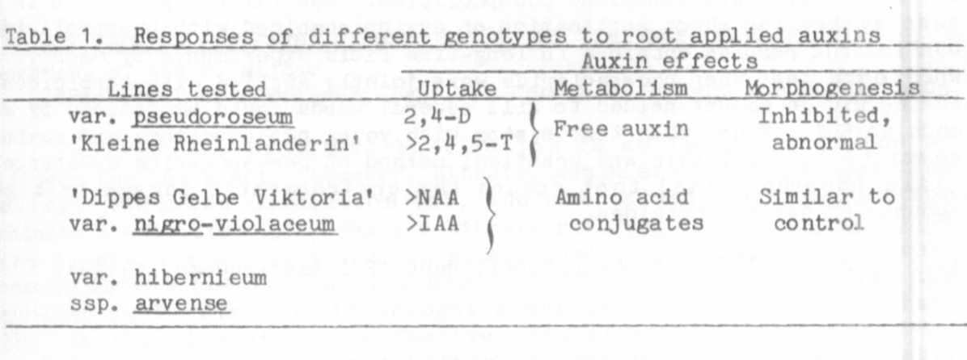
1. Ingensiep, H. W. , M. Hertl, and H. L. Jacobsen. 1981.
PNL 13:21-23.
2. Ingensiep, H. W. 1982. PNL 14:19-20.

A TEST SYSTEM FOR SHOOT APPLICATION OF AUXINS COMBINED WITH
PHOSPHOLIPIDS USING SEEDLINGS OF PISUM SATIVUM

Ingensiep, H. W. Institute of Genetics, University of Bonn
Federal Republic of Germany

A test system is described which allows us to characterize the
auxin-sensitivity and effects of phospholipids in auxin solutions
following application to the shoots of young pea seedlings. Co-applied
phospholipids may be useful to reduce the amount of herbicides as has
been demonstrated previously in field experiments by Maas (1). Simple
test systems as introduced here may be a practical means of screening
for substances which reduce the amount of auxin-herbicides or of
identifying mutants of Pisum with abnormal auxin-sensitivity.
The test system is schematically summarized in Fig. 1. One-week-
old etiolated seedlings cultivated on moist vermiculite were further
cultivated for two days under a light/dark rhythm of 16 hr/8 hr to
induce light dependent morphogenesis. Then the auxins were applied to
the shoots by dipping the top of the epicotyl in aqueous auxin solutions
(10⁻⁴ M) with and without phospholipids (0.02%). As typical
auxin-herbicides we used ¹⁴C-labelled 2,4-D, 2,4,5-T, and MCPA. After
this treatment the seedlings were again cultivated on moist vermiculite
and the uptake or radioactivity was measured during the following 24
hours. At each measuring point the seedlings were dipped in ethanol to
remove the surface-associated auxin and after that the shoot tissue was
extracted by an ethanol procedure. Auxin-radioactivity on the shoot and
in the shoot were obtained and measured by a liquid scintillation
counter. The distribution of radioactivity one week after the shoot
application was also measured by autoradiography of the whole seedlings
on X-ray films.
These experiments showed that the presence of phospholipids in the
aqueous auxin solutions enhanced the detectable auxin-radioactivity on
the shoot surface up to three times and in the shoot tissue up to two
times compared with solutions containing only the auxins. Moreover, the
analysis by autoradiography showed broader spots of radioactivity on the
leaves if phospholipids were present in the solutions. Also the typical

