FURTHER GENES INFLUENCING THE PENETRANCE OF GSNE bif-1 FOR STEM
BIFURCATION

Gottschalk, W. and A. Abou-Salha Institute of Genetics
University of Bonn, Federal Republic of Germany

The penetrance of gene bi f-1 for dichotomous stem bifurcation,
hornoz ygous] y present in mutant 1201A of our collection, depends on both
errvironmentai factors and other mutant genes of the genome (1). During
the past years, further genes were found to influence its penetrance
positively or negatively; some of them are discussed in the present
paper. The method used consists in comparing bifurcated recombinants
with mutant 1201A with regard to the penetrance of bif-1 .
Mutant 1201A, the donor of bif-1 . shows a broad variation of
penetrance ranging between 22 and 84% in 20 generations due to a
specific environmental factor(s) which is not yet known to us.
The 10 different recombinants studied can be subdivided into three
groups according to the penetrance behavior of bif-1 (Fig. 1, upper
part). The 4 genotypes of Group I show in principle the same degree of
penetrance as mutant 1201A. This means that those mutant genes, which
additionally present in their genomes, do not influence the
penetrance of bif-1 .
A different picture emerges in Group II. Recombinant RM 83 6 was
selected after having crossed the waxless mutant 445 with R 46C,
homozygous for bif-1 and gene efr for earliness. In two generations,
the action of bif-1 was not expressed (P=0%). In the other three gener-
ations tested the penetrance was extremely low, ranging between 2 and
4%. Thus, the gene for waxlessness suppresses the penetrance of bif-1
almost completely. A similar behavior was observed in recombinant
RM 427 arisen in F2 of the cross of mutant 176A with recombinant R 862,
which itself arose after having hybridized the fasciated mutant 123 with
the early flowering recombinant R 46C. The plants of RM 4 27 have the
folowing characters:
Stem bifurcation (gene bif-1 from R 46C)
Early flowering (gene efr from R 46C)
Narrow leaflets and stipules (gene dim-1 from mutant 17 6A)
Slightly reduced internode length (gene short I from mutant 123)
In this combination, the penetrance of bif-1 ranged between 0 and
15%. Thus, one of the other mutant genes present in RM 427 likewise has
a suppressing effect on the penetrance of bif-1 .
The opposite effect was observed in 4 recombinants of Group III.
In R 177, RM 516, and RM 1010, the penetrance of bif-1 varied between 86
and 100% over 3 to 10 generations. All the plants of RR 507 were bifur-
cated, i.e. full penetrance of the gene. The 4 recombinants have the
following genotypic constitutions:
R 177: Stem bifurcation (bif-1 from 1201A)
Reduced seed size (sg. from the fasciated mutant 489C)
R 507: Stem bifurcation (bif-1 from 1201A)
Reduced seed size (sg from 489C)
Reduced internode length (short-I from 489C)
RM 516: Stem bifurcation (bif-1 from 1201A)
Reduced internode length (short I from the fasciated
mutant 251 A)
Later flowering (from 251 A)
HM 1010: Stem bifurcation (bif-1 from 1201A)
Later flowering (from 489C)

RESEARCH REPORTS
PNL Volume 15
1983
3

These 4 recombinants do not have a specific gene in common which could
be responsible for stabilizing the penetrance of bif-1. In R 177 and
RR 507, this effect could be due to the presence of gene sg for small
grains. This gene, however, is not present in the genomes of RM 516 and
RM 1010. Both these genotypes begin flowering a few days later than the
mother variety, but this is not a very reliable trait.
The seed production of the material tested i- given in the lower
part of Fig. 1. A strong correlation between see< yield and penetrance
of bif-1 could not be found, as is evident if wo compare the recom-
binants of Group I with mutant 1201A. The penetrance of bif-1 is about
equal to, but the seed production of the 4 recombinants is considerably
lower than, that of mutant 1201A. If, however, we compare the genotypes
of Groups II and III with each other, a certain parallelism between
penetrance behavior and seed production is evident. At least in some of
these genotypes, the low or high penetrance could contribute to the low
or the high yield, respectively.

1. Gottschalk, W. 1978. PNL 10:13.
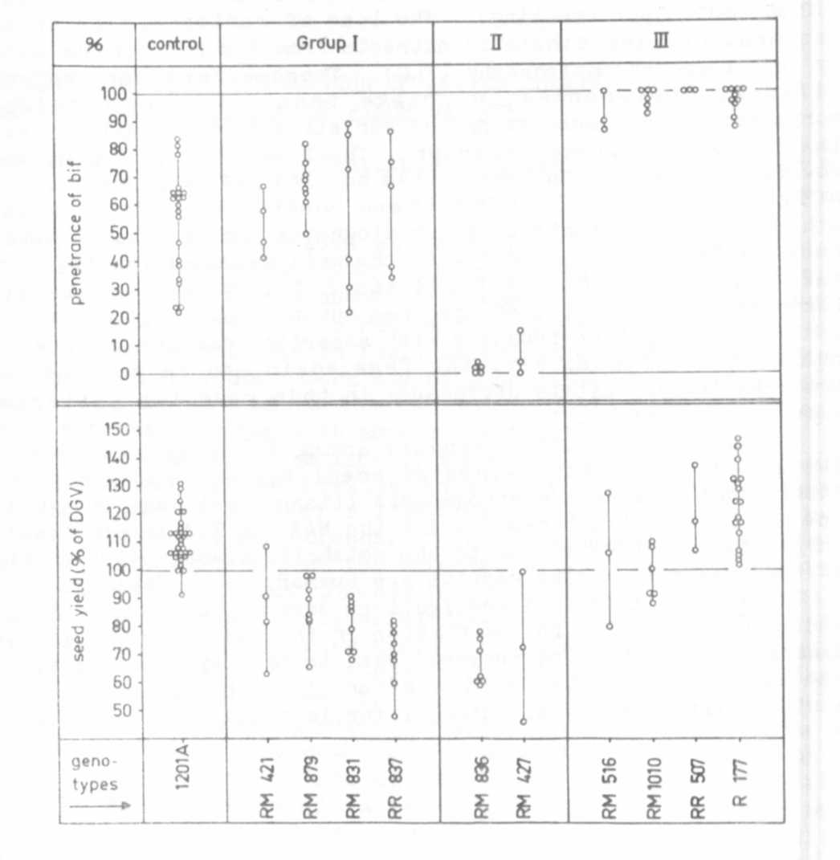
Upper part: The penetrance of gene bif-1 in mutant 1201A
(the donor of the gene) and in 10 recombinant lines
homozygous for bif-1 and for other mutant genes.
Lower part: The seed production (number of seeds per plant)
of the 11 genotypes studied as related to the correspond-
ing values of the mother variety 'Dippes Gelbe Viktoria'
(DGV; = 100%.
Each dot give the mean value for one generation.

