24
PNL Volume 15 19 83
RESEARCH REPORTS

UNUSUAL PHOTOPERIODIC REACTION OF PISUM RECOMBINANT B 112 F

Gottschalk, W. Institute of Genetics, University of Bonn
Federal Republic of Germany

Recombinant R 142F of our collection arose after having crossed the
weak mutant 142B, homozygous for gene dgl, with the high-yielding fas-
ciated mutant 48 9C. Gene dgl causes a degeneration of stipules and
leaflets, but expression is delayed so the apical leaves of the plants
are normally green whereas the basal ones are brown and unable to
photosynthesize. Because of this defect, the seed production of mutant
142B is very low (Fig. 1) and many plants produce no seeds at all.
The plants of recombinant R 142F are non-fasciated; thus, they do
not contain one of the three or four genes for stem fasciation present
in the parental mutant 489C. They show the following characters:
Degenerating leaves (gene dgl from 142B)
Very long internodes (long III from 489C)
Slightly reduced chlorophyll content (from 489C)
Lateness (from 489C)
Not flowering under short-day conditions (gene fis from 489C)
Under long-day field conditions in West Germany, the plants of
R 142F begin flowering 15-16 days later than those of the mother
variety. Mutant 489C likewise begins flowering about 10-12 days later
than the mother variety (data of 1981, 1982). However, our results in-
dicate that the genes present in 489C and R 142F are not identical.
Mutant 142B does differ from the mother variety with regard to its
flowering behavior.
The seed production of R 142F was extraordinarily variable in the 9
generations tested so far (Fig. 1) indicating a strong influence of en-
vironmental factors. This becomes particularly clear from the values of
Fg/1978 when the material was grown in two different locations. In
locality I, the yield was similar to the control value (DGV) whereas it
was 60% higher at the second locality. The recombinant has, in general,
a considerably higher yield than mutant 142B in spite of the presence of
gene dgl for leaf degeneration. Its productivity is mainly due to the
vigor of the plants which offsets the expression of dgl. Thus, the
negative selection value of gene dgl could be strongly improved by com-
bining it with specific other mutant genes of the genome.
Under short-day phytotron conditions (12 hr light, 12 hr darkness;
night temperature 15, day temperature 25 C), plants of 489C and R 142F
did not flower whereas 142B and the mother variety showed normal flower-
ing behavior. Sixty-one days after sowing (the control plants already
had well developed pods), the phytotron conditions were changed to long-
day (18 hrs light, 6 hrs darkness). Three weeks later, mutant 489C had
flower buds, but R 142F did not show any flower bud formation. Even
after more than 5 weeks in long-days, the R 142F plants showed no sign
of flower initiation and tiny foliage leaves were present exclusively at
their apical growing points.
In a second trial, the genotypes were grown under permanent light
whereas the other phytotron conditions remained unchanged. Mutant 4890
began flowering 15 days, and recombinant R 142F 30 days, later than the
mother variety. The very tall plants of R 142F formed their first
flowers at the 37th node, an unusually high number under these
conditions. In the field, the first flowers were produced at the 22nd
node, the total number of internodes at the end of ontogenesis being 28.

The non-flowering of mutant 489C in short-day is due to the action
of gene fis controlling the photoperiodic behavior. Recombinant R 142F
obviously has the same gene. It is, however, negatively influenced by
another mutant gene causing a very large delay in the initiation of
flowering under photoperiodic conditions which allow flowering of the
two genotypes. Furthermore, the comparison of the data of field and
phytotron plants shows that the flowering behavior of R 142F is in-
fluenced not only by the photoperiod but in addition by another
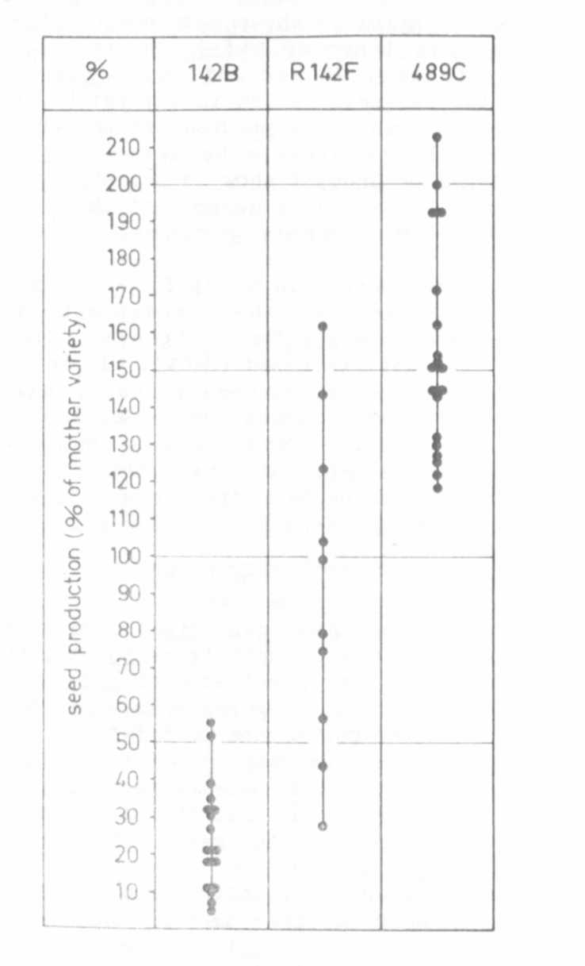
environmental factor, probably temperature.
Fig. 1. Seed production of mutants 142B, 489C and recombinant R 142F in
relation to DGV under German long-day field conditions. Each
dot represents the mean value for the trait "number of seeds
per plant" for one generation.

