RESEARCH REPORTS 2 3
PNL Volume 15 1983

THE SEED PRODUCTION OF 33 PISUM GENOTYPES UNDER PERMANENT LIGHT
PHYTOTRON CONDITIONS.

Gottschalk, W.
Institute of Genetics, University of Bonn
Federal Republic of Germany

Many genotypes appear to yield poorly when grown in permanent
light. The initial variety in our radiation trials, 'Dippes Gelbe
Viktoria' (DGV), and recombinant R 46C both yield fewer seeds in per-
manent light than in long days (Fig. 1). However, the data in Fig. 1
show that some genotypes can still perform relatively well in permanent
light. Recombinant RM 1122B, selected from cross R 46C x 489C, is par-
ticularly notable in this respect. In the field RM 1122B produced a 30
to 50% higher yield than DGV in three different trials. However, under
permanent light in the phytotron, RM 1 122B out-yielded both DGV and
R 46C by about 500%.
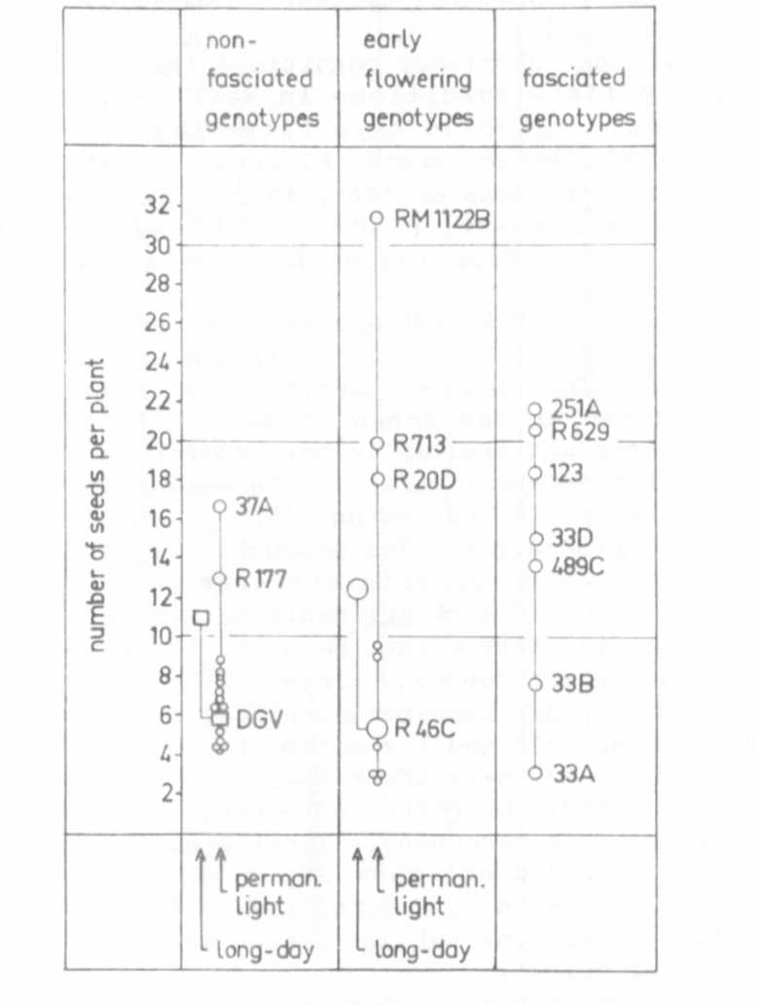
Fig. 1. The seed production of 20 mutants, 12 recombinants and the
initial line 'Dippes Gelbe Viktoria' (DGV) under permanent
light phytotron conditions. Generally, each dot represents the
mean value of 8 plants. In the control material (DGV and
R 46C), the number of plants was higher. For these 2
genotypes, the long-day phytotron values also are given.

