RESEARCH REPORTS 1
PNL Volume 15 1983

FLOWERING BEHAVIOR OF 1 8 PISUM GENOTYPES UNDER THREE PI F FE RENT
PHOTOPERIODS

Gottschalk, W. Institute of Genetics, University of Bonn
Federal Republic of Germany

Nine mutants, 8 recombinants and the initial variety ' Dippes Gel be
Viktoria' (DGV) were grown in the phytotron under the following
conditions:
- Short-day (12 hr light, 12 hr darkness)
- Long-day (18 hr light, 6 hr darkness)
- Permanent light

In all 3 light regimes the temperature was a constant 15 C from
9 PM to 6 AM rising to 25 C from 6 AM to 10 AM and decreasing to 15 C
from 4 PM to 9 PM. Humidity was 60%. Eight plants of each genotype
were grown in Mitscherlich pots and evaluated for number of days to
first open flower (DF), flower bud abortion and other characteristics.
The data in Fig. 1 illustrate variation in DF for the mother
variety DGV and the early flowering recombinant R 46C. The following
mean values for DF were obtained:
Interestingly, not all the genotypes studied showed the same
behavior. Instead, the material can be subdivided into 5 groups as far
as the reaction to photoperiod is concerned (Fig. 2). Six of the 18
genotypes tested agreed principally with DGV and R 46C (group 1; only
the mean values for the genotypes are given). In the two genotypes of
the second group, there is no difference, or almost no difference, be-
tween the permanent light and long-day plants but a very strong
difference between these two categories and the plants grown in short-
day. The two mutants of group 3 (two closely related fasciated
genotypes with different internode lengths) do not show any clear dif-
ferences among the three phc toperiods, i.e. the photoperiod has no
influence on their flowering behavior. The genotypes of groups 4 and 5
need long-day conditions in order to produce functional flowers. There
is a characteristic difference between the two groups. In the recom-
binants of group 4, flower formation was initiated under short-day
conditions but only tiny buds were produced which did not undergo fur-
ther development. The mutants of group 5, however, remained vegetative
in short-days due to the presence of gene fis. They required long-days
for the initiation of flower formation. With regard to the differences
between long-day and permanent light, the genotypes of groups 4 and 5
showed the same reaction of those of group 1.
It is surprising that such large differences in flowering behavior
are found in such a small group of genotypes which derive from the same
mother variety, i.e. the genetic differences involved are likely to be
few in number. These genotypes are an interesting material for inves-

RESEARCH REPORTS
PNL Volume 15
1983
22

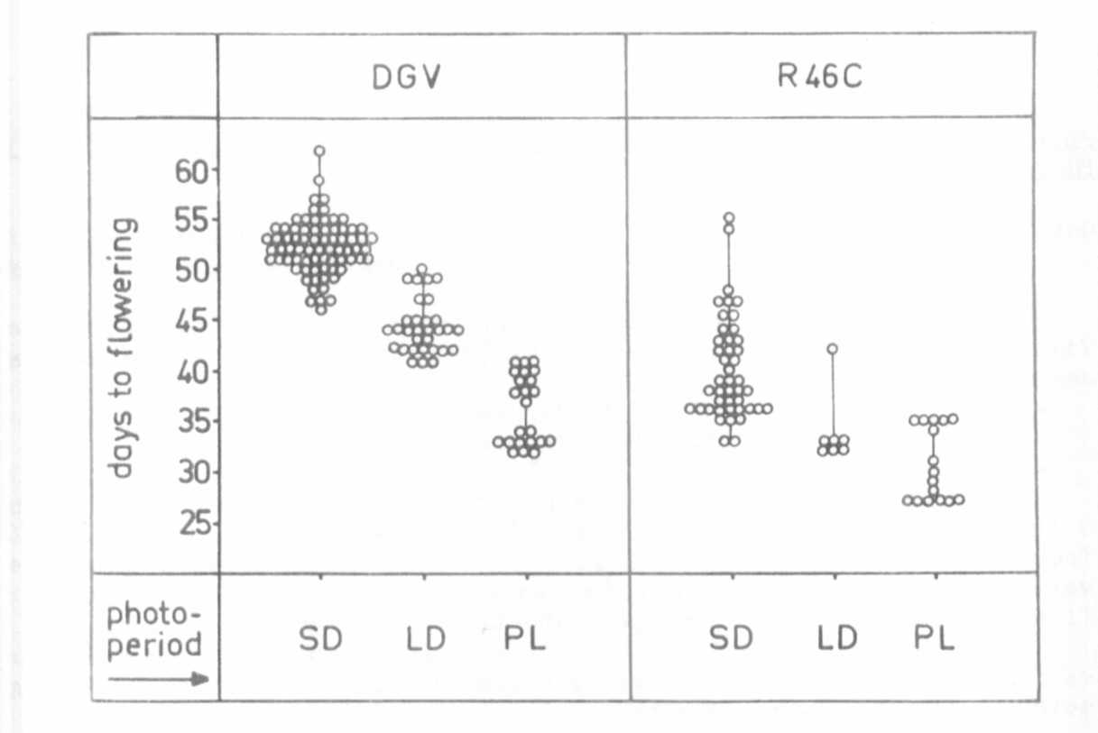
Fig. 1. Flowering behavior of the early flowering recombinant R 46C and
its mother variety 'Dippes Gelbe Viktoria' (DVG) in three different
photoperiods. Each dot is the value for a single plant. (SD r short-
day; LD = long-day; PL = permanent light).
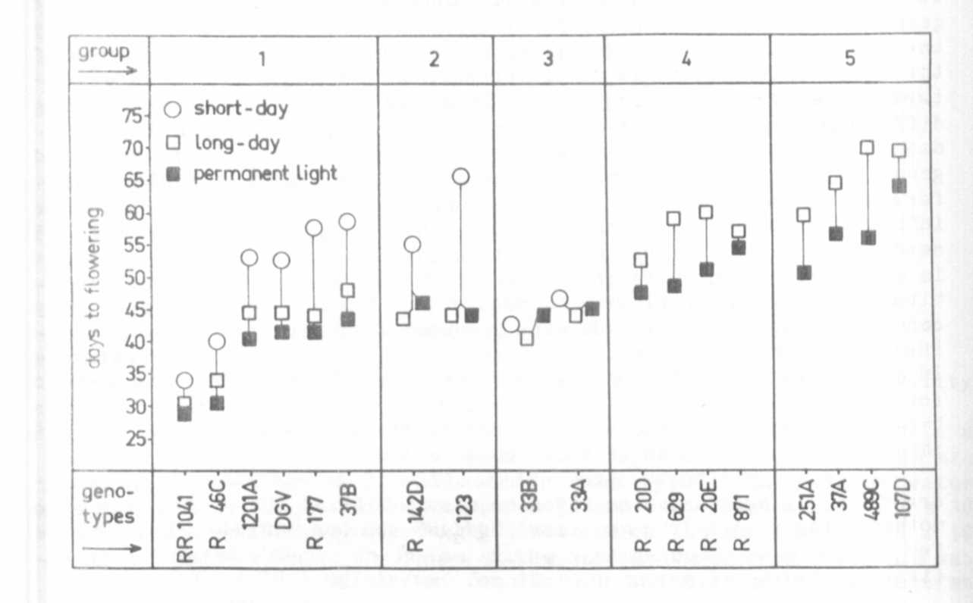
Fig. 2. Flowering behavior of 9 mutants, 8 recombinants and the mother
variety (DGV) under three different photoperiods in the phytotron. Each
point represents the mean value for the respective genotype.

