PNL Volume 15 1981
RESEARCH REPORTS
15

FUNCTIONAL STOMATA ON THE PODS OF THE ARGENTEUM MUTANT OF PISUM SATIVUM

Donkin, M. E. , D. N. Price, and E. S. Martin
Plymouth Polytechnic, Plymouth, U. K.
Smith, C. John Inne3 Institute, Norwich, U. K.
Hull, T. Rumleigh Experimental Station, Bere Alston, U. K.

Many fruits, including pods of the Leguminosae, have stomata on
their outer surface; however, very little is known about the movements
and functions of the stomatal apparatus. Some stomata may open and
close normally but many remain open permanently, especially when they
are present in the inner epidermis of fruits. The function of stomata
on pods such as those of Pisum sativum is of great importance when con-
sidering the carbon economy of the pod.
Recently a mutant of Pisum. Argenteum (Arg.), was described (2,3),
the leaves of which have an easily detachable epidermis. This makes it
ideal for the study of stomatal behavior. We have recently investigated
the behavior of stomata on the upper and lower epidermis of this mutant
(1), and we were also interested in the behavior of stomata on the
epidermis of the Arg pod. The pod epidermis does not detach as readily
as that of the leaves but it appears to be easier to remove from young
pods of Arg than from those of other Pisum lines.
The in situ behavior of the pod stomata was investigated in two
ways. The first experiment (Table 1) was a "split pod" experiment in
which pods were removed from the plant, split in half, and the seeds
were removed. Each half was kept either in the light or dark for 4
hours and at the end of this period strips were removed from the pods
and the stomata] apertures were determined under the microscope.
Table 1 shows that in this type of experiment the stomata were slightly
more open in the light than in the dark (about 1 mkm). The second ex-
periment involved taking epidermal samples from pods still attached to
the plant at various times in a light/dark cycle; stomatal apertures
were determined by microscopic measurements. Table 2 shows that under
these conditions the stomata on the pods had a wider aperture in the
light period than in the dark period.

Table 1. Stomatal apertures on "split pods" in the light or dark. Three
8-day old pods were taken from the plant and split into two
halves. Each half was placed onto water, inner surface down,
in a Petri dish. One dish was kept in the light (140 mkmol
m⁻² s⁻¹) 400-700 nm, and the other in the dark for 4 hr at
20 C. At the end of this period three strips of epidermis
were taken from each pod half and 10 apertures were measured
on each strip (90 apertures in total per treatment). The
results were analyzed by a paired t-test and showed a sig-
nificant difference between light and dark (P=0.025, df=2).
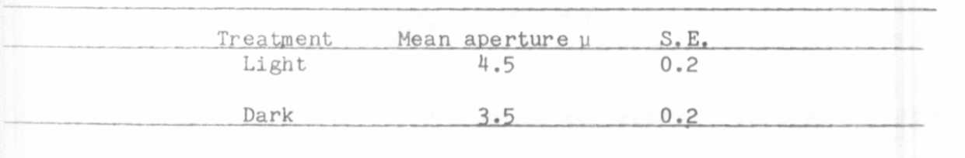

RESEARCH REPORTS
PNL Volume 15
16
1983

Table 2. Stomatal apertures of pods from plants in the light or dark
period of a diurnal rhythm.
Three strips of epidermis were taken from each of three 9-day-
old pods on plants in either the light or dark period of their
diurnal rhythm. Ten stomatal apertures were measured on each
strip (90 apertures in total per treatment). The results were
analyzed with an unpaired t-test and were found to be
significant (P=0.001, df=4).


Since these data showed evidence of functional stomata, further
investigations were carried out to see if changes in K⁺ and starch were
involved in the movements. Histochemical studies with epidermal strips
taken from pods on plants either in the light or dark showed that Kdoes appear to accumulate in the pod guard cells in the light (Fig. 1
A, B) and also that starch which is present in the guard cell
chloroplasts in the dark (Fig. 1D) disappears during the light period
(Fig. 1 C).
These reactions are well documented for stomata on leaves of many
species but so far relatively little work has been carried out on the
functions of pod stomata. From these studies it would appear that the
stomata on the pods of the Arg mutant function in a similar way to leaf
stomata, although they do not open as wide as those on the leaf. A more
detailed study of the function of pod stomata with age would be useful
to enhance our knowledge of the role of pod stomata in the development
of the seed.

1. Donkin, M. E., A. J. Travis, and E. S. Martin. 1982.
Z. Pflanzenphysiol. 107:201-209.
2. Marx, G. A. 1978. PNL 10:34-37.
3. Marx, G. A. 1982. J. Heredity 73:413-420.

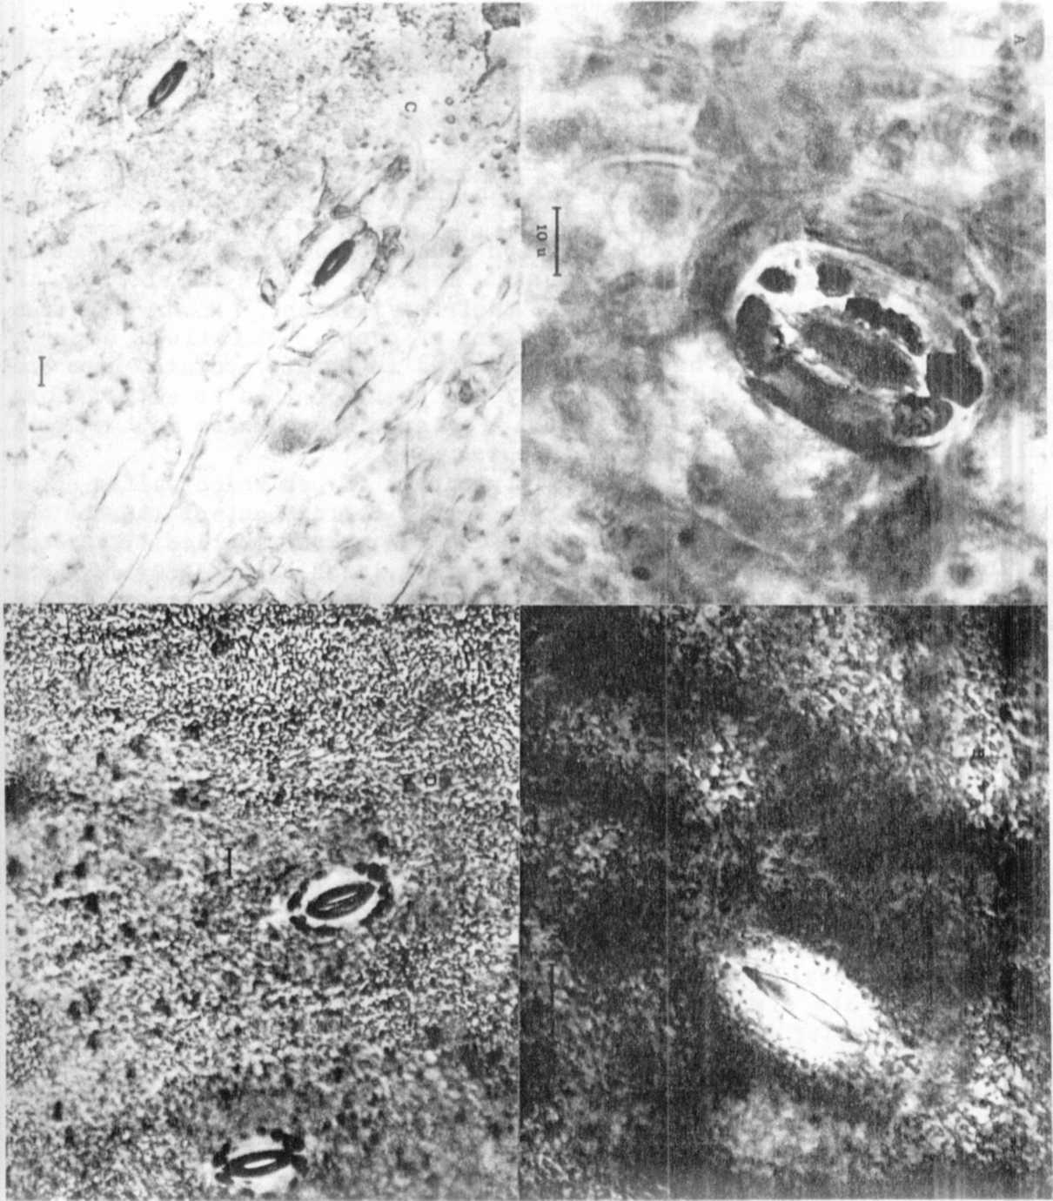
A = light, B = dark
Fig. 1. Light micrographs of K+
+ and starch staining in Argenteum pod
guard cells in the light or dark.
A and B show staining for K in the guard cells by the MaCallum
stain.
C and D show staining for starch in guard cell chloroplasts by
the I₂/KI stain.
C = light, D = dark
The dark deposits on the epidermal surface in B and D are
cuticular wax. The bar on the micrographs is equal to 10 um.

