A COMPARISON OF STOMATAL BEHAVIOR BEFORE AND AFTER FLOWERING IN THE
ARGENTEUM MUTANT OF PISUM SATIVUM

Donkin, M. E., and E. S. Martin Plymouth Polytechnic
Plymouth, U. K.
Hull, T. Rumleigh Experiment Station, Bere Alston, U. K.

The recently described Argenteum (.Arg) mutant of Pisum (4,5) has
proved to be extremely useful for the investigation of stomatal physiol-
ogy in the pea plant. This mutant, which is characterized by a silvery
appearance of the leaves, has been shown to have extensive intercellular
air spaces between the epidermis and the mesophyll tissue (2) which
makes the epidermis easily removable for stomatal studies.
Some studies of the stomatal behavior of this mutant have been
carried out (1,3) but so far as we know no work has been done on the
stomatal response to flowering in Arg or indeed in any other variety of
pea. This may be an important omission since during the process of
flowering and pod production hormonal changes take place which may in-
fluence the behavior of the stomata and subsequently the overall
physiology of the plant.
We have therefore carried out a designed experiment (details in
legend to Fig. 1) in which the stomatal responses to light and CO₂ of
detached epidermis were investigated In non-flowering and flowering Arg.
plants. The results shown in Fig. 1 indicate that overall the stomatal
apertures are reduced in the flowering plants. It is also apparent that
the stomatal response to light is decreased in the flowering plants par-
ticularly in the absence of CO₂ but the response to CO₂ is similar in
both flowering and non-flowering Arg plants. These conclusions were
confirmed by subjecting the data to analysis of variance, which showed
that there were large significant effects (P=0.001, df=7) of light, C0₂
and flowering, with a significant interaction between light and flower-
ing (P=0.05, df=1,7), but no interaction between C0₂ and flowering.
Interpretation of these results is difficult since under these con-
ditions we cannot separate an. effect of age from an effect of flowering,
the flowering plants being several weeks older. However, the leaves
used for the flowering plants were not showing any signs of senescence.
The most interesting feature would seem to be that of the effect of
flowering on the light response of stomata without an effect on the CO₂
response. The explanation for these observations may lie in the sensi-
tive balance of key hormones at this stage of development, since the
ratio of the hormones IAA/ABA are known to affect stomatal opening.

1. Donkin, M. E., A. J. Travis, and E. S. Martin. 1982.
Z. Pflanzenphysiology 107:201-209.
2. Hoch, H. C, C. Pratt, and G. A. Marx. 1980. Amer. J. Bot. 67:905-
91 1.
3. Jewer, P. C. , L. D. Incoll, and J. Shaw. 1982. Planta 155:146-153-
4. Marx, G. A. 1978. PNL 10:34-37-
5. Marx, G. A. 1982. J. Heredity 73:413-420.

3 PNL Volume 15 1983
RESEARCH REPORTS

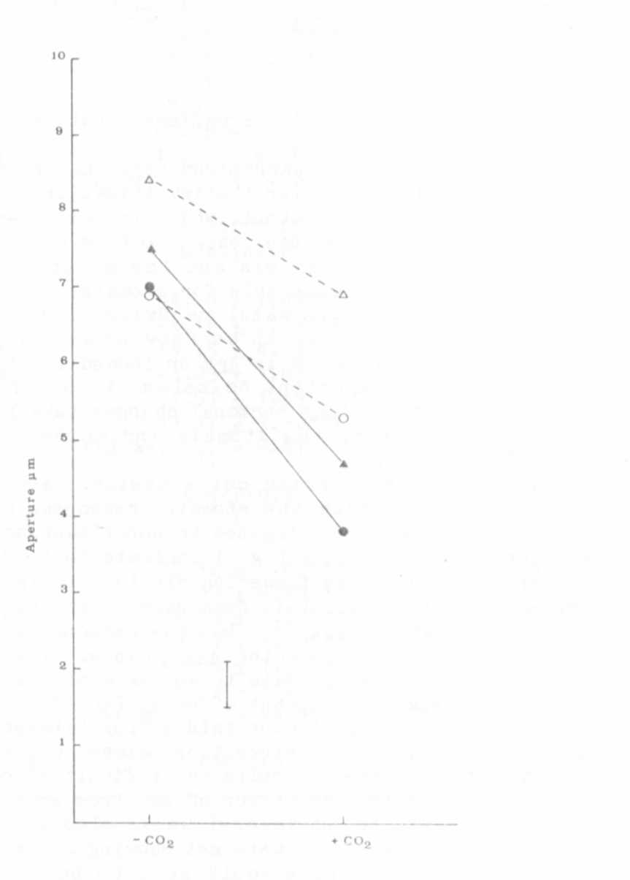

Hu

th
an
cl
ar
on
si

th

PO'

wav
whi

Fig. 1. Diagram to show the effects of light, C0₂ and flowering on
stomatal aperture in detached epidermis of Argenteum.
Lower epidermis was detached from leaves of non-flowering (140 cm
tall) plants or flowering plants (180 cm tall) of the Argenteum
mutant of Plsum sativum. The epidermal strips were floated on
25 mM KC1 in 10 mM MES buffer pH 6.15 in small Petri dishes which
were illuminated from the bottom through a water bath at 25°C. The
treatments applied in a randomized block design with two replicates
were +/- light, +/-C0₂ and flowering or not-flowering. The diagram
shows the mean apertures for each treatment and the bar represents
the Least Significant Difference (P=0.05, df=7).


