RESEARCH REPORTS 1
PNL Volume 14
1982

ORANGE POD (orp): A NEW GENE ON CHROMOSOME 2

Swiecicki, W. K. Plant Experiment Station, Wiatrowo, Poland

A new mutant designated orange pod (org) was recovered from an ex-
periment conducted in 1980 at Wiatrowo. After treating seeds of
Wt 3527 (cv. 'Paloma') with a combined dose of 200 r Nf/0.014% NEU (1) a
population consisting of 500 M₂ families (10 seeds each) was grown and
examined. One of the families produced three plants of the mutant
described herein.
In the early stages of development the plants appeared normal.
Then, before the plants reached the flowering stage, the basal portion
of the stem began to turn dirty orange in color. Later, the color
progressed upward and eventually affected the peduncles and pods. Upon
opening the pod it was found that only the sclerenchyma layer in the in-
terior of the pod was orange; removing the parchment layer restored the
normal green pod color. In the stem, the orange color was confined to
the phloem-xylem tissue. The remaining parts of the plant (leaflets,
stipules, leaf-petiole) were green. Because the most distinguishing
feature of the mutant is the orange pod, I have given it the name and
symbol mentioned above, and both have been officially accepted. The
type line for orp in the Wiatrowo collection is Wt 10263.
It is important to note that orp was induced in a line recessive
for a (without anthocyanin). Moreoever, the mutant is the first known
to involve the sclerenchyma of the pod.
Wt 10 263 (orp) was crossed with the Weibullsholm line WL 1 238 in
an attempt to determine the mutants* linkage relations. The F1's were
normal and the F2 showed monogenic recessive inheritance (Table 1A).
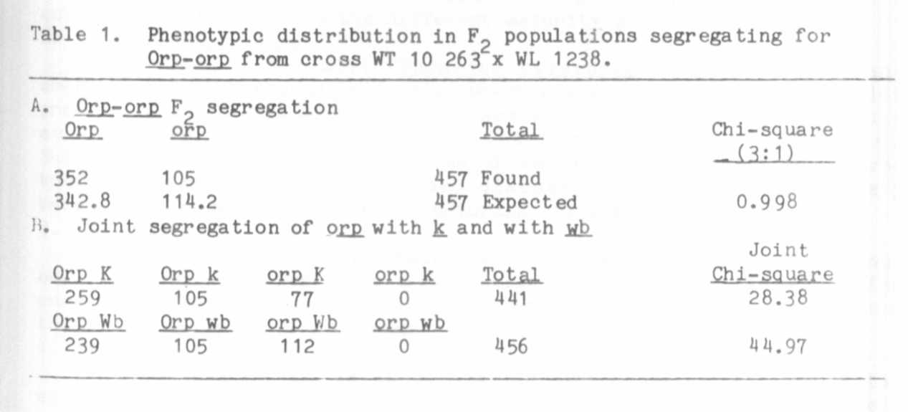

1. Swiecicki. W. K. 1979. PNL 11:33-34.
WL 1238 has a number of markers, among them being k and wb on
chromosome 2. Table 1B shows the linkage analysis involving orp. k, and
wb. The analysis was performed on the Wang computer at Weibullsholm,
courtesy of Dr. Blixt. The estimated crossover values and the gene or-
der are as follows:
A chemical analysis of orp expression would be a worthwhile and
interesting undertaking. Moreover, I intend to combine orp with .p and v
since the latter remove pod sclerenchyma.

