A SURVEY OF THE EFFECT OF GENETICS AND TEMPERATURE OF GERMINATION ON
LENGTHS OF THE FIRST AND SECOND INTERNODES OF ETIOLATED PEA SEEDLINGS

Seguin, S. and C. Nozzolillo Department of Biology
University of Ottawa, Canada

Germinating seeds of Pisum sativum buried at varying depths in the
soil will elongate until they reach the surface. Light is the impor-
tant factor influencing elongation. In fact, if no light reaches the
seedling, it will elongate until all food reserves in the cotyledons are
utilized or even cease before complete depletion has occurred (1). This
phenomenon, etiolation, is characterized by a very rapid stem elongation
and by the suppression of leaf expansion (2). A survey of 34
Weibullsholm lines* was made to assess the extent to which genetic dif-
ferences might affect etiolation.
The experimental procedure was as follows: The seeds were
surface-sterilized with a 20% solution of sodium hypochlorite (Javex)
for 5 minutes, then rinsed well. Following imbibition in distilled
water for 24 hrs in darkness at 15±1 C, the seeds were placed on a shal-
low layer of heat-pasteurized, moistened sand in aluminium soil moisture
cans (diam 9.0 cm). Each can was covered with a 48-oz Juice can (diam
10.5 cm. ht 17.5 cm) to prevent light penetration, and put in a
temperature-controlled (15±1 C) growth chamber. After two weeks,
seedling development was checked using a dim green safety light [a small
amount of green light has no significant effect on the growth of
dark-grown seedlings (1)]. Those with fully developed first and second
nodes were removed and measured. All. others were allowed to continue
their development and were checked each following week until all the
germinated seedlings had reached the appropriate stage of development.
The effects of temperature on etiolation were examined with two of
the Weibullsholm lines (WL-1451, WL-267) chosen because of the dif-
ferences shown in their internodal lengths at 15 C and their fairly high
germination percentage. The experiments (imbibition and growth) were
done in growth chambers where the temperature was maintained at 5, 10,
20, 25, and 30 C respectively.
The results of the survey, expressed as mean value + standard
deviation, are summarized in Table 1. There was wide variation among
lines, and lengths bear little or no relationship to whether the lines
were "dwarf" or "tall" when grown in light. Some lines (eg. 58, 369,
1088, 1267, 1366, 1391 , 1508) had very short internodes while others
(eg. 1415, 1416, 1451 , 1467, 1570, 1754) had much longer internodes.
The relationship between the first and second internode varied also. The
two were almost the same length In some lines (eg. 58, 1570); in others
they were very different. For example, lines 5 and 1227 had a longer
first internode while in lines 1415, 1416, 1545, and 1614 the second in-
ternode was longer.

•Courtesy of S. Blixt.

RESEARCH REPORTS 2
PNL Volume 14 1982

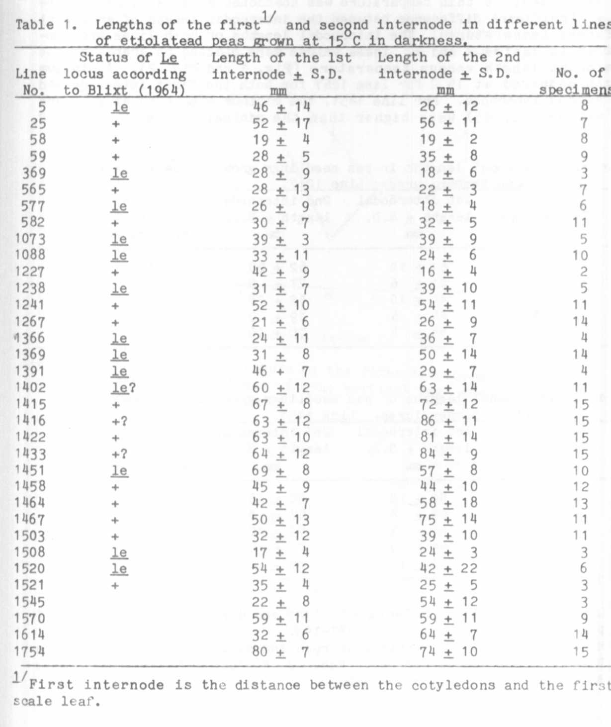
xxxxxxxxxxxxxxxxxxxxxxxxxxxxxxxxxxxx
x Editor's Note: Information in the "Status of the Le locus" column
x in Table 1 was inserted by the Editor without first consulting
x the authors. The information was extracted from "A presentation
x of the Lamprechtian Pisum material" (Second, revised and extended
x edition); Edited by S. Blixt; Weibullsholm Plant Breeding Insti-
x tution, Sweden; Report from the Institute, November 1964.
xxxxxxxxxxxxxxxxxxxxxxxxxxxxxxxxxxx>

RESEARCH REPORTS
PNL Volume 14
1982
4

Line 1267 and line 1451 were submitted to the temperature
experiments. The seeds germinated at 5 C, but growth was so slow that
the experiment at this temperature was abandoned after 3 weeks. There
was a significant difference between the internodal length of groups at
different temperatures. The internodal lengths of both lines are sum-
marized in Tables 2 and 3. These values were plotted on graphs of the
internodal length versus temperature (Fig. 1 and Fig. 2). A minimum
length occurred at 15 C for line 1267 for both the first internoge and
the second internode. For line 1451. the minimum was found at 20 C and
the values (45, 4 5) were higher than the minimal values of line 1267
(21, 26).
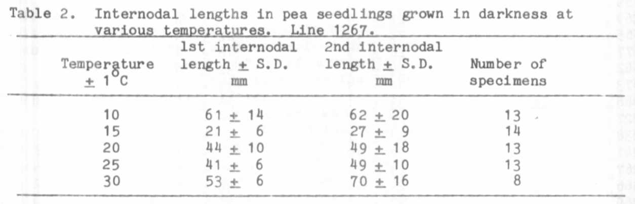
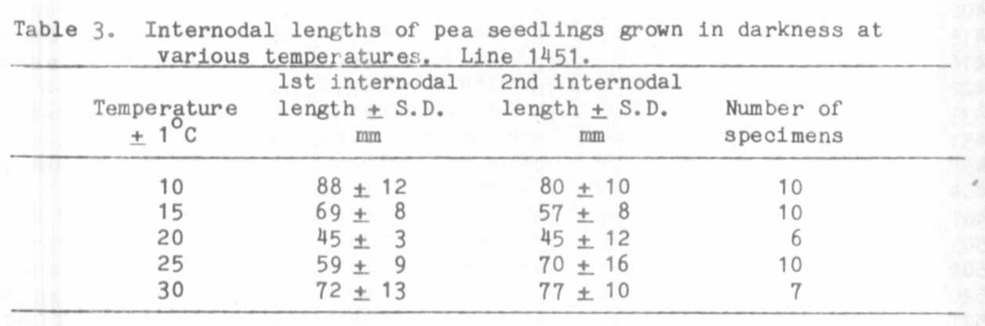

1. Low, V.H.K. 1971. Effects of light and darkness on the growth of
peas. Aust. J. Biol. Sci. 24:187-195.
2. McComb, A. J. 1977. Control of root and shoot development. In: The
Physiology of the Garden Pea. Eds. J. F. Sutcliffe and J. S. Pate.
Academic Press, New York, 2 35-26 3.

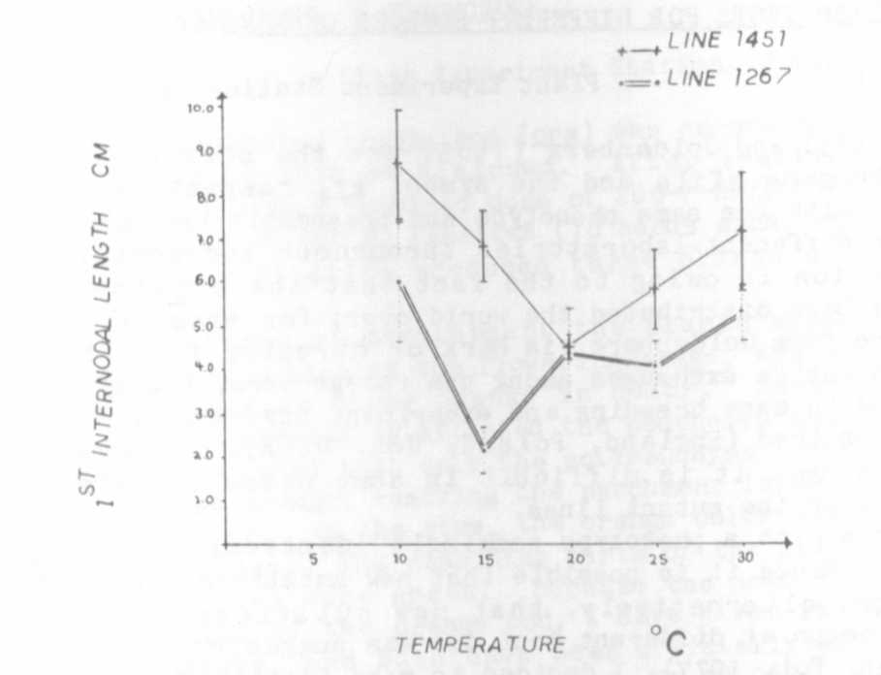
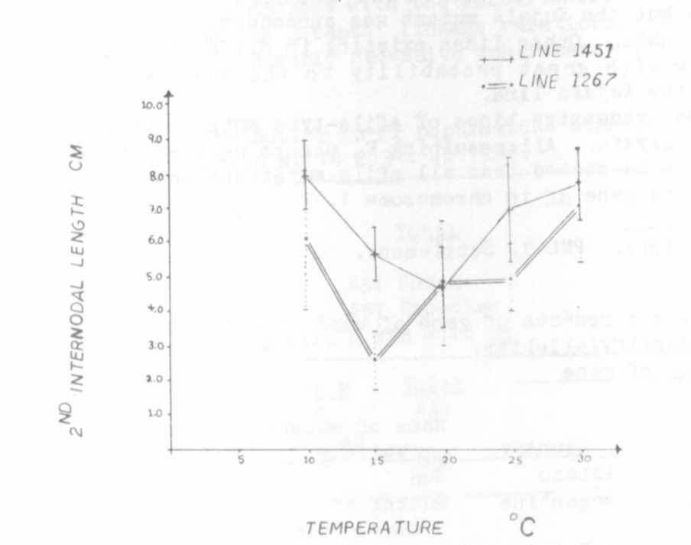
Fig. 1. Effect of the temperature on the first internodal length
in two different lines of pea; vertical bars represent
the standard deviation.
Fig. 2. Effect of the temperature on the second internodal length
in two different lines of pea; vertical bars represent the
standard deviation.

