QUANTITATIVE DETERMINATION OF EXTRACTABLE PROTEINS FROM PISUM SEEDS AND
PODS DURING DEVELOPMENT

Gaul, E. Institute of Genetics, University of Bonn
Federal Republic of Germany

As pea seeds ripen, changes occur in the rate of protein deposition
and in the type of protein synthesized. The mother plant provides the
carbonaceous and nitrogenous nutrients for the biosynthesis of the
storage proteins in the seeds. The nitrogenous substances are not
translocated directly to the seeds but are in part stored in the pods as
protein, which is then broken down and transferred to the developing
seeds.
In this experiment., protein content was determined at eight stages
of pod and seed development in var. 'Dippes Gelbe Viktoria' in order to
follow the changes in protein concentration (% of dry weight) and con-
tent (mg) during development. Based on their characteristics of
solubility, the extracted proteins were divided into albumins and
globulins from seed and into water soluble (wsp) and water insoluble
proteins (wip) from pods.
Results are given as percentage of dry weight (Fig. 1a, 2a) and mg
per pod (Fig. 1b), as well as mg protein of seeds per pod (Fig. 2b).
The protein content of the pods alone, expressed as percentage of
dry weight, decreased continuously during seed ripening (Fig. 1a).
However, the real or absolute protein content of the pods
(mg protein/pod) at fir:;t increased, then reached a maximum, and finally
declined (Fig. 1b). The initial decrease in percentage protein was de-
pendent upon the growth of pods, which showed a rapid increase in dry
weight. Later the reduction in percentage protein was attributable to a
diminution in total protein. Water soluble and water insoluble proteins
followed a similar trend, but the water insoluble proteins represented
an insignificant fraction of the total at all stages of development
(Fig. 1b).
In the case of seed protein, expressed as percentage of dry weight,
the concentration declined in the early stages of development; there-
after, it increased considerably (Fig. 2a). Total seed protein,
calculated with regard to the number of seeds per pod, increased
steadily from the first stage of development (Fig. 2b). The major
protein synthesis did not begin until after the lowest value of per-
centage protein had been reached (stage e). From that time on, the
protein accumulation contributed substantially to the increase in dry
weight. The concentration of globulins was lower in the last stage of
development, just as was total protein, whereas albumin increased
continuously. In the early stages the albumins represented the main
fraction, but in dry seeds the globulin content was 1.3-fold higher.
From these results it would appear that the onset of massive
protein synthesis in the seeds is correlated with the reduction of total
protein content in the pods.

PNL Volume 14 1982
RESEARCH REPORTS 2

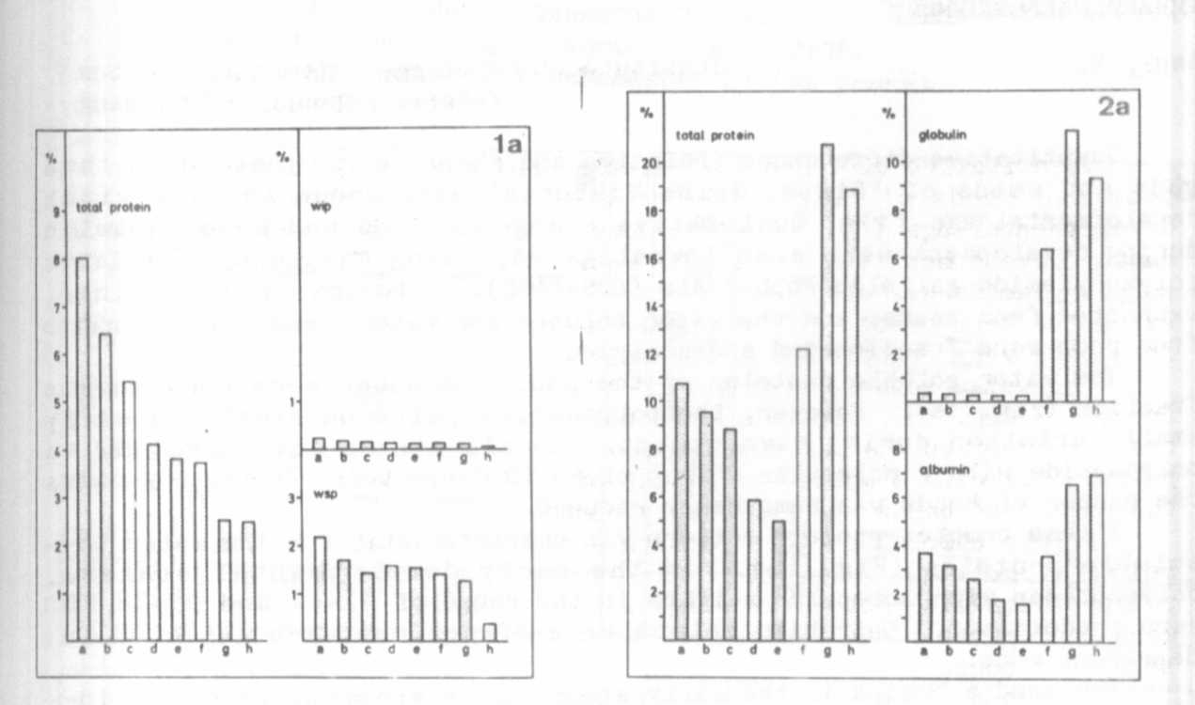
Fig. 1. Protein content of pods without seeds at eight stages of
development (a-h).
(a) percentage of dry weight (b) mg protein per pod
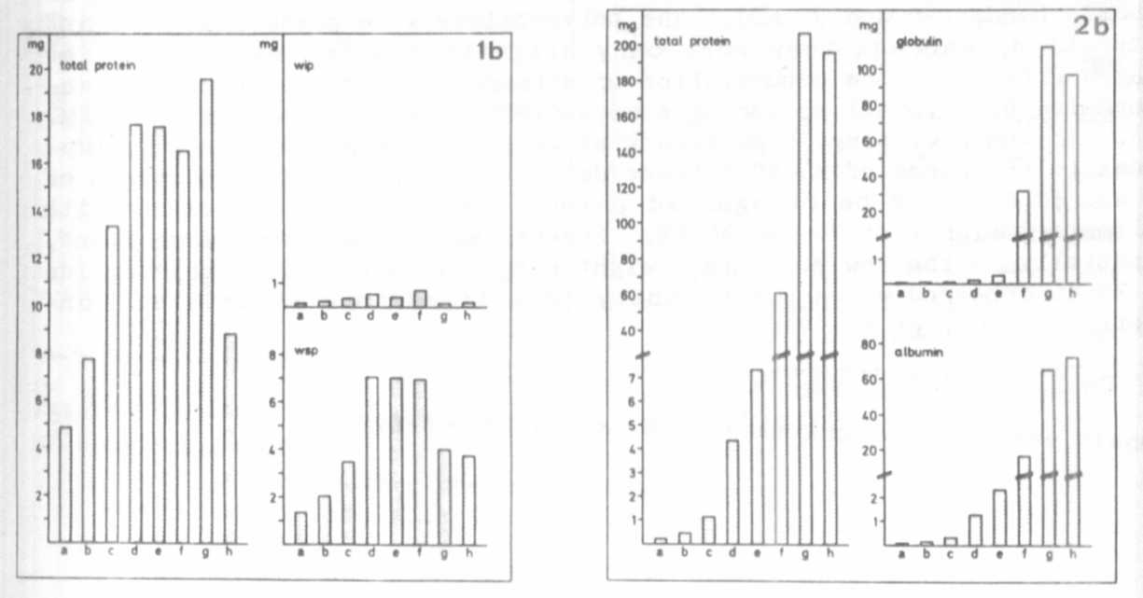
Fig. 2. Protein content of seeds at eight stages of development and
ripening (a-h)
(a) percentage of dry weight (b) mg protein of seeds per
pod

