FURTHER ELECTROPHORETIC STUDY OF ENZYME POLYMORPHISM IN PISUM

Parzysz, H. and J. Przybylska, Institute of Plant Genetics
Polish Academy of Sciences
Poznan, Poland
Blixt, S. Weibullsholm Plant Breeding Institution
Landskrona, Sweden

The earlier reported electrophoretic analysis of leucine aminopep-
tidase and amylases (in cotyledons of mature seeds), glutamate
oxaloacetate transaminase (in leaves), and peroxidases (in roots) in the
genus Pisum resulted in detection of a variation which has been tenta-
tively attributed to about 30 alleles at 7 loci (1). In further
investigations of enzyme polymorphism in Pisum additional enzyme systems
were examined. This report presents preliminary data of electrophoretic
screening for variation in alcohol dehydrogenase (ADH), isocitrate
dehydrogenase (IDH), and esterases (Est) in cotyledons of mature seeds.
As in previous investigations, 108 lines and populations repre-
senting P. elatius (four lines), P. humile (three lines), P. sativum (85
lines), P. abyssinicum (11 lines), and P. fulvum (five lines) were
analyzed. Electrophoretic separation of the examined enzyme systems was
carried out in starch gels. Activity of esterases was detected under
ultraviolet light using 4 methylumbelliferyl acetate as a substrate.
Since multiband spectra of esterases were difficult to interpret, only
one zone of activity, with bands having Rp values in the range ca 0.43 -
0.48, was considered.
The observed variation in the investigated enzyme systems is shown
in Fig. 1. For the present, we have simply identified the distinguished
phenotypes by numbers instead of by gene symbols.
As regards distribution of the distinguished phenotypes, it is in-
teresting from the taxonomic point of view that some phenotypes (ADH,
Nos. 1 and 2; Est, No. 1) were found only in P. abyssinicum. Of the ADH
phenotypes. No. 1 was found in 10 lines while No. 2 was found in one
line (JI 691) of P. abyssinicum. The Est phenotype No. 1 was observed
in all the examined P. abyssinicum lines.
In the previous paper (1) several Pisum accessions were reported to
show rare electrophoretic phenotypes and to contribute significantly to
an overall diversity of the investigated material. Two of the acces-
sions, Gat. 255 (P. elatius) and JI 224a (P. fulvum), had rare
phenotypes at 4 and 2 independently varying enzyme activity zones,
respectively. Rare electrophoretic phenotypes were also shown in the
present investigations. Gat. 255 (P. elatius) and JI 224a (P. fulvum)
were the only accessions showing Est phenotype No. 2 and ADH phenotype
No. 5, respectively.

- A cooperative investigation performed under an agreement between the
Royal Swedish Academy of Sciences and the Polish Academy of Sciences.
This work was Supported by the Polish Academy of Sciences, partly
urrder the Government Project PR-4.

RESEARCH REPORTS
3
PNL Volume 14
1982

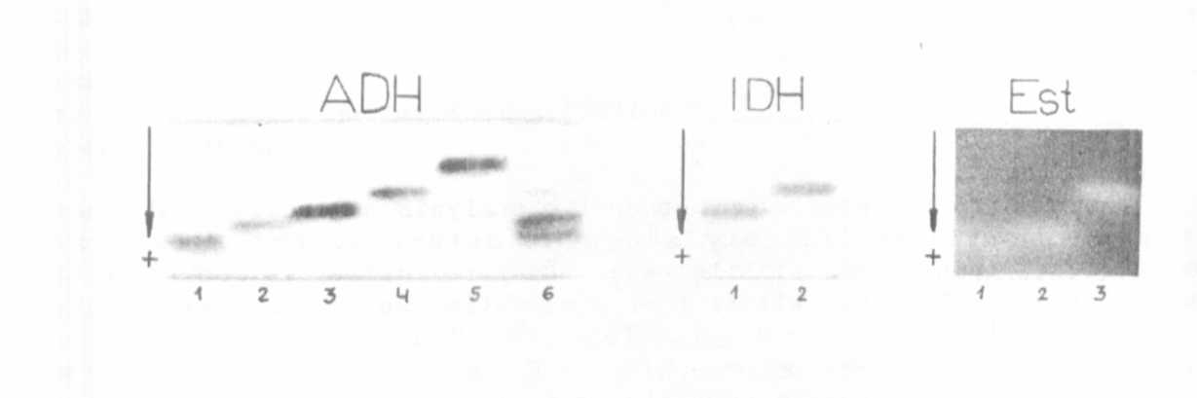
Fig. 1. Electrophoretic phenotypes of ADH, IDH and Est (on variant
zone) systems revealed in Pisum. The presented phenotypes are
produced by the following lines.
ADH: 1 - P. abyssinicum. W 808; 2 - P. abyssinicum. JI 691;
3 - P. sativum. W 110; 4 - P. sativum. W 1935;
5 - P. fulvum. JI 224a; 6 - P. sativum. W 1896;
IDH: 1 - P. humile. JI 261; 2 - P. sativum. W 110;
Est: 1 - P. abyssinicum. W 1570; 2 - P. elatius. Gat. 255;
3 - P. fulvum. W 1256

1. Przybylska, J. , S. Blixt, H. Parzysz, Z. Zimniak-Przybylska. 1982.
Genetica Polonica (in press).

