Arg EXPRESSION IN RELATION TO EPICUTICULAR WAX DISTRIBUTION

Marx, G. A. NYS Agricultural Experiment Station, Geneva, NY USA

The gray-green leaves on argenteum (Arg) plants were shown by Hoch
et al. (1) to result from the presence of extensive air spaces located
between the leaf epidermis and parenchyma. At present, this is the only
known effect of Arg. Hoch et al found nothing to show that surface
wax was in any way involved in determining the characteristic gray-green
leaf color. Removal of the surface wax of leaves modifies but does not
fundamentally change Arg mutant expression. This can be demonstrated
directly, by mechanically or chemically removing leaf wax, or in-
directly, by incorporating mutants known to reduce epicuticular wax on
the leaves. In the course of our investigations, Arg has been combined
with nearly all the known wax mutants. In plants bearing the combina-
tion Arg wlo, for example, the upper surface of the leaflets are shiny
and less gray-green than in Arg Wlo plants, but the presence of Arg is
unmistakable.
Still, the gray-green color of Arg plants is not confined ex-
clusively to the leaves but includes the stem and pods as well. The
color contrast between mutant (Arg) and normal (arg) is, however, much
less distinct in the stem and pods than in the foliage. Moreover, the
gray-green color of stems and pods, unlike the leaves, disappears upon
gentle rubbing, thus suggesting that Arg influences pod wax. Also, the
pods of plants with the combination Arg wp are waxless and appear iden-
tical with pods borne on arg wp plants. In arg wel plants all parts
(leaves, stems, and pods) have reduced wax. When Arg is added (i.e.
Arg wel) the leaf parts show the modified expression of Arg similar to
that on the upper surface of the leaflets of Arg wlo plants. However,
the pods and stems of Arg wel plants are shiny green and phenotypi cal ly
identical with pods and stems of arg wel plants. Fig. 1 depicts the
interactions among Arg, wp and wel. These observations imply that Arg
exerts an effect on stems and pods which is different from that on
leaves, thus complicating the interpretation of gene action.

1. Hoch, H. C., Charlotte Pratt, and G. A. Marx. 1980. Amer. J. Bot.
67:905-911.

RESEARCH REPORTS
2
PNL Volume 14
1982

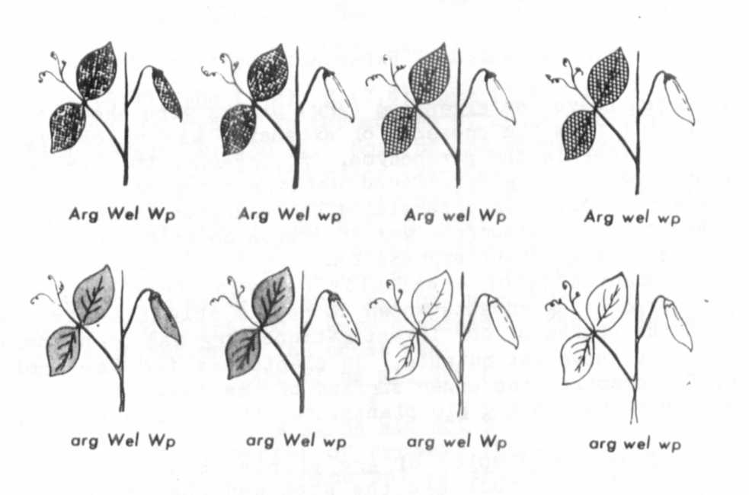
Fig. 1. A schematic illustration of the phenotypic effects on leaf and
pod wax resulting from the interaction of Arg, wel. and wp. Shading in-
dicates presence of wax; no shading indicates absence of wax. Fine
crosshatching indicates effect of Arg on normal waxy tissue. Coarse
crosshatching indicates effect of Arg on waxless leaf tissue. Note that
in Arg wp and Arg wel plants the pods are waxless, Just as in arg wp and
arg wel plants.

