PNL Volume 14 1 982 RESEARCH REPORTS

LINKAGE RELATIONSHIPS AMONG SIX GENES IN CHROMOSOME 6

Marx, G. A. NYS Agricultural Experiment Station, Geneva, NY USA

Genes na (9,4), .sbm. (1,2), E (7,8), Arg (3,4), and art (5) recently
have been found to reside in ohromosome 6, along with well-established
markers such as wlo, p, and Pl. Most of the known markers appear to be
clustered at one (wlo-p) or the other (Pl-Arg-Fl) end of the chromosome.
This is a record of an attempt to establish and/or verify the order
of the following six genes: na., wlo, art, Pl, and Arg. Two separate
series of crosses are reported, supplemented by data from a four-point
linkage analysis referred to in the previous article (6). In the first
series, four of the markers, Arg. Pl, na, wlo were associated together
in one parent, while art and p were combined in the other parent. Thus
the genetic constitution of the cross was:
Arg Pl na wlo. Art P
x
arg pl Na Wlo art p.
The F1's of this series of crosses therefore segregated for six
genes simultaneously. A second set of crosses involved only three
markers: wlo p, and art. The genetic formula in this case was:
Wlo-p-Art
x
wlo-P-art
In the populations segregating simultaneously for six genes the
presence of na. presented some difficulties since a disproportionate
share of the na plants succumbed before producing pods and seeds. Their
short stature rendered the .na. segregants relatively less competitive in
relation to the Na/- segregants, the latter shading out the former.
This situation dictated that the gene analysis be carried out by pairs
or by three's or by four's (Table 1). Thus, depending on which genes
were involved, the total number of plants involved differed. For ex-
ample, the na-wlo pair was analyzed separately from the rest because the
plants were easily and accurately scored in the seedling stage, before
the onset of severe competition.
A pair-wise analysis was also made for genes Arg and Pl. The genes
art, p, and wlo were analyzed together but because wlo is closely linked
with na and since some of the na segregants did not survive to maturity,
the three-point analysis reveals a deficiency of wlo segregants. This,
however, was not the sole reason for the deficiency of wlo segregants,
since the deficiency was evident even in the seedling stage, before
shading became a factor.
The second series of crosses, in which na was not involved, also
showed a deficiency of wlo segregants (Table 2).
The available data, including the four-point analysis of
Arg-Pl-Wlo-Na from a previous study (6) (Table 3), suggest the following
gene order:
art —— na —— wlo —— p —— Pl —— Arg
Because certain single gene ratios were disturbed, some measure of
doubt is cast on the gene order as presented, i.e, there still is some
question as to which side of wlo the na gene is located. Note that the

distance separating Arg and Pl from Art is such that the linkage chi-
squares were non-significant. Also, the location of Arg raises anew the
possibility that Arg is an allele at the Fl locus.

1. Gritton, E. T. and D. J. Hagedorn. 1975. Crop Sci. 15:447-448.
2. Hampton, R. 0. and G. A. Marx. 1981. PNL 13:16-17.
3. Marx, G. A. 1978. PNL 10:34-37.
4. Marx, G. A. 1981. PNL 13:35-37.
5. Marx, G. A. 1981. PNL 13:38-39.
6. Marx, G. A. 1982. PNL 14:47-49.
7. Murfet, I. C. 1971. Heredity 27:93-110.
8. Murfet, I. C. 1980. PNL 12:59.
9. Wellensiek, S. J. 1972. PNL 4:60.
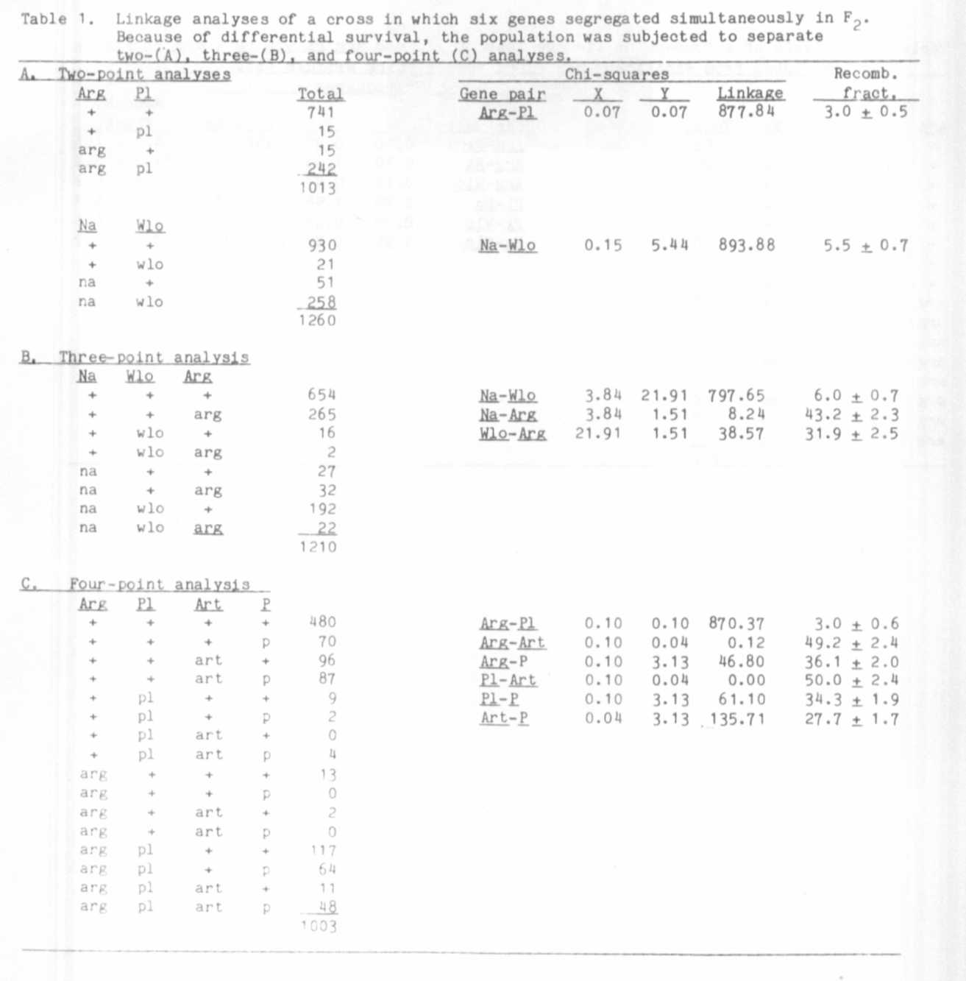
4 PNL Volume 14 1982
RESEARCH REPORTS

