PNL Volume 1M 1982 RESEARCH REPORTS 1

INFLUENCE OF NON-ALLELIC INTERACTIONS ON THE PHENOTYPE OF na

Marx, G. A. NYS Agricultural Experiment Station, Geneva, NY USA

A preliminary experiment was conducted to study the linkage rela-
tions and interactions of nana (na) and microdwarf (lm), two genes known
to reside in chromosome 6 (1,5,6). The na. parent derived from the na
mutant isolated at Geneva (2); it also carried other chromosome 6
markers, viz. Arg. Pl, and wlo. WL 1329, obtained from Dr. Blixt, was
used as a source of lm. In Blixt's inventory WL 1329, besiges being
identified as lm, is listed in the "genotype" category as cry^{s} , but in
the "origin" category as "microcryptodwarf". Unlike the na parent,
WL 1329 is arg pl and Wlo. Thus the known or presumed genotypes of the
two parents were:

The populations also segregated and were scored for genes which were
not relevant to the study, and, except to say that the genes segregated
according to expectation, they will not be considered further. Each of
two F₂ populations examined descended from an individual plant grown
in the field. The two parents, additional F1 plants, and F2 populations
then were planted at the same time and grown in the same glasshouse
where they were fully classified and measured for internode length.
Nodes to flower were also recorded. A four-point linkage analysis of
Arg-Pl-Wlo-Na was performed on the combined populations and is presented
in the following article. Arg or Pl are not immediately relevant to
this article.
All F1's were classified as dwarf. The individual and combined F₂
distributions (Table 1) reaffirm the known linkage between na. and wlo.
but the estimate of linkage intensity (10.8 ±_ 2.2) was somewhat higher
than other estimates (2,3). The distributions do, in fact, appear dis-
turbed, the Na wlo class being noticeably larger than the na Wlo class.
Despite this, segregations for either gene in the individual and com-
bined F2 populations were statistically not significantly different from
expected.
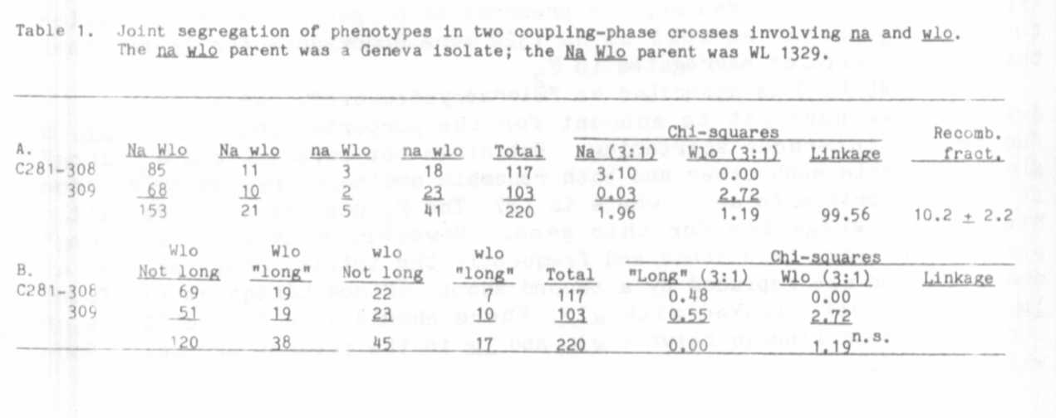

The data suggest that the numerical imbalance of phenotypes might be
explained by something other than chance or misclassification. Part B
of Table 1 gives the Joint distribution between the Wlo-wlo locus and a
phenotype designated "long". This designation is used to characterize
F2 segregants that resembled the internode length and total height of
plants of the WL 1329 parent. This, and the two other phenotypic
classes (dwarf and nana). were determined visually and by measurement
(Table 2). There were a total of 55 "long" plants in the combined F₂
populations, the number expeoted for a perfect 3:1. Thus "long" was in-
herited as a recessive character. Of the 55 "long" plants, 38 were
associated with Wlo and 17 with wlo. indicating that "long" and wlo were
independently inherited (linkage chi-square = 0.12^{n.s.}).
Now, (a) since .na. is known to be rather tightly linked with wlo (2),
and (b) since there were 17 "long" plants with wlo (too many to be con-
sidered as crossover products), it may be reasonable to suppose that the
17 "long" wlo plants carried na. but that the nana phenotype'was masked
by the "long" phenotype. Therefore, by subtracting 17 (the "long" wlo
segregants) from the Na wlo class in Table 1 A (21-17=4) and transfer-
ring them to the na wlo class (41 + 17 = 58), we are left with a
distribution which shows the expected balance among the phenotypes. The
adjusted distribution becomes 153:4:5:58 for the Na Wlo. Na wlo, na Wlo.
na wlo classes, respectively. This produces an estimated recombination
percentage of 4% between na and wlo. a figure which is consistent with
estimates obtained in other crosses (2,3). Of course, this Juggling of
the data would be highly inappropriate were it not for the known tight
linkage between na and wlo.
On the basis of these assumptions, i.e. that na is hypostatic to
"long" and that "long" is not linked with na, what then is the genie
basis for the phenotype designated "long"? Although parental line
WL 1329 is represented as carrying cry , its phenotype more closely
resembles cryptodwarf (la cry ) than it does "slender" (la cry ).
Moreover, the phenotype of the "long" F_ plants closely approximated the
phenotype of the parental WL 1329 plants (Table 2). There were no
slender segregants. It would seem therefore that WL 1329 is cry rather
than crv and that the genotype as given in Blixt's inventory is a
typographical error. Even so, the presence of cryptodwarfs in F₂ implies
that the na parent as well as WL 1329 were homozygous for la and that
the Cry-cry alleles segregated in F2.
Still, WL 1329 is described as "microcryptodwarf", not as crypto-
dwarf, so we have yet to account for the purported presence of lm. a
factor for internode shortening. But since the parental and F2 "long"
plants resemble each other and both resemble ordinary cryptodwarrs, then
it is appropriate to ask: where is lm? The F₂ populations give little
hint of a segregation for this gene. However, many or most "long"
plants had weak, thin stems and frequently the Initial shoot aborted at
emergence and was replaced by a second shoot. Since Lindqvist (1) found
1m to be closely linked with wlo. there should have been evidence of
repulsion phase linkage between wlo and la in the present crosses. None
was detected.
RESEARCH REPORTS 4
PNL Volume 14 1982

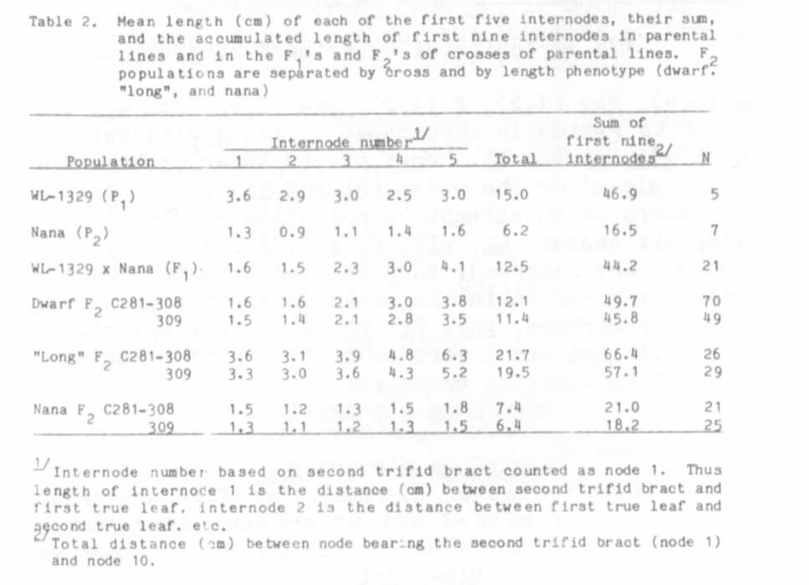
The conclusion that cryptodwarf is epistatic to na is consistent
with other observations which indicate that the na phenotype is subject
to modification by genes at other loci (2). If this hypothesis is cor-
rect, then the ascending order of height for na plants is assumed to be:
na La Cry, na La cry^{c} na La cry^{s}, na la Cry, na 1a cry^{c} , and
na la. cry^{s}. Presumably, the presence of na cannot be visually detected
in certain of the forgoing gene combinations. Since Wellensiek's na is
extremely short, possibly it is Le na La Cry. It cannot be excluded,
however, that Le itself shortens na. Obviously, the evidence developed
in this experiment is not in accord with the assumption that WL 1329
carries Lm. If its presence was obscured by gene interactions and hence
merely not detected, then perhaps a cross between WL 1329 and a known
cryptodwarf would reveal its presence. It would be important that the
two lines would have the same or similar flowering genotype since inter-
node length is influenced by time and node of flowering.
We are left with the interesting proposition that La is dominant to
le., that na is epistatic to Le and to le (4), but that na is hypostatic
to combinations of le, la, cry^{c} and crv^{s} . As such this scheme is rife
with implications in physiological genetics. For example, what is the
phenotype of plants with the genotype Le. na la cry^{s} ?

1. Lindqvist, K. 1951. Hereditas 37:389-420.
2. Marx, G. A. 1981. PNL 13:35-37.
3. Marx, G. A. 1982. PNL 14:50-52.
4. Murfet, I. C. 1978. PNL 10:54-55.
5. Rasmusson, J. 1938. Hereditas 24:231-257.
6. Wellensiek, S. J. 1972. PNL 4:60.

