PROPOSED ORDER OF MARKERS IN CHROMOSOME 3

Marx, G. A.
NYS Agricultural Experiment Station, Geneva, NY, USA

Some of the data collected for the previous article (18), while
only indirectly applicable to the linkage relations of creep_{f} bear
directly on the linkage relations of markers on chromosome 3. Many good
markers have been mapped to chromosome 3 but their order has yet to be
clarified. Besides presenting the analysis of a linkage experiment con-
ducted in 1981, this article attempts to coordinate evidence collected
previously.
Table 1 shows the analysis of a three-point coupling phase cross
involving genes St., B, and Chi-6.
The present results accord with results from two other experiments
heretofore not reported. The first was a small greenhouse population
segregating simultaneously for M, St, B, and Chi-6 (Table 2) and the
second a field population grown in 1973 (Table 3). All are consistent
in showing that b lies between st and chi-6. Thus for the three experi-
ments the results can be summarized as follows:
Additional linkage data involving the Wilty (wil) gene were col-
lected subsequent to the original report of linkage in 1976 (12). The
results of four three-point linkage analyses are given in Tables 4-6.
Since wil is distal to b, wil is expected to be close to chi-6. Two
hitherto unreported two-point testcross populations and a two-point F2
show the linkage between st. and wil to be 23, 28, and 30% respectively
(data not presented).
Since bulf was shown (16, 17) to be situated between st and chi-6,
bulf presumably lies between b and chi-6. This, however, has not yet
been experimentally verified; there is some small possibility that bulf
lies between b and st.
By combining all available evidence, my own best estimate of the
order of markers on chromosome 3 that I have worked with is as follows:
uni-M-alt-wel-F-Pu-st-la-b-(yp)-b-bulf-wil-twp-chi-6
It is quite possible that bulf and wil actually occur in reverse
order from that given. There is still insufficient data to propose the
placement of genes dp, ch4. Dpo. Gty. er. En. or och. My tests for
linkage of rb with at and chi-6 have been negative. The possibility
remains that rb is located at the M end of the chromosome.
Not all the references given below, although pertinent to the dis-
cussion, were specifically cited in the text.

I. Blixt, S. 1968. Agri. Hort. Genet. 26:100-106
2. Blixt, S. 1972. Agri. Hort. Genet. 30:1-293-
3. Blixt, S. 1976. Agri. Hort. Genet. 34:83-87.
4. Blixt, S. 1978. Agri. Hort. Genet. 36:23-47.
5. Gritton, E. T. 1971. PNL 3:15-16.
6. Gritton, E. T. and D. J. Hagedorn. 1980. PNL 12:26-27.
7. Marx, G. A. 1971. PNL 3:18-19.

PNL Volume 14 1982
RESEARCH REPORTS
3

8. Marx, G. A. 1972. PNL 4:30-31.
9. Marx, G. A. 1973. PNL 5:25-26.
10. Marx, G. A. 1973. PNL 5:27.
11. Marx, G. A. 1974. PNL 6:30-31
12. Marx, G. A. 1976. PNL 8:40-41.
13. Marx, G. A. 1977- PNL 9:29-30.
14. Marx, G. A. 1978. PNL 10:41-42.
15. Marx, G. A. 1978. PNL 10:46.
16. Marx, G. A. 1980. PNL 12:47-48.
17. Marx, G. A. 1981. PNL 13:29-30.
18. Marx, G. A. 1982. PNL 14:41-42.
19. Monti, L. and F. Saccardo. 1971. PNL 3:28.
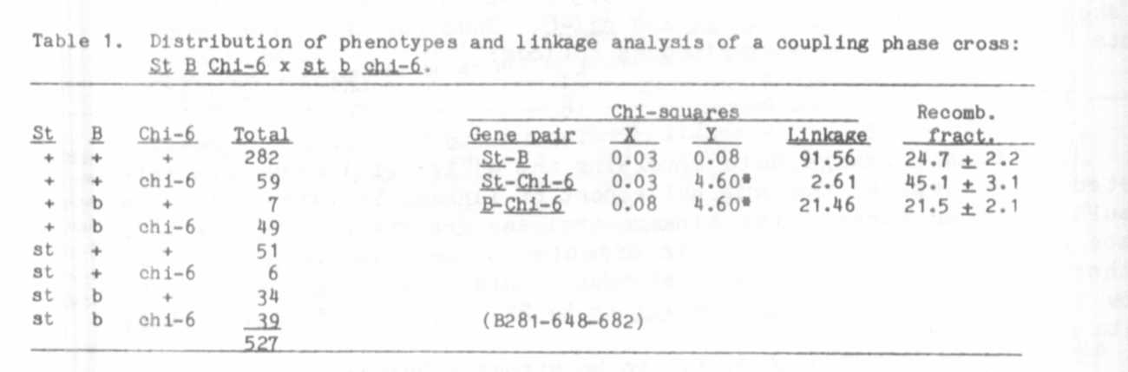
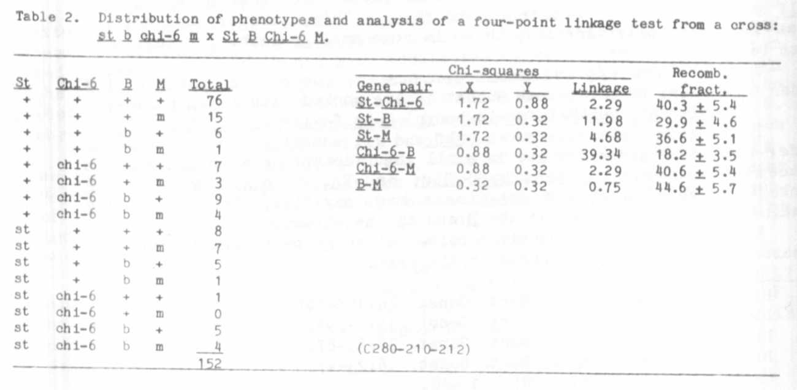
20. Murfet, I. C. 1967. Heredity 22:602-607.

RESEARCH REPORTS 4
PNL Volume 14 1982

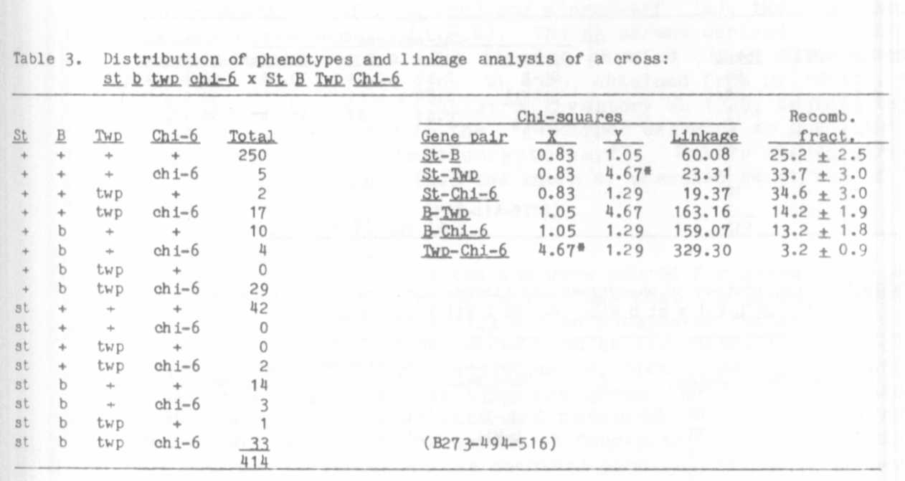
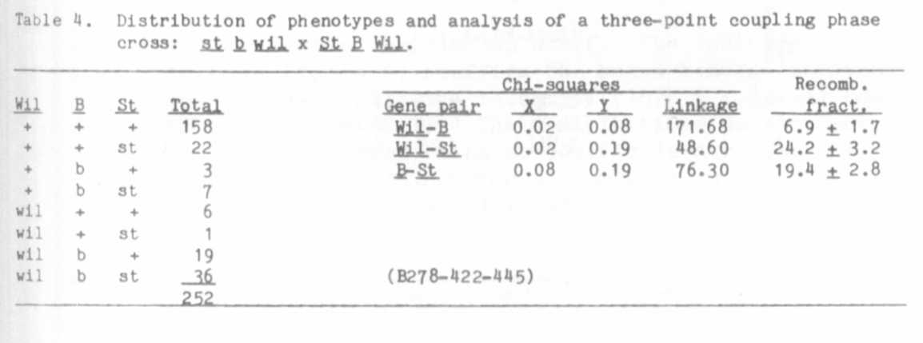

RESEARCH REPORTS
PNL Volume 14
1982
5

