LINKAGE RELATIONS OF creep ON CHROMOSOME 5

Marx, G. A. NYS Agricultural Experiment Station, Geneva, NY USA

Plants of the EMS-induced mutant creep (1) grow prostrate along the
ground. This distinctive behavior establishes creep as a worthy
seedling marker as well as a candidate for physiological studies. The
type of line for this mutant, WL 5859, is tall (Le.) and lacks an-
thocyanin pigmentation (a), the mutant having been induced in the
variety 'Torstag'. I crossed WL 5859 with one of my own le A lines
preparatory to attempting linkage studies. The A line had speckled
seeds but it was unknown at the time whether its genotype was F, Fs,
F fs, or f Fs.
As expected, the F1's of the initial cross were wild type with
respect to height, flower color, and habit, i.e. Le/-.A/-.Creep/-. The
F1 's also had speckled seed. The of a small field population grown
in 1980 and scored for Creep-creep and for speckled vs. non-speckled
seed showed the segregation pattern indicated in Table 1. This F2 also
segregated for A-a but the .a/a plants were not included in the summary.
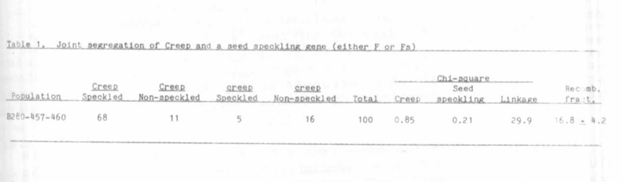
It is clear that only one of the polymeric genes for seed speckling
segregated, but it still was unknown whether the segregating locus in
question was F or Fs. However, since the Creep A parent was either F or
Fs but not both, it is evident from the results that the creep a parent
was homozygous recessive for both f and fs. Therefore, the segregation
data in Table 1 suggest the possibility of linkage between creep and f
on chromosome 3 or fs. on chromosome 5.
F3 plants were grown from F2 segregants with the genotype
A, creep, f., f.s. To test whether creep was linked with £ on chromosome
3 or with Fs on chromosome 5, the creep F3 plants were crossed recipro-
cally with each of two marker lines. The first marker line carried
st-b-chi-6. (f being closely linked with st). This first marker line had
speckled seeds, resulting from the presence of Fs alone, i.e. it was
known to be f. Fs. Reciprocal crosses were also made between the creep
F3 line and a ce (A) line, .ce residing near fs. on chromosome 5. The ce
line had colorless seeds (f, fs). The relevant genic makeup of the two
crosses was as follows:

RESEARCH REPORTS
PNL Volume 14
1982
3


All F1's from the crosses involving the chromosome 3 markers had
speckled seeds, whereas all F1's from the ce. crosses had colorless
seeds, and all F1's from both crosses had a normal (Creep/-) growth
habit. The F1's from both series of crosses were scored in the field in
1981 (Table 2).
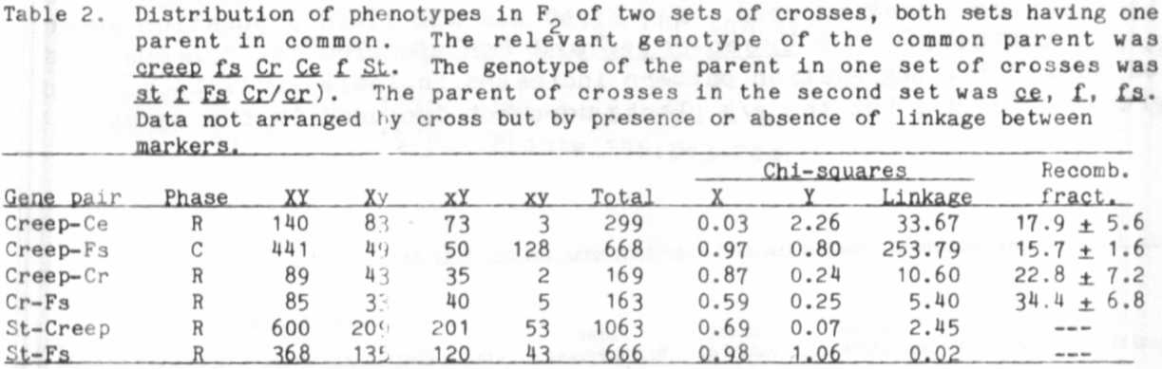

Direct and indirect evidence from both crosses show that creep is
situated in chromosome 5. One piece of direct evidence comes from the
cross involving The calculated estimate of linkage between creep
and was 17.9 ± 5.6 (Table 2). Additional direct evidence came from
the cross involving the st parental line. Since the st line carried Fs
(but not F), the line provided a chromosome 5 marker as well as the
chromosome 3 markers. The Fs-creep linkage estimate was 15.7 ± 1.6.
The st. line also provided corroborating negative evidence inasmuch
as st shown to be independent not only of creep but also of Fs.
Moreover, the st-b-chi-6 parent was heterozygous for Cr (Cr/cr). so some
of the data could be used in a three-point analysis involving cr, creep.
and fs. Although the data are meager, there is evidence of repulsion
phase linkage between creep and cr. in this cross.
The data are considered insufficient to establish gene order be-
cause these crosses did not allow a direct test of linkage intensity
between ce. and fs. But the recovery of ce-creep-fs segregants in
provided the genotype for three-point coupling phase crosses now in
progress.

1. Sidorova, K. K. 1975. PNL 7:57-58.

