THE REACTION OF am FLOWERS WITH ACID

Crowden, R. K. Botany Department, University of Tasmania
Hobart, Tasmania, Australia

In reporting the gene am (pinkish-white flower color) de Haan (1)
observed that treatment of am. flowers with acid caused them to develop a
strong red coloration. Wellensiek (2) later reported the gene aw which
he supposed to be very similar to de Haan's am. He showed also that aw
flowers, like those with am. could be diagnosed from white genotypes by
their reaction with acid. However, a discrepancy is evident in their
respective reports regarding the nature of the reaction:

Lamprecht (3) confirmed the identity of am with aw. by genetic
analysis, but did not carry out any chemical tests which might have
resolved the apparent anomaly.
In an attempt to clarify the situation I have tested many white-
flowered and weakly-colored lines available at Hobart (listed below) and
1 can confirm that only A, am lines give a positive reaction with HC1,
The reaction occurs only with wing petals. The test is made very
simply by submerging a single petal in 50$ HC1. A positive reaction ap-
pears within 1-2 minutes.
In many A, am flowers, margins of the wing petals frequently show a
faint pink coloration in early stages of anthesis but the main body of
the petal is white. After treatment with acid, red coloration appears
throughout the petal. In other weakly-colored lines, e.g. ce, pigment
is evident throughout the wing petal at all times, and the color is
intensified by acid treatment. Of the nominated am lines tested, two
failed to give the reaction. These were Weibullsholm lines 1725 and
1726. It was noted also that neither of these lines had colored axils,
suggesting that they might be aa.
A plausible biochemical interpretation of this reaction is that a,
am flowers accumulate pseudobases which convert to anthocyanins in the
presence of mineral acid. Evidence supporting this suggestion and the
likely biochemical significance of pseudobase formation in Pisum is dis-
cussed elsewhere (4).

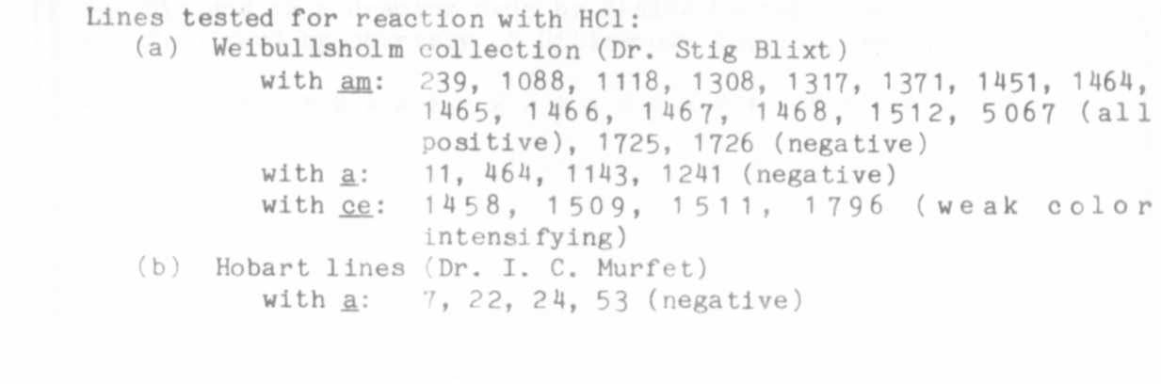

1. de Haan, H. 1930. Genetica 12:321.
2. Wellenaiek, S. J. 1947. Genetica 24:74.
3. Lamprecht, H. 1954. Agri. Hort. Genet. 12:38.
4. Crowden, R. K. 1982. Phytochemistry 21 (in press).

xxxxxxxxxxxxxxxxxxxxxxxxxxxxxxxxxxxxx

x Editor's Note: WL-1466 was shown (PNL 7:28-29, 1975; PNL 10:38-40,
x 1978) to carry the gene am-2 instead of am-1 as was originally as-
x sumed. Hence, am-2. like am-1. shows the acid reaction discussed
x above. It is unknown at present whether some of the other lines
x listed as am-1 are actually am-2.
x
xxxxxxxxxxxxxxxxxxxxxxxxxxxxxxxxxxxxx

