few outstanding cases and segregation and selection from F2 - F5, with
backcrosses and their segregations) during the last three and a half
years has clearly pointed to recessive epistasis and dominance as the
main causes of the heterosis observed in crosses of fasciated with non-
fasciated lines.

1. Loenning, W. E. 1982. Theor. Appl. Genet, (in press).

THE INHERITANCE OF THE ABILITY TO REGENERATE PLANTS FROM CELL CULTURES

OF PISUM SATIVUM L. — A PRELIMINARY ANALYSIS

Malmberg, R. L. Cold Spring Harbor Lab, Cold Spring Harbor, NY USA

Previously we had reported that certain wild or primitive forms of
peas had some ability to regenerate from callus cultures (1, 2).
Specifically, two lines obtained from G. A. Marx (B77-259 and B77-276)
were found to be able to give rise to whole plants when epicotyl derived
callus was shifted to shoot inducing medium after as long as six months
in culture; however, these lines showed an increasing difficulty in ob-
taining regeneration as a function of time, requiring progressively
longer incubations on shoot medium to give rise to regeneration events.
Also, because the pea callus grew very slowly, with doubling times on
the order of three to four weeks, the six months regeneration window did
not reflect very many cell divisions. Thus the ability to regenerate
from cultures was very limited. In this note we report some preliminary
results of crosses between one of the regenerating lines (B77-259) and a
non-regenerating multiply marked line (A1078-234-0) also kindly provided
by G. A. Marx. A partial genetic characterization of these lines is as
follows:
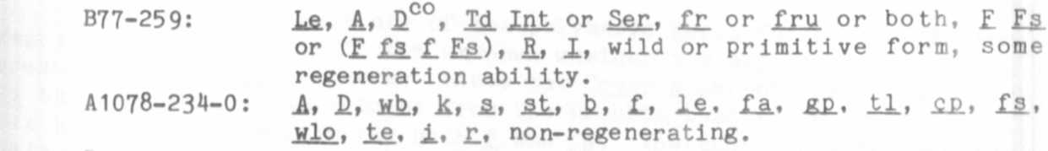
By standard crossing methods we constructed F1, F2, and backeross
generations. As previously described (1, 2) seeds to be tested for
their callus/regeneration ability were surface sterilized and germinated
on an agar medium. The epicotyls were dissected out two to three days
later and cultured on callus medium for four to six months, after which
they were transferred to shoot inducing medium. Successfully
regenerated shoots were then rooted and transferred to soil and growth
chamber conditions with a great deal of care at initially keeping the
humidity high. Two problems with this experimental design seem
unavoidable. First, the assay for regeneration potential can require as
much as twelve months, e.g. six months in culture, four months to
regenerate shoots, two months to obtain roots plus transplant to soil.
This is before any linkage data could be obtained by monitoring the
growth of the plants and scoring the markers. Second, non-regenerating
calli cannot be scored at all for the whole plant markers, thus we lost
a substantial portion of the linkage data that was present in the seeds.
Initial data indicated that there was no maternal effect so subsequent
data have been pooled.
F₁ seeds showed no regeneration at all. In the F₂, 3 2 out of 139
seeds gave rise to callus that has subsequently regenerated well formed
shoots, a frequency of 23%. This suggests a recessive trait with per-
haps a simple pattern of inheritance. The backcross data are consistent
with this in that backcrosses to the regenerating parent sometimes
regenerate, and those to the multiply marked parent never do. A problem
has arisen in that not all of the regenerating shoots have successfully
rooted and transplanted to soil, in contrast with the original line
which always did so. This suggests a possible second genetic factor
responsible for the hardiness to transplantation. Analysis of the
generation is still in progress; to date we have observed segregation
for genes st, b, le, cp. tl, suggesting that these are unlinked to the
regeneration factors. Because of the small sample size, 3 2, which is
regenerating, we may not be able to assign a linkage to the regeneration
genetic factors. Also, we will need F3 data to estimate the gene num-
ber, since 23% segregation in the F₂ could be compatible with models
other than just the obvious single segregating locus. We believe that we
have demonstrated some genetic basis for the difference between strains
in ability to regenerate from callus.

1. Malmberg, R. L. 1979. PNL 11:21-22.
2. Malmberg, R. L. 1979. Planta 146:243-244.

