GENE-ECOLOGICAL STUDIES IN PEAS: INFLUENCE OF MICROCLIMATE

Loennig, W. E. Institute of Genetics, University of Bonn
Federal Republic of Germany

Although only short distances apart, different fields and plots of
land may have quite different microclimates which In turn can have sub-
stantial effects on plant growth and development. Figs. 1, 2 and Table
1 show differences in plant height and yield (seeds per plant) for
'Dippes Gelbe Viktoria' and for ten fasciated lines grown at two dif-
ferent locations. The second location was at a higher elevation and
Fig. 1. Length of DGV and a few fasciated lines in % of DGV at location I.

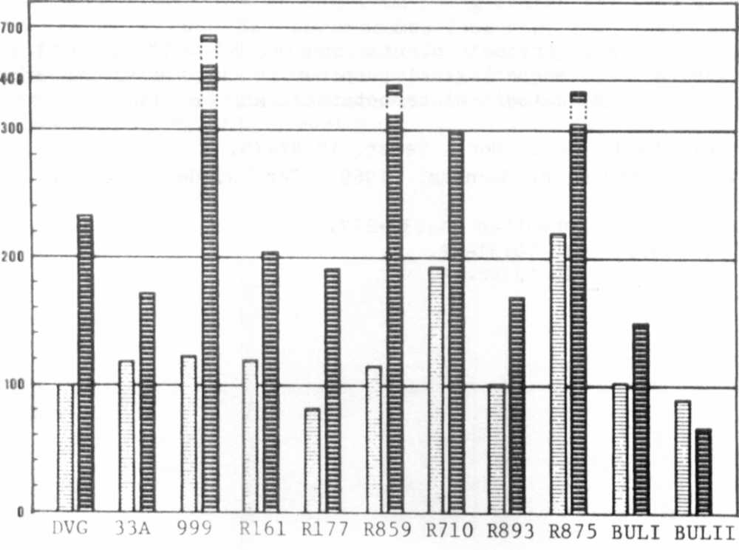
some 2 km from the first.
Fig. 2. Seeds per plant.
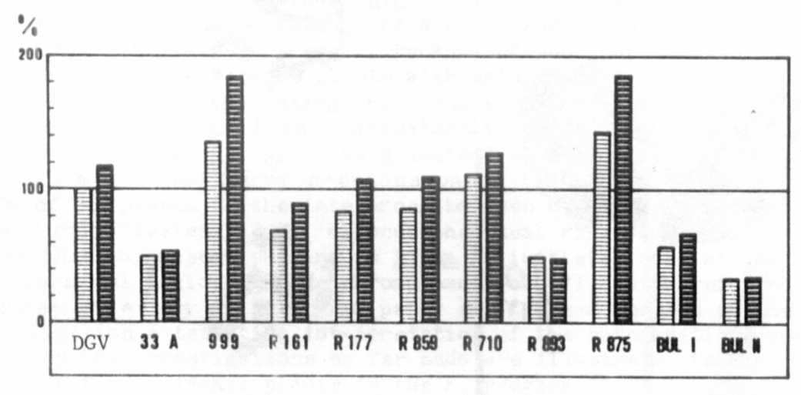

RESEARCH REPORTS 2
PNL Volume 14
1982

With respect to plant height, most of the values were well within
the range of variation shown by the control groups of the same lines on
the same field. Mutant 99 9 and recombinant 875 were exceptions which
should be included in further investigations. Under the extremely rainy
weather conditions in Central Europe in 1980 the ratio of 100
(location I): 136 (location II) was found for DGV, reducing most of the
relative values of other lines on location II to a certain degree, but
systematic comparisons of the above mentioned mutants and recombinants
were not made during that year.
As was expected from the 233% seed production (Fig. 2) of the 63
plants of DGV on location II compared to the control groups at location
I (54 plants), most of the mutants and recombinants were not able to
compensate this increased productivity and accordingly their values are
lowered in relation to DGV on location II. Distinct gene-ecological
reactions seem to be involved in the relative differences between the
mother variety DGV and most of its mutants and recombinants under the
conditions investigated. Moreover, mutant 999 and R 859 strongly sur-
passed its mother variety in seed production on location II and
additional gene-ecological reactions seem to be involved here.
