INVERSION OF THE ASSOCIATION AMONG PROTEINS AND SUGARS WHEN COMPARING
THE GREEN PEA AND DRY SEED STAGES

Krarup, A. Universidad Austral de Chile, Valdivia, Chile

Previous work (1) indicated that the correlation among protein and
sugar content at the dry seed stage was positive and significant,
whereas that for the green pea stage for the same parameters was nega-
tive, thus indicating a possible Inversion of this association.
This finding was confirmed in a different set of lines by means of
a path-coefficient analysis of proteins vs. sugars. The total correla-
tion for proteins vs. sugars was positive in both stages, but in the
green pea stage there was no detectable correlation at all (r = .0545).
However, in the path-coefficient analysis the direct effects showed a
clear negative (-.4259) relationship, and that pooled indirect effects
of alcohol insoluble solids (AIS) and dry matter (MS) shift the sign to
positive (see Table 1). In the case of dry seed the pooled Indirect ef-
fects have a negative sign, but the direct effect remains positive and
is of great magnitidue (.8445).
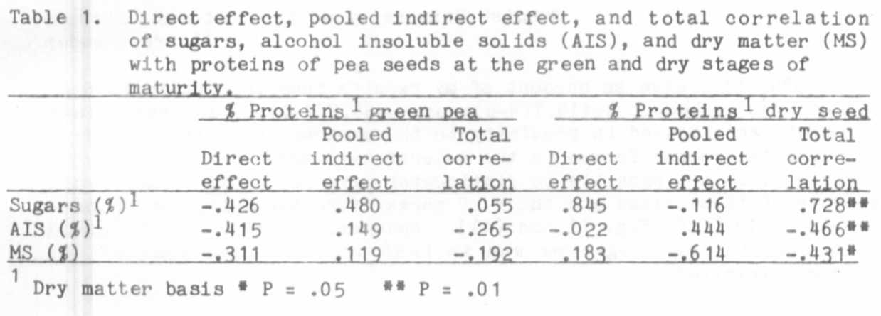
Table 2 shows the relations among yields (green and dry) with
sugars, proteins, AIS, and MS. The path coefficient analysis confirms
the signs of the associations between yields with proteins and sugars at
both stages (see signs of direct effects). Thus, as suggested by Pandey
and Gritton (2), and later by the author (3), selections made at the dry
seed stage for high protein content would not necessarily result in
genotypes with low seed yields. To this we can now add that when
selecting for higher protein content, we would be also selecting for
higher sugar content at this stage. This would not be true at the green
pea stage.

2 PNL Volume 14 1982
RESEARCH REPORTS

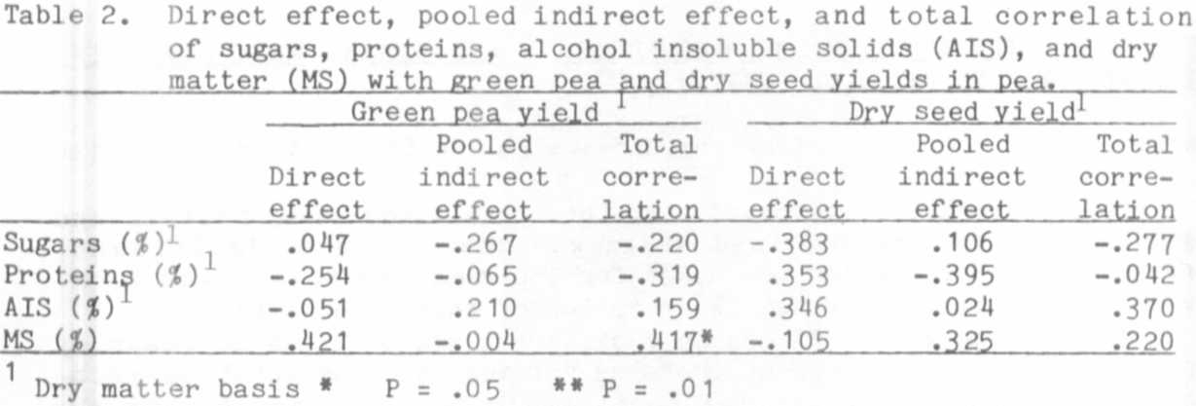

1. Krarup, A. 1980. PNL 12:40.
2. Pandey, S. and E. T. Gritton. 1975. Crop Sci. 15:353-356.
3. Krarup, A. 1977. PNL 9:25.

FURTHER STUDIES OF AN INTERCROSS IN PISUM

Lamm, R. L. Swedish University of Agricultural Sciences
Alnarp, Sweden

In 1980 (5) I gave an account of my results from the application of
the intercross method to L-114,T(4-6)a and L-58,T(4-6)b. In these lines
the T-points are located in proximity to the centromeres with the effect
that chiasmata are not formed in the interstitial segments. Under the
microscope it is not possible to distinguish with certainty between the
karyotypes of these lines and those of normal structural type as repre-
sented by L-110 t(cf. Fig. 1) and (1)]. However, in L-114 the T points
are situated in the long arms and in L-58 in the short arms of the
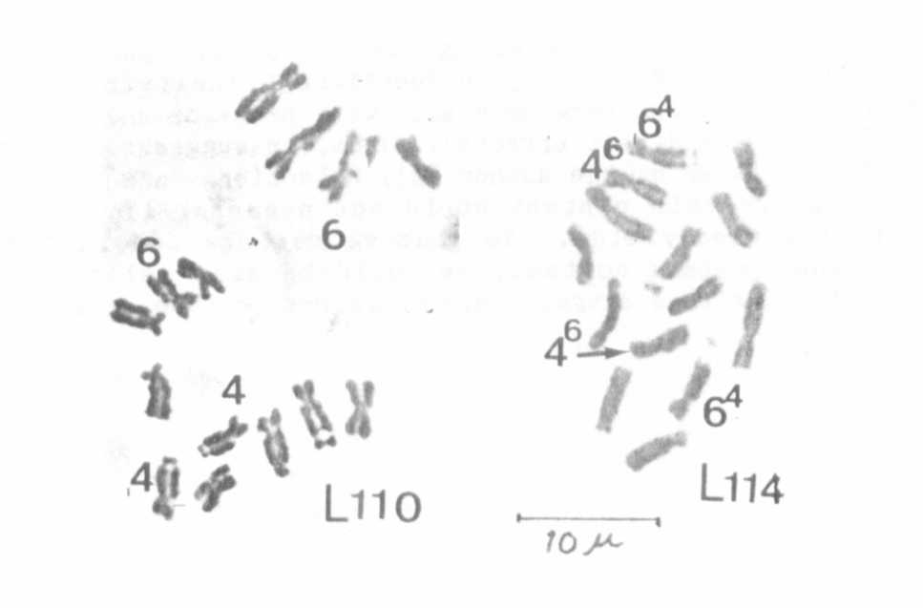
Fig. 1. Mitosis in root tips of L-1 10 (standard for the normal struc-
tural type) and L-114,T(4-6)a.
chromosomes involved.

