PNL Volume 14 1982
RESEARCH REPORTS

UTILIZATION OF THE HALF-SEED TECHNIC IN THE BREEDING OF HIGH PROTEIN
VARIETIES OF PEA. I. GENETIC ANALYSIS OF LINES AND THEIR HYBRIDS WITH
RESPECT TO CHOOSING CROSS COMBINATIONS FOR BREEDING

Kaczmarek, Z. and M. Surma

Swiecicki, W. K.
Institute of Plant Genetics, Poznan
Poland
Plant Experiment Station, Wiatrow, Poland

Earlier investigations showed the potential of using the half seed
method of estimating protein content (PNL 13:54-56). We intend to use
this technic in genetic-breeding work towards developing lines of pea
with high protein content. In practice it will involve selection of
single seeds on the basis of the analysis of protein content in a half
of a seed without the embryo.
On the basis of the earlier studies the following four lines were
chosen for further investigation (with the average protein content):
Mt 4042 - 29.2%, Wt 3527 - 24.4%, Wt 3026 - 29.2%, and L.X. - 25.6%.
These lines were crossed in the following combinations: L.4042 x L.3527,
L.4042 x L. 3026 , L. 4042 x L.X, L.3527 x L. 3026 , L.3527 x L.X,
L.3026 x L.X. For each cross combination, the protein content was
analyzed (micro-Kjeldahl) in halves of seed without the embryo in the
parental F1, F2, and backoross populations.
With such information it is possible to get general genetic-
breeding information concerning the whole set of lines studied and their
hybrids (diallel analysis of the F1 and generations) and more
detailed genetic information concerning each of the cross combinations
(analysis of the generations P1, P2, F1, F2, B1, B2). The estimation of
general combining ability, obtained on the basis of the diallel
analysis, were similar for both generations, F1 and F2. The high
protein lines L.4042 and L.3026 had significant positive effects whereas
lines L.3527 and L.X. showed significant negative effects.
The diallel analysis revealed an additive-dominant model of gene
action for both F1 and F2. Thus, it was possible to obtain an estima-
tion of genetic parameters according to Mather, i.e. D,F, h², H₁, H₂, and
to estimate dominance and broad and narrow sense heritabi Fities
(Table 1).
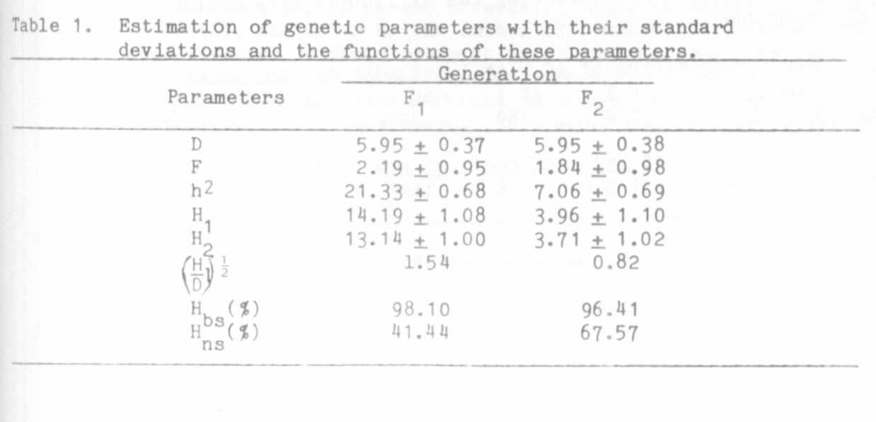

RESEARCH REPORTS
PNL Volume 14
1982
4

The diallel analysis showed a significant dominance for low protein
content, but the degree of dominance was different in different cross
combinations. It varied from 1.06 (L.4042 x L.X.) to 8.47
(L.4042 x L.3026). The highest value was obtained in crosses involving
two high protein lines, L.4042 and L.3026, indicating a genetic dif-
ference between them in spite of the similarity in protein content in
the lines theemselves. On the basis of the results of diallel analysis
and the analysis of particular cross combinations two hybrids,
L.4042 x L.3026 and L.3026 x L.3527, were chosen for further breeding.

SUPPLEMENTARY EVIDENCE FOR THE LINKAGE OF afila WITH MUTANTS ON
CHROMOSOME 1

Kielpinski, M. Plant Breeding Station, Prusinowo, Poland

The afila (af) gene which converts leaflets into tendrils is now
widely used in breeding programs around the world.
The data of Khangildin (1), Marx (2), and Snoad (3) place aX in
chromosome 1 in the region of I.. My own findings confirm those presented
by others.
The following lines were used:
— Induced af ila mutant in cv. 'Wasata' (genotype: af Red I_)
— WL 1535 from Weibullsholm collection (genotype: Af red i)
—Variety 'Allround' (genotype: Af Red i)
The genetic analysis was carried out on F_ progeny derived from the
following crosses: a_f Red I (Wasata) x Af Red i. (Allround) and
af Red I (Wasata) x Af red i (WL 1535).
The crosses revealed the expected linkages, i.e. af-i and af-red.
The Cro value for genes af -1 was 8.3 ± 2.9, and for genes af-red
3.1 + 1.3 (Table 1). This compares with 14.5 ± 1.6% between af-1 as
determined by Snoad (3) and < 9% between af-red (1). It should be noted
that my data, like those of Marx (1), show a deficiency of red
segregants, thus evidently confirming the difficulty of scoring for red
in an af background.
