clear or definitive statement about the biological activity of an auxin-
analog could be made.

1. Ingensiep, H. W. , M. Herlt, and H.-J. Jacobsen. 1981.
Morphogenetic response, translocation and metabolism of root-applied
auxin in pea seedlings. PNL 13:21-23.
2. Jacobsen, H.-J., H. W. Ingensiep, M. Herlt, and M. L. H. Kaul.
1980. Tissue culture studies in Pisum sativum. In: Plant Cell
Cultures: Results and Perspectives. F. Sala, B. Parisi, R. Cella
and 0. Ciferi, editors. Elsevier/North Holland Biomedical Press,
Amsterdam, p. 319-324.

CHANGES OF ELECTROPHORETIC ALBUMIN PATTERNS IN GERMINATING SEED OF
FIVE DIVERSE PISUM LINES

Jakubek, M. and J. Przybylska Institute of Plant Genetics
Polish Academy of Sciences
Poznan, Poland

An electrophoretic analysis of seed albumins of lines within the
genus Pisum revealed five distinct protein patterns which differed in
number and in electrophoretic mobility of the major bands (1).
Preliminary genetic studies showed that two of these patterns were con-
trolled by two alleles of one locus (2). The albumins corresponding to
the characteristic electrophoretic variants seemed to have a molecular
weight (MW) of approximately 40,000 and to consist of two subunits of MW
approximately 23,000 (3).
Recently, Murray reported that the subunits of MW 23,000 did not
disappear during germination of J?, sativum seeds and suggested that
these polypeptides could function as structural components (4).
The possible physiological role of the specific albumins was inves-
tigated by examining changes in electrophoretic albumin patterns during
seed germination of five Pisum lines, each with a distinct banding
pattern. Seeds of the following lines from the Weibullsholm collection
were investigated: WL 110 (P. sativum): WL 936 (P. humile): WL 1490
(P. cinereum) ; WL 808 (P. abyssinicum; and WL 1256 (P. fulvum). Seeds
were germinated in darkness on moist filter paper. Albumins were ex-
tracted from cotyledons at five-day intervals until the 20th day, with
0.15 M acetate buffer, pH 4.6 or with 5% K₂SO₄ in 0.1 M Na-phosphate,
pH 7.0 according to Murray (4). Native proteins were submitted to disc-
electrophoresis , dissociated proteins to SDS-electrophoresis, as
described elsewhere (3).
Extracts obtained both in pH 4.6 and in pH 7.0 gave generally
similar electrophoretic spectra. The electrophoretic patterns of the
albumins from germinating seeds of the five lines are shown in Fig. 1.
In general, the characteristic patterns persisted until the 20th day.
Some alterations were observed only in P. abyssinicum and P. cinereum.
In P. abyssinicum the characteristic band "f" split into two about the
10th day; in P. cinereum the bands "b" and "d" became faint ap-
proximately after the 15th day. The latter observation should be
interpreted with caution, because the relative intensities of the bands
"c" and "d" in P. cinereum were known to vary depending on uncontrolled

This work was performed under Government Project PR-4

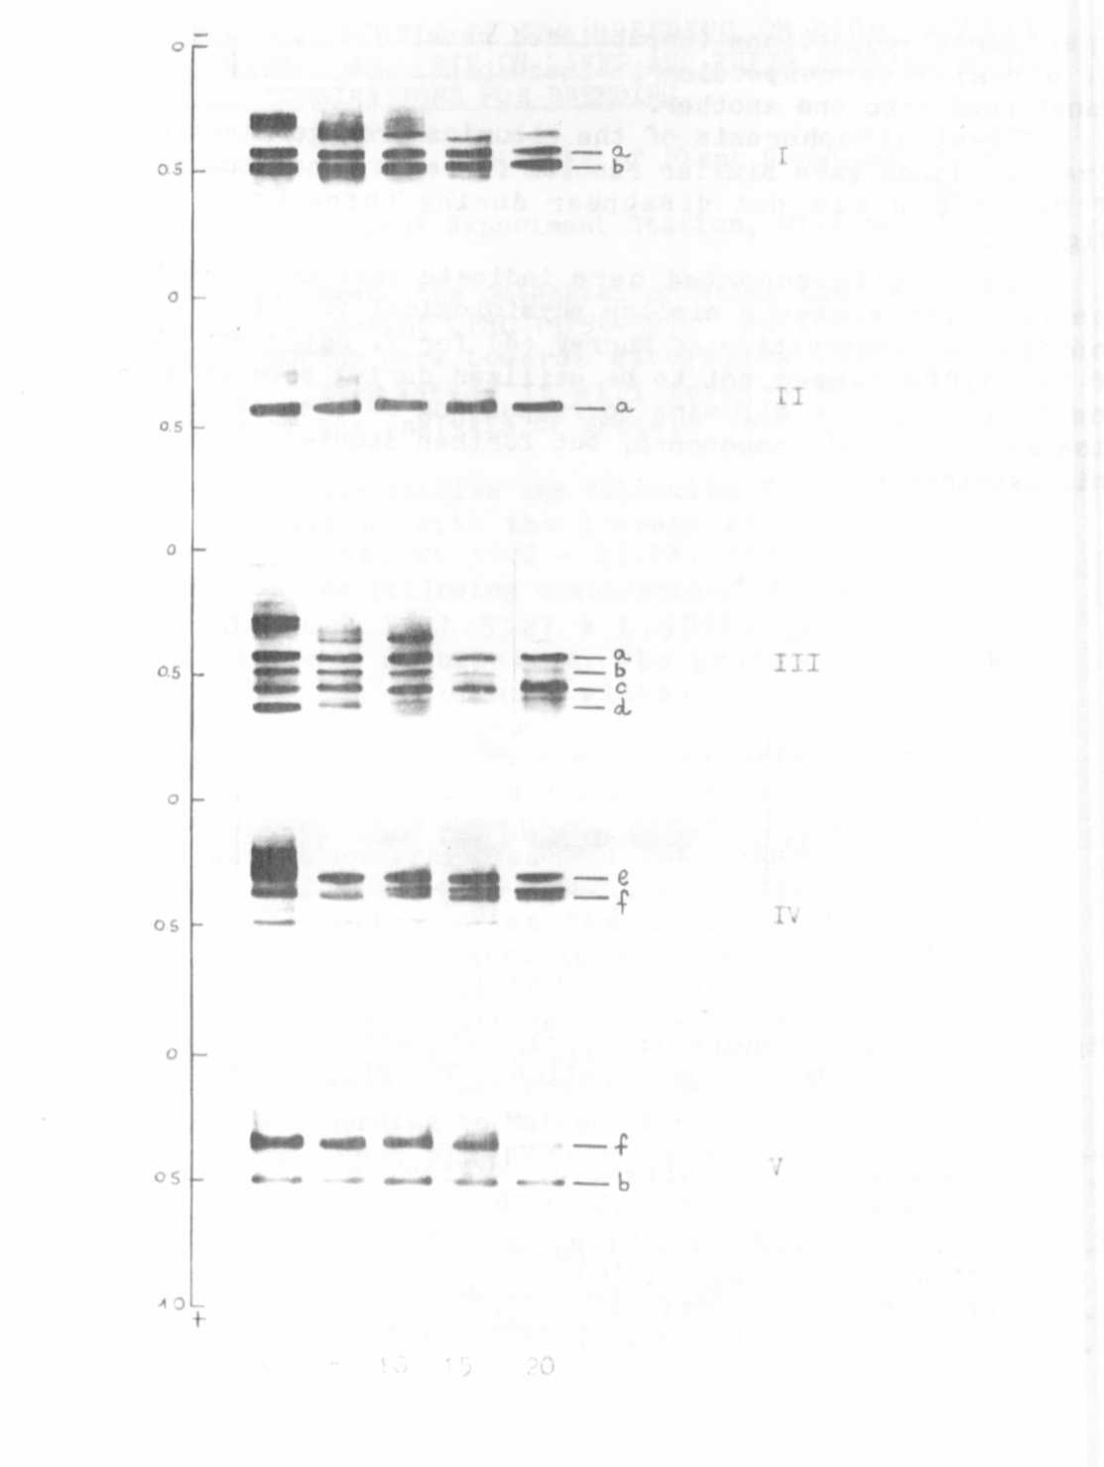
Fig. 1. Gel electrophoresis of the albumins extracted from cotyledons
of germinating seeds of five diverse Pisum lines. 0 — start-
ing material (dormant seeds); 5, 10, 15, 20 days of
germination, a-f characteristic bands. I W 110
(P. sativum ) ; IIW9 3 6 (P. humile ) : III W 14 90
P. ci nereum: IV — W 808 (P. abyssinicum):V — W 1256
(P. fulvum).
RESEARCH REPORTS
1982
PNL Volume 14
4

experimental conditions (unpublished results). It could be assumed that
the albumins corresponding to these bands are labile and can be easily
transformed into one another.
SDS-electrophoresis of the albumins from germinating seeds of the
five pea lines gave similar results for each line studied. Polypeptide
of MW 23,000 did not disappear during three weeks of germination
(Fig. 2).
The results reported here indicate that the specific albumins of
the five lines have a similar physiological function. These data also
confirm the observation of Murray (4) for P. sativum: the polypeptides
of MW 23,000 seemed not to be utilized during seed germination. It is
possible that the albumins corresponding to these subunits could func-
tion as structural components, but further studies are required to prove
this hypothesis.
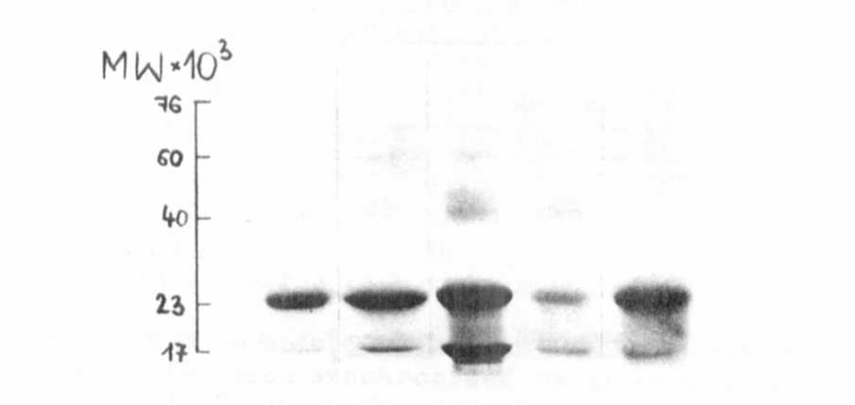
X . »

Fig. 2 . SDS-electrophoresis of the albumins extracted from cotyledons
after 20 days of germination. The Pisum forms are denoted as in
Fig. 1.

1. Przybylska, J., S. Blixt, J. Hurich, and Z. Zimniak-Przybylska.
1977. Genetica Polonica 18:27-38.
2. Blixt, S. , J. Przybylska, and Z. Zimniak-Przybylska. 1980.
Genetica Polonica 21:153-161.
3. Jakubek, M. and J. Przybylska. 1979. Genetica Polonica 20:369-380.
4. Murray, D. R. 1979. Plant, Cell and Environment 2:221-226.

