RESEARCH REPORTS 1
PNL Volume 14
1982

REACTIONS OF PEA EPICOTYLS TO VARIOUS AUXINS AND NON-ACTIVE AUXIN
ANALOGS

Jacobsen, H. J. Institute of Genetics, University of Bonn
Federal Republic of Germany

Morphogenetic reactions of plant tissues to the application of cer-
tain types of phytohormone were shown to depend on (a) the plant's
genetic background and (b) the amount of free active hormone in the
cells. In the case of auxin effects in pea, we demonstrated that the
ability of intact pea seedlngs to reduce the auxin concentration by
oxidation (IAA) or conjugation (NAA) led to negligible morphogenetic
damages, while 2,4-D applied to the roots caused severe damage of the
seedlings because this growth regulator is metabolized to a much lesser
extent (1). On the other hand, we were able to demonstrate that the
fasciated mutant 489 C was able to form roots from auxin-induced callus,
while its initial line was not (2).
In a recent experiment, we tested the ability of a number of auxins
and so-called "non-active'' analogs on callus induction in epicotyl seg-
ments of the initial line (2 x 10 replications with 10~⁴ M of the
hormone, grown on Murashige/Skoog medium). The results, shown in
Table 1, were scored after 4 weeks in culture and are grouped in accord-
ance with the frequency of the parameter "%-callus induction".
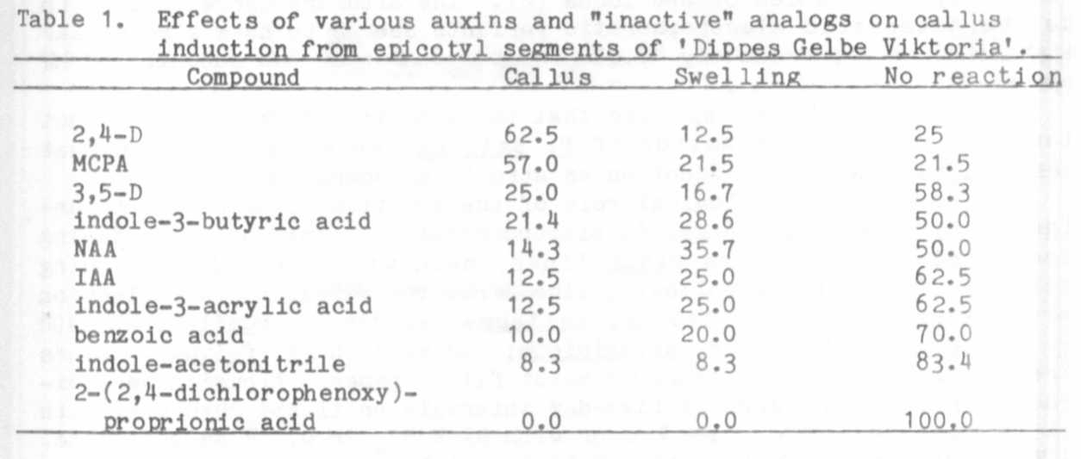
Obviously, the phenoxy compounds 2,4-D, MCPA, and, surprisingly,
3,5-D were most effective in callus induction, while the other auxins
IBA, NAA, and IAA were less effective in this system at the applied
concentration. Compounds like 3,5-D, indole-3-acry lie acid, benzoic
acid, or indole-acetonitrile generally are referred to as "inactive"
auxins, where a behavioral pattern like that observed with 2-(2,4-
dichlorophenoxy)-proprionic acid would be expected. The effects on
callus induction or swelling of some of the explants were probably due
to interactions of these compounds with the reactions of the segments on
wounding. In any case, from the results of the present experiments no

clear or definitive statement about the biological activity of an auxin-
analog could be made.

1. Ingensiep, H. W. , M. Herlt, and H.-J. Jacobsen. 1981.
Morphogenetic response, translocation and metabolism of root-applied
auxin in pea seedlings. PNL 13:21-23.
2. Jacobsen, H.-J., H. W. Ingensiep, M. Herlt, and M. L. H. Kaul.
1980. Tissue culture studies in Pisum sativum. In: Plant Cell
Cultures: Results and Perspectives. F. Sala, B. Parisi, R. Cella
and 0. Ciferi, editors. Elsevier/North Holland Biomedical Press,
Amsterdam, p. 319-324.

CHANGES OF ELECTROPHORETIC ALBUMIN PATTERNS IN GERMINATING SEED OF
FIVE DIVERSE PISUM LINES

Jakubek, M. and J. Przybylska Institute of Plant Genetics
Polish Academy of Sciences
Poznan, Poland

An electrophoretic analysis of seed albumins of lines within the
genus Pisum revealed five distinct protein patterns which differed in
number and in electrophoretic mobility of the major bands (1).
Preliminary genetic studies showed that two of these patterns were con-
trolled by two alleles of one locus (2). The albumins corresponding to
the characteristic electrophoretic variants seemed to have a molecular
weight (MW) of approximately 40,000 and to consist of two subunits of MW
approximately 23,000 (3).
Recently, Murray reported that the subunits of MW 23,000 did not
disappear during germination of J?, sativum seeds and suggested that
these polypeptides could function as structural components (4).
The possible physiological role of the specific albumins was inves-
tigated by examining changes in electrophoretic albumin patterns during
seed germination of five Pisum lines, each with a distinct banding
pattern. Seeds of the following lines from the Weibullsholm collection
were investigated: WL 110 (P. sativum): WL 936 (P. humile): WL 1490
(P. cinereum) ; WL 808 (P. abyssinicum; and WL 1256 (P. fulvum). Seeds
were germinated in darkness on moist filter paper. Albumins were ex-
tracted from cotyledons at five-day intervals until the 20th day, with
0.15 M acetate buffer, pH 4.6 or with 5% K₂SO₄ in 0.1 M Na-phosphate,
pH 7.0 according to Murray (4). Native proteins were submitted to disc-
electrophoresis , dissociated proteins to SDS-electrophoresis, as
described elsewhere (3).
Extracts obtained both in pH 4.6 and in pH 7.0 gave generally
similar electrophoretic spectra. The electrophoretic patterns of the
albumins from germinating seeds of the five lines are shown in Fig. 1.
In general, the characteristic patterns persisted until the 20th day.
Some alterations were observed only in P. abyssinicum and P. cinereum.
In P. abyssinicum the characteristic band "f" split into two about the
10th day; in P. cinereum the bands "b" and "d" became faint ap-
proximately after the 15th day. The latter observation should be
interpreted with caution, because the relative intensities of the bands
"c" and "d" in P. cinereum were known to vary depending on uncontrolled

This work was performed under Government Project PR-4

