ABERRATIONS IN SHOOT MORPHOGENESIS OF PEA SEEDLNGS AFTER TREATMENT WITH
MICROTUBULE DISORGANIZERS AND 2.4-D

Ingensiep, H. W. Institute of Genetics, University of Bonn
Federal Republic of Germany

Microtubules are known to be involved in morphogenetic activities
on the cellular level and it can be assumed that genes that influence
the organization of microtubules may also influence the plant's
morphology. On the other hand, auxins are known to influence plant mor-
phology on the intercellular level, the auxin-herbicide 2,4-
dichlorophenoxyacetic acid (2,4-D) being especially noted for causing
abnormal growth (1). In a comparative study we treated young
pea seedlings with microtubule disorganizers and 2,4-D to determine
their morphogenetic effects on shoot development.
One-week-old etiolated pea seedlings were treated with the follow-
ing compounds: colchicine (5xlO~³M), vinblastine (100 ug/ml) and 2,4-D
10⁻⁴M) dissolved in water. From 5-10 ul of each solution were applied
between the primary leaves of the apical hook. The seedlings were fur-
ther cultivated under a light/dark regime of 16/8 hours on moist
vermiculite to induce light-dependent morphogenesis. Under these condi-
tions the MT-disorganizers (colchicine, vinblastine) and the auxin-
herbicide 2,4-D, produced different morphological changes in the shoot.
Within one week after treatment the colchicine-treated population ex-
hibited aberrations ranging from strong swelling in the apical tissue of
clearly inhibited seedlings to abnormal leaf formation in slightly fur-
tner developed seedlings (Fig. 1a). Deviations in leaf shape were
common in this population. For example, one of the stipules was often
a sent, reduced in size, or altered in shape. The leaflet blades also
differed in size, shape, and conformation. The stems were thickened or
broadened toward the tip similar to fasciated structures. Nevertheless
leaves and stems were green and growth was not at all inhibited.
The vinblastine-treated seedlings showed similar but less striking
aberrations in shoot development, and shoot morphogenesis in general was
only slightly inhibited (Fig. 1b).
The 2,4-D-treated seedlings were not so drastically Inhibited, but
several morphological aberrations were evident (Fig. 1c). Again, the
leaf blades were abnormal in size and shape, but not in color. Apical
leaves often showed extremely disturbed morphogenesis, e.g. blade curva-
ture and stem broadening. The stipules were not affected so strongly,
but they did show changes in size and shape similar to seedlings treated
with colchicine.
These preliminary investigations demonstrate that the light-
dependent morphogenesis of young pea seedlings is affected substantially
by MT-disorganizers and by 2,4-D. Both compounds induced similar abnor-
malities in leaflet, stipule, or stem formation, thus supporting the
view that microtubule organization within the plant cells may be
directed by auxins.

1. Audus, L. J. (ed.) 1 964. Physiology and Biochemistry of
Herbicides. Academic Press, London.

RESEARCH REPORTS
PNL Volume 14
3
1982

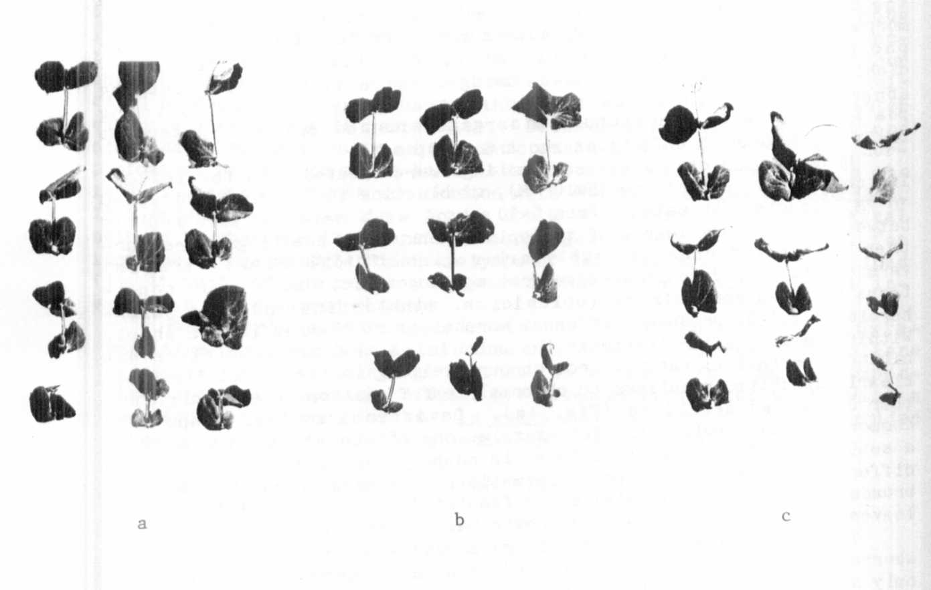

Fig. 1. Leaf aberrations
pea seedlings with:
2,4-D.
resulting from treating one-week-old
(a) colchicine, (b) vinblastine, or (c)

