THE SEED PRODUCTION OF EARLY FLOWERING FASCIATED PISDM RECOMBINANTS

Gottschalk, W. Institute of Genetics, University of Bonn
Federal Republic of Germany

Our high-yielding fasciated mutants have some negative characters
which reduce their breeding value. They are too late and too tall;
moreover, they are homozygous for gene .sg. for reduced seed size.
Theoretically, the breeding value of these genotypes could be improved
by eliminating some of these negative traits. This sems to be possible
since the characters just mentioned are not part of pleiotropic patterns
of the fasciata genes. Instead, they are controlled by independently
acting genes. Another approach to improvement is to incorporate useful
genes from other mutants.
An important consideration bearing on this objective is the fact
that the fasciated mutants are homozygous for 14-18 mutant genes. Thus,
highly heterozygous hybrids arise when they are crossed with non-
fasciated genotypes. Complicated segregations occur in their progenies
and a great number of different recombinant types can be selected. They
have been propagated and are available in the form of pure lines at our
institute.
Most of the genes present in our fasciated mutants are hypostatic
and are therefore not discernible in the plants. This holds true also
for some genes controlling traits of agronomic interest such as inter-
node length, plant height, flowering, and ripening.
We have crossed these mutants with recombinant R 46C carrying gene
efr for early flowering. A large number of fasciated recombinants with
different genotypic constitution is available, all of them containing
efr. as additional mutant gene. These early flowering, fasciated recom-
binants have been tested for seed productivity. They are compared to
both parental groups (the fasciated mutants and the early flowering
recombinant R 46C) as well as to the mother variety used for our ir-
radiations in Fig. 1.
As the figure shows, R 46C did not yield as well as the mother
variety, pooled mean for all the 23 generations tested being only 13% of
the control value. Thus, the genotype cannot be utilized agronomical ly
in its present form. The fasciated mutants, on the other hand, were
found to have an excellent seed production in most generations tested
(lefthand part of the figure). In the righthand part, the yield of 44
different recombinant strains is given, homozygous for efr. for one or
several genes of the polymeric fasci ata group, and for different genes
controlling internode length. They are subdivided into four groups ac-
cording to their plant height.
The first sub-group contains recombinants with the genes "short
III" and "short II" having plant heights ranging between 20 and 50
centimeters. In spite of the stem fasciation, their yield was very low,
about similar to that of the non-fasciated R 46C. Thus, stem fasciation
does not lead to an increase of the seed production in the presence of
the genes for strongly reduced internode length. The recombinants of
the second sub-group contain gene "short I" in addition to efr and fas-
ci ata genes which reduce the internode length only slightly. Their seed
production was better than that of the first group but considerably

RESEARCH REPORTS
1982
PNL Volume 11
3

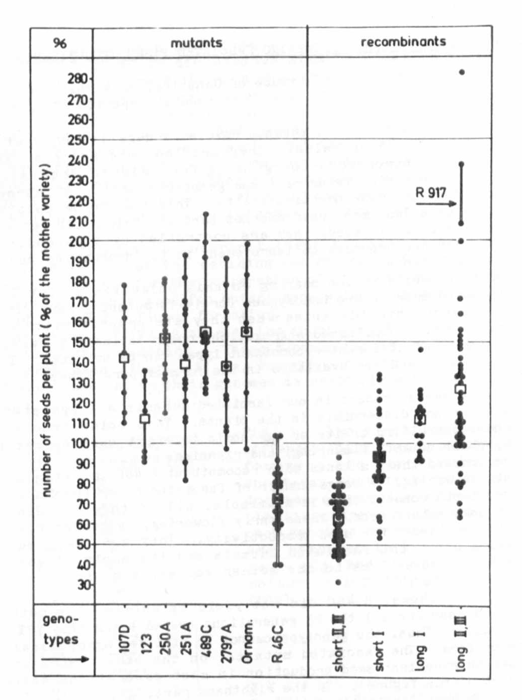
Fig. 1: Lefthand part: The seed production of 6 fasciated mutants:
the fasciasted fodder pea variety 'Ornamenta' and genotype R 46C con-
taining gene efr for earliness.

Righthand part: The seed production of 44 recombinant lines homozygous
for efr, for fasci ata genes, and for genes for different internode
lengths. The material is subdivided into 4 groups according to plant
height.

Each dot represents the mean value for the character "number of seeds
per plant" for one generation as related to the control value of the
mother variety. The squares represent the pooled means of the material
tested.

worse than that of the fasciated mutants. The third sub-group had plant
heights similar to the fasciated mutants. The additional presence of
gene efr for earliness did not lead to an improvement in yield. Only
some genotypes of the fourth sub-group yielded more than the fasciated
mutants, but they are so tall that they are not suited for field
cultivation.
The findings show that the combination of gene efr for earliness
and distinct genes for reduced internode length with the fasci ata genes
has a negative influence on the seed production of the plants. It was
not possible to maintain the high yield of the fasciated mutants when
otherwise desirable genes were incorporated.

A PROPOSED ASSAY FOR DETECTION OF AUXIN-SENSITIVE MUTANTS OF PISUM USING
INTACT SEEDLINGS

Ingensiep, H. W. Institute of Genetics, University of Bonn
Federal Republic of Germany

Many of the morphological differences among mutants or recombinants
may result from the action of genes that control plant growth regulators
such as auxins. Experiments show that exogeneously applied auxins are
able to induce several morphological changes in plant form and size. In
such experiments different morphogenetic effects often are caused by
different auxins applied under equimolar conditions, and for Pisum
sativum these different effects could be correlated with differences in
metabolic availability and translocation of the applied auxins (1).
These studies led us to propose a simple test system to screen for
mutants which affect auxin metabolism, using intact pea seedlings.
Experimental background: Our previous experiments showed that nor-
mal pea seedlings exhibit a characteristic morphogenetic effect when
auxins 2,4-D, IAA, and NAA were applied via the root system (1).
Seedlings treated with 2,4-D were strongly inhibited in root and shoot
development, while IAA- and NAA-treated seedlings were not. This could
be correlated with higher metabolic availability of the IAA and NAA
molecules by different mechanisms: IAA is mainly decarboxylated or
conjugated to aspartic acid; NAA is mainly conjugated; and 2,4-D is
neither decarboxylated nor conjugated to any extent. In the case of IAA
and NAA, these mechanisms prevent the morphogenetic alteration of the
seedling by inactivating many of the free molecules. Hence, these
auxins are not able to reach the vascular tissue in the root in high
amounts and are not translocated into the shoot to cause morphogenetic
aberrations there. On the other hand, 2,4-D does reach the vascular
tissue and is actively translocated in lethal amounts into the shoot.

