THE BEHAVIOR OF GENE efr FOR EARLINESS IN NEW RECOMBINANTS UNDER SHORT-
DAY PHYTOTRON CONDITIONS

Gottschalk, W. Institute of Genetics, University of Bonn
Federal Republic of Germany

The reaction of gene efr under controlled short-day conditions in
some recombinant types was discussed previously (1). In the meantime,
new recombinants, homozygous for efr but different for other mutant
genes, have been selected and developed into pure lines. Thirty-eight
of them were grown together with their mother variety and recombinant
R 46C (the donor of gene efr) in our phytotron under short-day condi-
tions as follows: 11 hrs full light (30,000 lux); 12 hrs darkness; 1 hr
dim light (1/2 hour before and 1/2 hr after full light); humidity, 60%;
temperature, 25 C in light, 15 C in dark. Eight normally developed
plants per genotype were grown in Mischerlich pots and the number of
days to flowering was recorded. Some other traits, such as position of
the first flower at the stem, plant height, number and length of inter-
nodes, seed production, and fresh and dry weight, were also determined.
Their flowering behavior is graphically presented in Fig. 1. In spite
of the homozygosity of the material studied and the equal environmental
conditions, there was considerable variation in number of days to
flower.
The mean value for R 46C was 39.3 days, individual values ranging
between 35 and 48 days. The corresponding mean of the mother variety
'Dippes Gelbe Viktoria' was 53-1 days with a range of 47 to 62 days.
Thus, the plants of R 46C started flowering about 14 days earlier than
fch'3 control plants under the conditions of this experiment.
Many recombinant types, homozygous for efr and specific other
genes, showed about the same flowering behavior as R 46C so the other
mutant genes involved apparently had little or no influence on the ac-
tion of gene efr. A few recombinants flowered earlier:
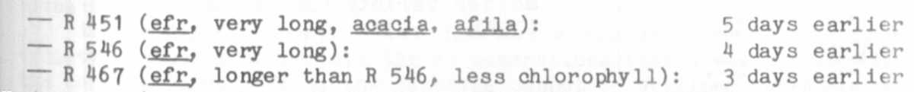
Host recombinants tested, however, flowered considerably later than
those of R 46C. Details can be seen in Fig. 1. Some of the genotypes
began flowering about the same time as the non-early mother variety or
even later. They are early due to homozygosity for gene ,efr. but this
gene is not able to manifest its normal action, presumably because of
its interaction with other mutant genes. Moreoever, Fig. 1 shows
another well-known feature: the later the plants flower, the greater
the variation in days to flower. The mean value for R 570, for example,
was 54.9 days, i.e. about 15 days later than R 46C. Of the 8 plants
studied, however, two flowered simultaneously with R 46C whereas the
others were much later. The causes for this behavior are not yet known,
but they are obviously connected with the tendency to form tiny floral
buds at low nodes which do not develop into normal flowers.
The most interesting recombinant of the group is R 713. derived
from the cross of the fasciated mutant 107D x R 46C. The plants are
homozygous for the following genes: efr for earliness (from R 46C);

RESEARCH REPORTS
3
PNL Volume 14
1982

"short I" (a hypostatic gene from 107D); a gene for stem fasciation
(from 107D); a gene for dichotomous stem bifurcation (not yet sure
whether it is bif-1 from R 46C or a similar gene from 107D).
In these plants floral induction occurred about the same as in
R 46C. Tiny floral buds were formed, but they remained undeveloped.
This holds true for all the buds produced by all the plants of this
genotype. They are genetically early, but they were not able to produce
fully developed flowers. This behavior, however, occurred only under
the short-day conditions; under the long-day field conditions of West
Germany R 713 flowers richly. After having changed the photoperiod in
the phytotron from short- to long-day, normal flowers appeared a few
days later.
It is difficult to interpret these findings. Undoubtedly, the
photoperiod is one of the deciding environmental factors. This is an
interesting example for the cooperation of an environmental factor, the
photoperiod, with a specific mutant gene which commonly suppresses the
action of a gene for flower formation.
Recombinant R 173 is already the fourth genotype of our collection
which shows this reaction. These 4 recombinants are genetically dif-
ferent from each other. It is, however, not yet clear which of the
mutant genes present in their genomes is responsible for the suppression
of efr.

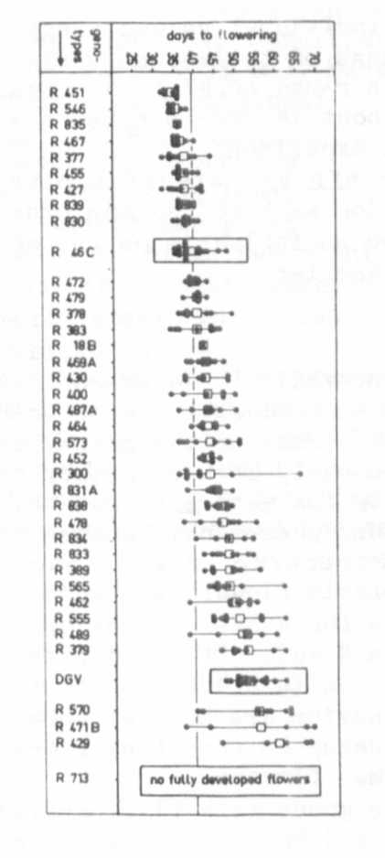
Fig. 1. The flowering behavior of 38
different Pisum recombinants homozygous
for gene efr for earliness, under
short-day phytotron conditions. Each
dot represents the value for a single
plant; squares are the mean values for
each genotype tested. The recombinants
are compared to R 46C, the donor of
gene efr. and to the late flowering
mother variety 'Dippes Gelbe Viktoria'
(DGV).

xxxxxxxxxxxxxxxxxxxx
x Editor's Note: The flower abor-
x tion phenomenon described here
x has been observed previously and
x has been discussed in publica-
x tions of I. C. Murfet and others,
x See particularly: Murfet, I. C.
x 1977. Ill Physiology of the Garden
x Pea. J. F. Suttcliffe and J. S.
x Pate, eds. Academic Press,
x London.
xxxxxxxxxxxxxxxxxxxx

