PNL Volume 14 1982 RESEARCH REPORTS

A NEW MUTANT WITH DICHOTOMOUS STEM BIFURCATION

Gottschalk, W. Institute of Genetics, University of Bonn
Federal Republic of Germany

Three X-ray induced mutants of our Pisum collection (Nos. 157A,
239CH, 1201A) show a dichotomous stem bifurcation resulting in the for-
mation of two corresponding stems in the upper part of the shoot.
Former investigations have shown that the two polymeric genes bif-1 and
bif-2 are responsible for this deviation from the normal shoot
structure. Mutants 239CH and 1201A were found to be genetically identi-
cal in this respect, containing gene bif-1. whereas mutant 157A is
homozygous for bif-2. The common peculiarity of the three mutants is
that each shows unstable penetrance of the bif genes, ranging between 20
and more than 80% over 13-22 generations of observation.
A few years ago, a fourth mutant with dichotomous stem bifurcation
was selected, the mutant having arisen after X-ray treatment (No. 3 7B).
The plants are phenotypically identical with those of the other three
mutants, but the penetrance of the bif gene in 37B is stable. Mutants
1201A and 37B were crossed with each other in order to clarify the
genetic constitution of 37B. Some of the few F₁ plants available were
bifurcated, others were not. In F2, 141 plants were available, 42 of
them (29.8%) showing stem bifurcation. These findings demonstrate that
the same locus is involved in the two mutants. Yet, as they showed
regularly clear differences in their penetrance behavior in each gener-
ation studied so far, the mutant genes seem not to be identical. It is
suggested that they represent two alleles of the Blf-1 locus which are
provisionally designated as bif-1¹²⁰¹ and bif-137 . Moreover, certain
conclusions on the dominance relations can be drawn from the F1 and F2
findings. As only some of the F1 and F2 plants were bifurcated, the al-
lele blf-1 cannot be dominant over bif-1¹²⁰¹. Therefore, we postulate
the following order of dominance of the multiple series:
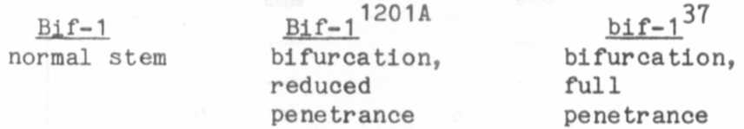

In mutants 157A, 239CH, and 1201A, a clear correlation exists be-
tween the degree of penetrance of the bif genes and the yield of the
plants: the higher the penetrance, the higher the seed production. It
should thus be expected that mutant 37B would show a better yield than
the other three mutants of the group because of the full penetrance of
its bif gene. This is, however, not the case (yielding comparisons of
only five generations are available so far for mutant 37B). Fig. 1
shows that at the mean values for the trait "number of seeds per plant"
of mutants 157, 239CH, and 37B were approximately equal and similar to
the control values of the mother variety. Only mutant 1201A was some-
what better if we consider its performance over 22 generations.

RESEARCH REPORTS 3
PNL Volume 1H
1982

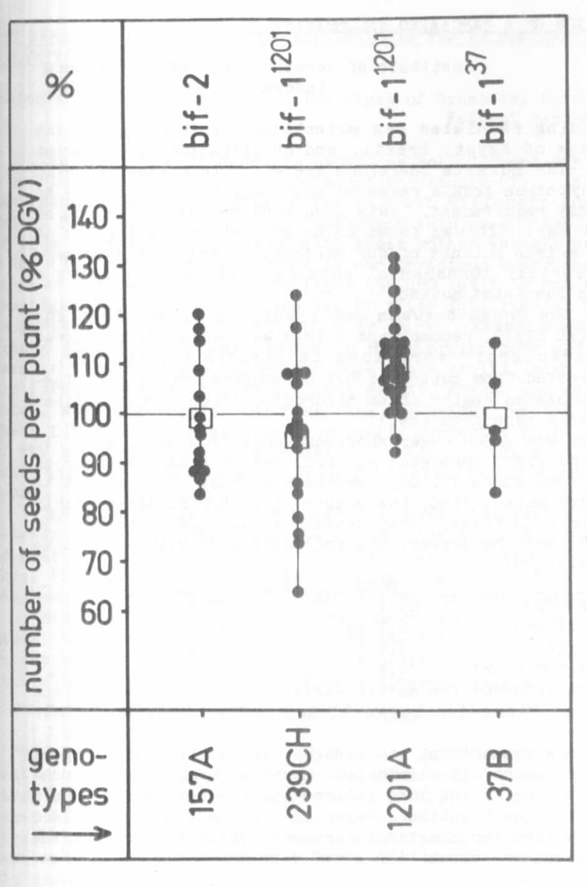

Fig. 1: The seed
production of the
bifurcated
mutants 37B,
157A, 239CH, and
1201A in a
varying number of
generations.
Each dot
represents the
mean value for
one generation as
related to the
corresponding
mean of the
mother variety.
The squares are
the combined
means for all the
generations
tested.

Thus, the stabilized penetrance of the bif-gene did not result in the
expected improvement in yield.
The differences in the yield between mutants 1201A and 239CH are
not yet explicable. Mutant 1201A contains only a single mutant gene
(bif-l^{l201})_{t} Mutant 239CH, however, is homozygous for two genes, one of
them being bif-1^{l201}. The second one has a slight influence on the
flower structure without reducing its function or fertility directly.
Tne somewhat lower yield of 239CH may be related to the presence of the
two genes together.

