QUANTITATIVE EXTRACTION OF REMAINING AMOUNTS OF SOLUBLE PROTEINS
FROM PEA SEEDS UNDER ALKALINE CONDITIONS

Gerhards, E. Institute of Genetics, University of Bonn
Federal Republic of Germany

The extractable proteins of the garden pea are separated according
to their solubility into two classes, the water soluble albumins and the
salt soluble globulins. To extract proteins completely, pulverized
seeds are treated with salt solution (NaCl) buffered with phosphate
(pH 7). However, even after repeated extractions, the residue still
contains some seed protein. Therefore, after extracting in salt solu-
tions, the seed flour was treated under alkaline conditions
(0.04 m NaOH) with small amounts (0.5%) of sodium dodecyl sulfate (SDS).
By this method additional soluble protein could be extracted from the
seeds.
The polypeptide composition of the seed proteins was determined by
SDS-Polyacrylamide-Gel-Electrophoresis (PAGE). The banding pattern of
the alkaline extract was compared with the polypeptides of the albumins
and globulins from var. 'Dippes Gelbe Viktoria' and mutant 1000 of
Gottschalk's collection. As shown in the pherogram, the albumin frac-
tions (Fig. 1a) of both genotypes differed distinctly from the globulin
fractions (Fig. 1b) and the alkaline fractions (Fig. 1c). However, the
globulins were similar to the alkaline-extracted proteins. Only two
small polypeptides In the alkaline fraction were lacking, as indicated
in Fig. 1. Thus, the third alkaline-extracted fraction did not repre-
sent an independent protein fraction. It seems to be a contradiction
to the classification of seed proteins because all types of globulin are
regarded as being soluble in salt solutions. However, the finding is in
agreement with the fact that the proteins of Pisum sativum could be sub-
divided exclusively in albumins and globulins. Nevertheless, this
method allows one to extract additional amounts of globulins from
ripened seeds not extractable under conditions mentioned above.

RESEARCH REPORTS 2
PNL Volume 14
1982

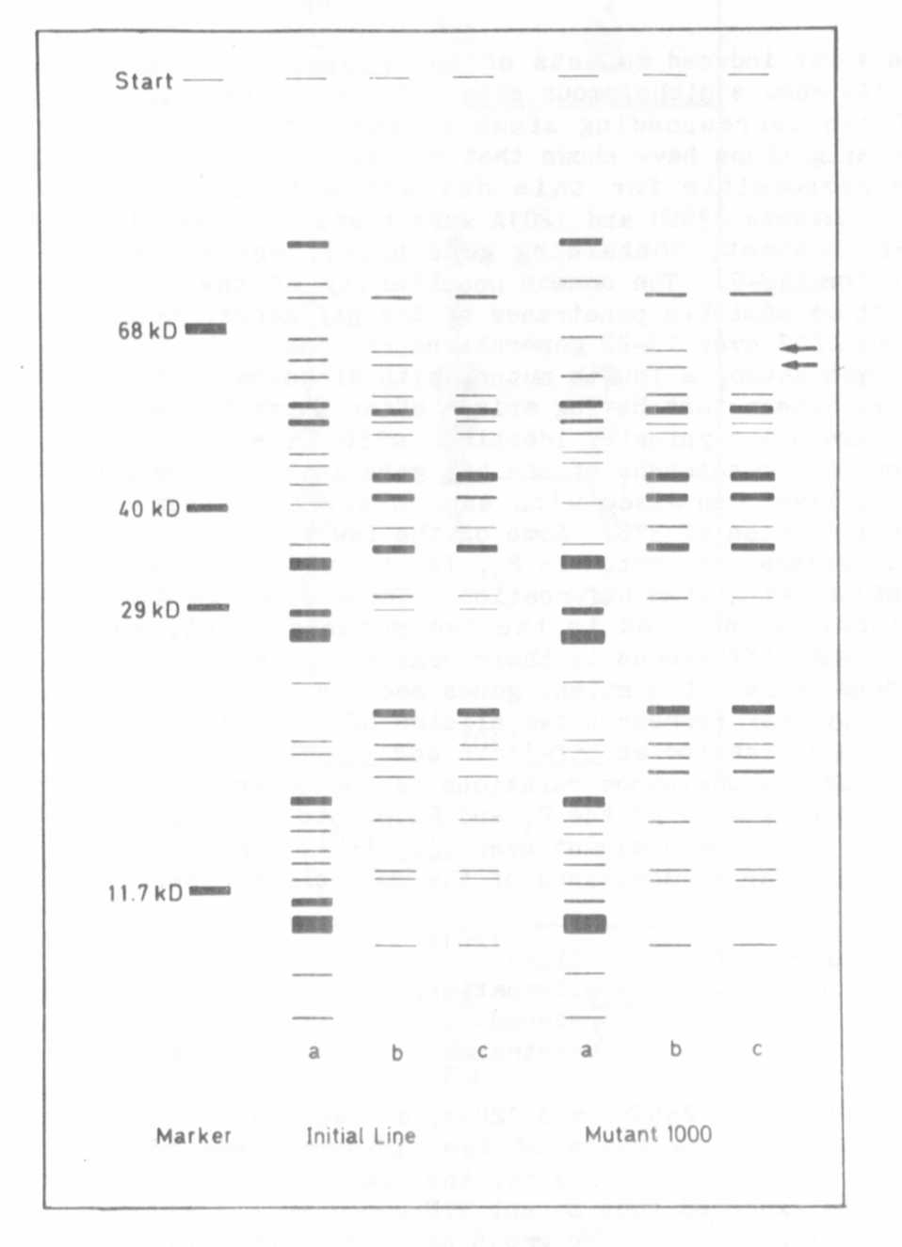
Fig. 1. Polypeptide composition of albumin fraction (a), globulin frac-
tion (b), and the alkaline extracted proteins (c) of the initial line
and mutant 1000 compared with a marker set. Arrows indicate deviations
in banding pattern of the alkaline fractions.
kD = molecular weight in kilo Daltons

