PNL Volume 13
1981
PREFACE
1

PREFACE

The Pisum Genetics Association (PGA) is a non-profit, unincorporated
organization established to facilitate the exchange of information and to
ensure the preservation of valuable genetic stocks. The number of PGA
members now stands at 157.

Membership

Merai

Index
Membership in the PGA is open to all interested persons.
Dues are $3.00 annually (U. S. currency) and are used to help
defray the costs of publishing the PNL. Members are encouraged
to pay dues for two or more years to simplify bookkeeping.
Please make prime banker's checks or money orders payable
to Pisum Genetics Association and send to G. A. Marx, Depart-
ment of Seed and Vegetable Sciences, New York State Agricul-
tural Experiment Station, Geneva, NY 14456, USA. The PNL
will be sent upon receipt of dues.

A few words of grateful praise are due a lady whom we
know as our "Clerk". It is no exaggeration to say that this
lady, Mrs. Fran Van Kirk, has been instrumental in keeping
the PGA on track. Indeed she has played a vital part in
whatever success we've achieved so far. I have regularly
acknowledged her competence and dedication at the end of the
Preface section but I wish now to underscore these sincere
sentiments. Mrs. Van Kirk's primary responsibility is that
of principal secretary for our department. The demands placed
on her in that capacity are ceaseless and varied, she being
a focal point of the department's business and administrative
affairs. What she does for us, the PGA, is done more or less
as a side issue, squeezing it into an already full schedule.
For your key contributions to our cause, we salute you, Mrs.
Van Kirk.

As time marches on there is an ever increasing need for
some charitable, selfless soul to volunteer to prepare a
cross-referenced index of the contents of the PNL. The only
compensation for this time-consuming task is self satisfaction
and peer gratitude.

PNL Volume 13
2
PREFACE
1981

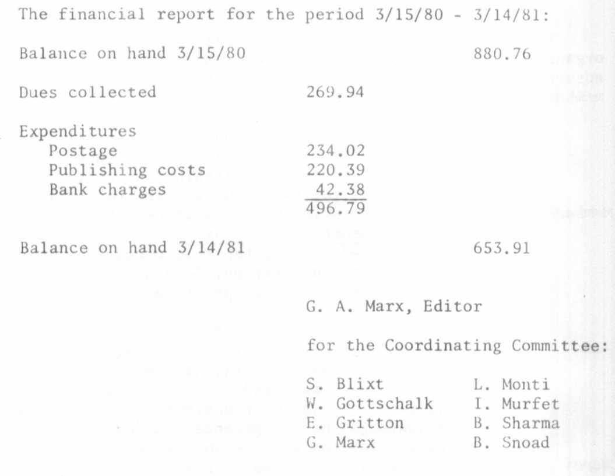

Financial
Report

COVER

The cover photo of Dr. DeHaan was taken in 1965 when I was in
Europe on a sabbatical leave. The photo was taken in the glasshouse
using 35 mm color film. Our own professional photographer, Mr. Paris
Trail, converted the photo to black and white so that we could feature
it on the cover.
DeHaan's few but significant and lasting papers mark him as an
important early contributor to pea genetics and one deserving of our
recognition.

