POLYMERIC GENES FOR WAXLESSNESS

Gottschalk, W.
Institute of Genetics, University of Bonn, Federal Republic of Germany

The following eleven waxless mutants have been selected after irradiatingj
seeds of the initial line:
A. Fully fertile genotypes (Fig. 1):
ll6 - Weakest degree of waxlessness. Small amounts of wax on the lower side
of the leaflets and on the top side of the stipules.
109B - Weak degree of waxlessness especially clearly visible at the stipules.
Intermediate between 116 and 423.
423, 445A - All green plant organs including the pods completely waxless.
Late ripening. Both mutants phenotypically identical.
B. Genotypes with strongly reduced fertility or sterility:
142A - Waxless flower mutant. Plants smaller than the control material.
Petals and filaments remaining within the calyx giving a bud-like appearance
to the fully developed flowers. Style jutting out of the calyx thus preventing
self-pollination. The plants are sterile although their gametes are fully
functional.
417B - Small and weak plants with degenerating areas at the margins of leaflet!
and stipules in the lower part of the plants. Reduced wax content in the
seedling stage; nearly normal during flowering stage.
250A - Small, waxless plants; very weakly fertile.
129 - Plants small; completely waxless. Fertility so low that the mutant
can only be maintained in heterozygous condition.
112A - Plants small, weakly waxless like 116, small greenish flowers, late.
Maintenance only through heterozygous plants.
C. Lethal genotypes:
99E, 413 - Waxless lethal mutants, dying after having formed 4 foliage leaves.1
The mutant genes of Group A can be regarded as polymeric genes influencing
the formation of wax each in a different way. Their genetic relations have
been studied by means of hybridization as follows:
F1's from 109B x 445A had normal wax and the F? segregated as follows:
Obs. 24 normal : 7 like 109B : 8 like 445A
Exp. (9:7) 21.9 : 17.1

F 's from 116 x 445A had normal wax and the F₂ produced:
Obs. 27 normal : 11 like 116 : 8 like 445A
Exp. (9:7) 25.9 : 20.1

F1 's from 423 x 445A were waxless. The F2, generation likewise was uniformly
waxless. I
The following conclusions can be drawn from these findings: The genes
of mutants 109B and 116 are not allelic to the gene of mutant 445A. They
are polymeric and presumably not linked. The genes of 423 and 445A are either
identical or allelic since they cause the same kind of waxlessness (see below).
Crosses between mutants L09B and 116 have not yet been made, so we do not
yet know whether these two genes are polymeric or allelic.
Theoretically, waxlessness would be a disadvantageous character, especially
in dry summers because of increased transpiration. This, however, was not
apparent for the 4 mutants just mentioned (Fig. 1). Their mean values for

PNL Volume 13 1981
RESEARCH REPORTS
3

the character "number of seeds per plant", although somewhat lower than the
control values of the initial line, were equal to or higher than other fertile
mutants of our collection.
The question whether the genes of the phenotypically identical mutants
423 and 445A are identical or allelic has been studied in two recombinants:
- Recombinant R 836 derived from the cross of mutants 445A x 46C (early
flowering).
- Recombinant R 837 derived from the cross of mutants 423 x 46C.
The two recombinant types were, as expected, phenotypically identical.
They are homozygous for both mutant genes, causing complete waxlessness and
formation of flowers at very low nodes of the plants. Their seed production
was somewhat lower than that of the waxless mutants (Fig. 1). In the phyto-
tron, however, certain differences between the two genotypes were noted with
regard to flower formation. Under short-day conditions (12 h darkness), the
plants of both the recombinants aborted the first few floral buds. Later,
however, normal, fertile flowers were produced. Thus, the recombinants are
genetically early flowering, although the environment alters the genotypic
expression. This anomaly was much more strongly expressed in recombinant
R 837 (=423/efr) than in recombinant R 836 (=445A/efr); i.e. the plants of
R 837 were even later than those of R 836 although they are identical with
regard to the gene efr for earliness (Fig. 2). This difference could be an
indication that the two genes for waxlessness of mutants 423 and 445A are
not identical but allelic.

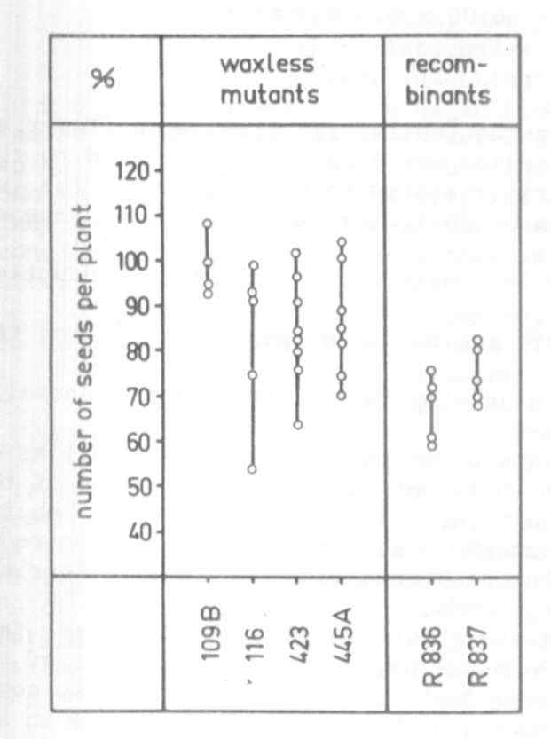
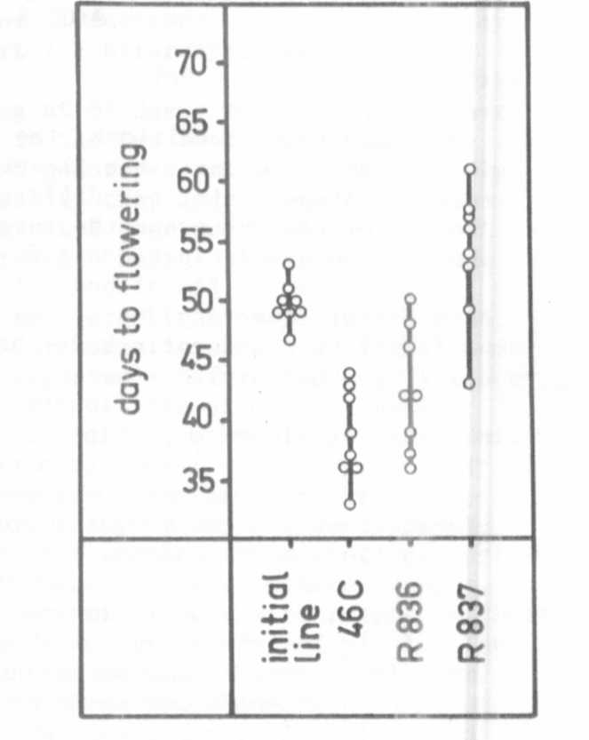

Fig. 1. Seed production of 4 waxless
mutants and 2 waxless recom-
binants as related to the control
values of the initial line=100%.
Each dot gives the mean value for
one generation.
Fig. 2. The number of days to
flowering for plants of each
of 4 genotypes grown under
short-day (12 h) conditions
in the phytotron. Each dot=
1 plant.

