1 RESEARCH REPORTS
PNL Volume 13
1981

INHERITANCE OF PROTEIN CONTENT IN PEA. IVb. PERFORMANCE OF PLANTS GROWN
FROM WHOLE SEEDS AND FROM HALF SEEDS

Swiecicki, W. K.,
Z. Kaczmarek, and M. Surma
Plant Experiment Station, Wiatrowo, Poland
Institute of Plant Genetics, Poznan, Poland

Our use of the half-seed technic in breeding research prompted us to ask
if and in what way the plants which grew from halves of seeds differ from
"normal" plants which grew from whole seeds. To answer this we set up an
experiment involving a randomized block design with 6 replications, 3 lines
of peas (Wt 3026, Wt 3527, Wt 4042), and two ways of plant propagation. Plant
growth rate was analyzed on the basis of the length of stem measured at 3
stages of development. Seed yield and % protein content were analyzed as well.
To compare the rate of growth of plants derived from half seeds (HS) with
that of plants grown from whole seeds (WS) plant height was measured when
the plants were at the 2-3 leaflet and 4-5 leaflet stage of development and
then at maturity. Multivariate analysis of variance (MANOVA) revealed that,
except for the 2-3 leaflet stage, there was no interaction between ways of
propagation and lines.
In the majority of cases HS plants were in all stages slightly smaller than
WS plants; however, the differences were statistically significant (at the
0.05 level) at the two first stages of development but not at maturity. (Table 1),
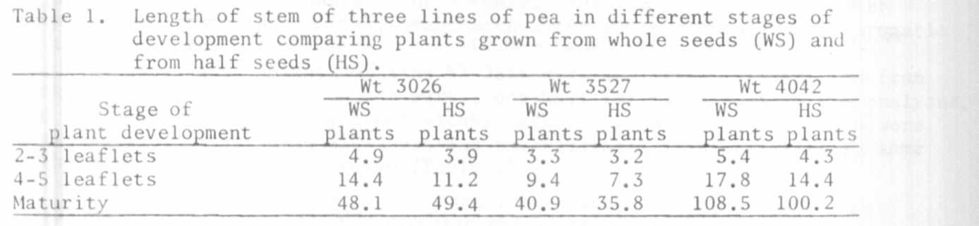
Besides growth rate, components of yield and % protein content were
studied (Table 2). A very low protein content, caused by the excess of rainfall
in 1980, is noteworthy. In normal years protein content for Wt 3026 is about
29%, WT 3527 - 22%, and WT 4042 - 27%. The MANOVA showed no interaction between
ways of propagation with lines for all characters analyzed or for protein
content. Moreover, although the mean number of pods and mean seed yield in
HS plants were slightly lower than in WS plants, the differences were not
significant.
Altogether the present results plus the high germination rate (96%) for
the HS plants indicate that the HS method is a promising research tool.
