INHERITANCE OF PROTEIN CONTENT IN PEAS. IVa. ANALYZING PROTEIN CONTENT BY
THE HALF-SEED TECHNIC

Swiecicki, W. K., Plant Experiment Station, Wiatrowo, Poland
Z. Kaczmarek, and M. Surma Institute of Plant Genetics, Poznon, Poland

Studies reported earlier (PNL 12:67-69), provided us with some information
about the mode of inheritance of protein in pea and led to several observations
essential for further studies. The necessity of analyzing the protein content
of individual seeds in order to increase the precision and effectiveness of
selection was discussed. Since, however, protein analysis is a destructive pro-
cess we attempted to apply a half-seed technic. The estimation of protein
content in one half and the possibility of getting a plant from the other
half would allow us to define the mode of inheritance of protein together
with elements of structure of yield.
Prior to conducting full-scale investigations we decided to check the
protein content estimated in a half seed with an embryo and in a half seed
without an embryo, both in comparison with the protein content of a whole
seed. Moreover, two methods of analyzing protein content (the Foss-Electric
automatic nitrogen analyzer and the standard Kjeldhal's method), were compared
for speed and precision. Both methods proved to be nearly equal with respect
to speed of analysis. However, the automatic analyzer requires a smaller
sample (0.5g) than the micro-Kjeldahl method (O.lg) and titration is automatic
in the former method.
The seeds of 20 plants of line WT 3527 were analyzed. Forty seeds from
each plant were divided into two parts, one half for estimation by the analyzer
and the other half by the micro-Kjeldahl method. From each 20 seeds 10 were
analyzed for protein as whole seeds and the remaining 10 as half seeds, some
with and some without the embryo (Table 1).
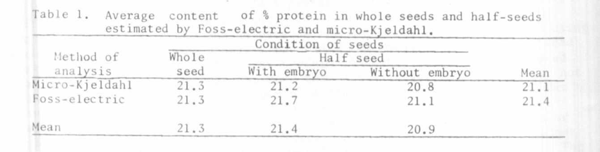
The results of analyses made by different methods are very close, both
with respect to the average protein content and to the variability of individua
samples.
The protein content in halves without embryos was lower (0.4-0.6%) than
LII halves with embryos or in whole seeds. The difference, though very slight,
was statistically significant. In order to estimate the protein content of
a whole seed on the basis of analysis of a half with and without an embryo,
it was necessary to compute a curvilinear regression. This provided a linear
correlation among the tested kinds of seeds, the degree of dependence being
defined by coefficients of correlation given in Table 2. Slight differences

PNL Volume 13 1981
RESEARCH REPORTS
2

in average protein content in halves and in whole seeds as well as the linear
nature of correlation between them suggest the possibilities of using results
of analyses of protein content in halves of seeds without embryos in genetic
and selection work.
