1 RESEARCH REPORTS
1981
PNL Volume 13

AMINO ACID CONTENT IN THE PROTEIN OF SEEDS OF DIFFERENT TAXONS OF PEAS

Stencel, M., and W. Swiecicki, Sr.
Plant Experiment Station, Wiatrowo, Poland

Because different workers have obtained different estimates (1,2,4,5)
of amino acid content in pea protein, we undertook in 1976-77 to investigate
the content of lysine, methionine, and cystine in 50 populations, lines, and
cultivars of peas belonging to different taxons.
Amino acid content in hydrolysates of pea-flour was estimated in two
repetitions by the Beckman automatic analyzer, "Multichrom B". Acid hydrolysis
of protein (6) was preceded by the oxidation of the flour (3). The results
of methionine and cystine were lower than the data given in the references.
This paper presents only the highlights of a large body of data that were
collected. The average results were compiled separately for wild and cultivated
peas (Tables 1 and 2). In the group of cultivated peas the classification
as to convarieties is related to use roughly as follows: medullare (garden
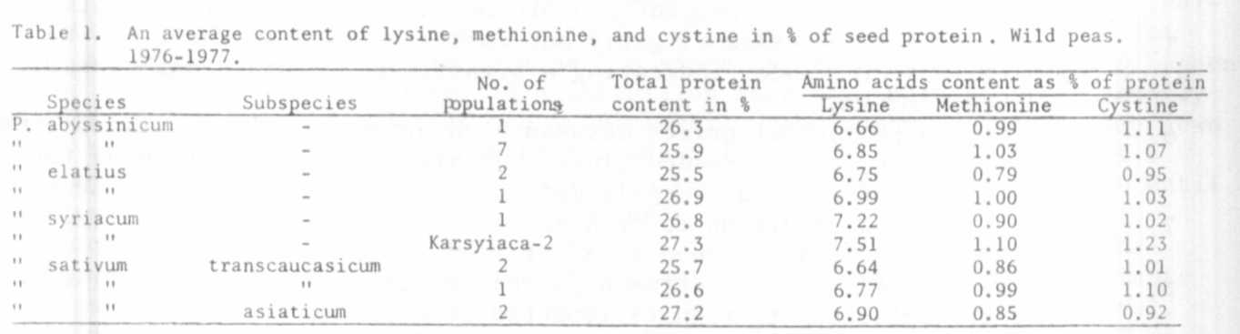
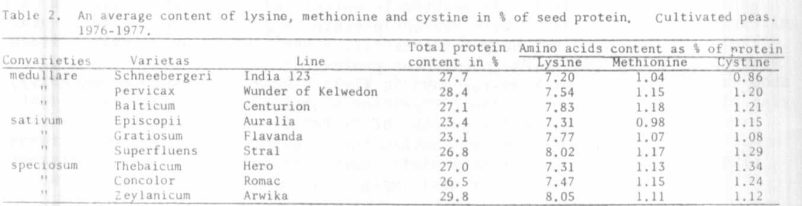
peas), sativum (field peas for seeds), speciosum (field peas for green forage).

Among the wild peas, populations of P. syriacum (Table 1) had the highest
lysine content. Little variation was noted, however, with respect to the
content of the sulfur containing amino acids, methionine and cystine. In
cultivated peas (Table 2), some variation in lysine content was evident.
However, the majority of fodder, colored flower, varieties had a slightly
higher total content of sulfur containing amino acids than the field and
garden, white-flowered peas. The exception was the variety Stral, obtained
by mutagenesis. Overall, the tables show that, except for P. syriacum, the
rest of the wild species and subspecies had a lower lysine content in the
protein of seeds than cultivated peas. Moreover, except for the Turkish
population, Karsyiaka, they also had less methionine and cystine. Thus the
most productive varieties, belonging to the groups episcopii, gratiosum,
and superfluens, had the highest amino acid content (7).
We plan also to analyze the collection of natural and induced mutations
gathered in Plant Experiment Station Wiatrowo.

1. Becker, M., K. Nehring. 1965. P. Parey Verlag, Berlin.
2. Chomyszyn, M., L. Furman, A. Wierny, F. Witczak. 1970. PWRiL, Warszawa.
3. Hesse, J., G. John, R. Fahnenstick. 1971. Zeitschr. fur Tierphysiology,
Tierernahr. u. Futtermit. B. 28, H. 3.
4. 0. Kellner, M. Becker. 1971. P. Parey Verlag, Berlin.
5. Nehring, K., M. Beyer, B. Hoffmann. 1972. Deutsche Landwirtschaftsverla
Berlin.
6. Spackmann, D. H., W. H. Stein, S. Moore. 1958. Anal. Chem. 30:190.
7. Swiecicki, W., Sr. 1980. PNL 12:66.

