VARIATION OF BASIC LEGUMIN COMPONENTS IN THE GENUS PISUM REVEALED BY
ISOELECTROFOCUSING

Przybylska, J., J. Hurich, Institute of Plant Genetics, Poznan, Poland
and S. Blixt Weibullsholm Plant Breeding Institution, Landskrona, Sweden

Previously reported data indicated the usefulness of electrophoretic
analysis of seed proteins in the classification of Pisum forms (1,2). Con-
sequently, investigations attempting to solve some taxonomic problems in Pisum
by means of electrophoretic analysis of proteins were recently undertaken.
This report presents data showing usefulness of isoelectrofocusing (IEF) to
detect variation in basic legumin components.
The investigated material comprised 107 Pisum lines representing
P. elatius (5 lines), P. humile (3 lines), P. sativum (82 lines), P. abys-
sinicum (12 lines), and P. fulvum (5 lines). The investigated lines originated
from the Weibullsholm Collection, Sweden (96 lines), the John Innes Institute,
England (6 lines), the Vavilov Institute, USSR (2 lines), the Gatersleben
Collection, GDR (1 line), the University of Melbourne, Australia (1 line),
and the Hebrew University of Jerusalem, Israel (1 line). For each line seed
samples harvested in two years were analyzed.
Preparations of legumin fractions were obtained as described previously
(2). IEF analysis was performed in gel slabs, containing 2% LKB Ampholines
and 6M urea, with the use of LKB Multiphor apparatus. The range of the pH
gradient was 7.0-10.0.
Under the conditions applied, the IEF analysis yielded multi-band patterns
of basic legumin components. Due to a high resolving power of the IEF technique
it was possible to reveal considerable variation of the components in the lines
investigated (Fig. 1). Significant variation was found in the group of closely
related P. elatius, P. humile and P. sativum. Lines of P. abyssinicum showed
rather uniform patterns with no distinct species-specific features. Of the
taxons examined, P. fulvum was distinguished by the lack, of protein bands
focused in pH range 9.5-9.7 (no correction for the presence of urea in gels
was made). All the investigated P. fulvum lines--which proved to vary with
respect to urea-PAGE patterns of acidic legumin components (2)--showed the
characteristic species-specific IEF pattern of basic legumin components.
The species-specific electrophoretic pattern of basic legumin components
has been already reported for P. fulvum (2). However, under the previously
applied conditions of electrophoretic analysis, SDS-PAGE arid urea-PAGE, no
satisfactory resolution of basic legumin components of Pisum could be achieved.
IEF analysis proved to be an efficient method for separation of the components.
With the use of IEF the variation of the components in P. elatius, P. humile,
and P. sativum, not observed previously, has been revealed and the distinctness
of P. Fulvum has been definitely confirmed. Therefore, IEF pattern of basic
legumin components appears to be a useful character in Pisum taxonomy.

PNL Volume 13 1981
RESEARCH REPORTS
2

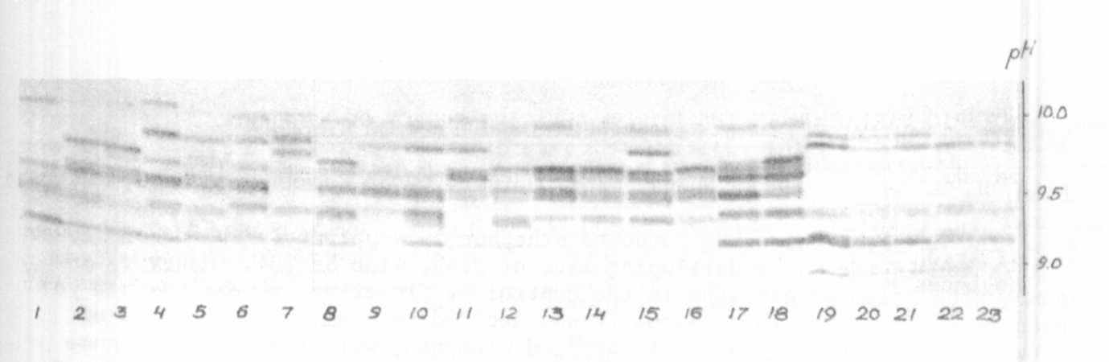

Fig. 1. Electropherogram illustrating the revealed variation in IEF spectrum
of basic legumin components in Pisum. IEF spectra of the following
lines are shown:
1-4 P. elatius, Gat. 255, W 226, W 805, W 1447;
5-7 -- P. humile, W 936, JI 241, JI 261;
8-16— P. sativum, W 110, W 806, W 807, W 1640, W 1833, W 1896,
W 1913, W 1932, W 1958;
17-18— P. abyssinicum, W 808, VIR 2759;
19-23— P. fulvum, W 1256, JI 224a (dark brown testa), JI 224b (light
brown testa), Vir 3397, and line from the Hebrew University
of Jerusalem.

1. Przybylska, J., S. Blixt, J. Hurich, and Z. Zimniak-Przybylska. 1977.
Genetica Polonica 18:27-38.
2. Przybylska, J., J. Hurich, and Z. Zimniak-Przybylska. 1979. Genetica
Polonica 20:517-528.

This work was performed under the Government Project PR-4 (Poland)

