4 0 RESEARCH REPORTS
PNL Volume 13
1981

THE LIKELY FLOWERING GENOTYPE FOR SEVERAL CULTIVARS AND MUTANTS

Murfet, I. C.
Botany Department, University of Tasmania, Hobart, Australia

Table 1 shows the likely flowering genotype, in terms of the four loci
lf, e, sn, and hr (5), for seven commercial cultivars which have recently
been used in this laboratory for various purposes. Some estimates are based
purely on phenotypic behavior and others also make use of the results of
crosses.
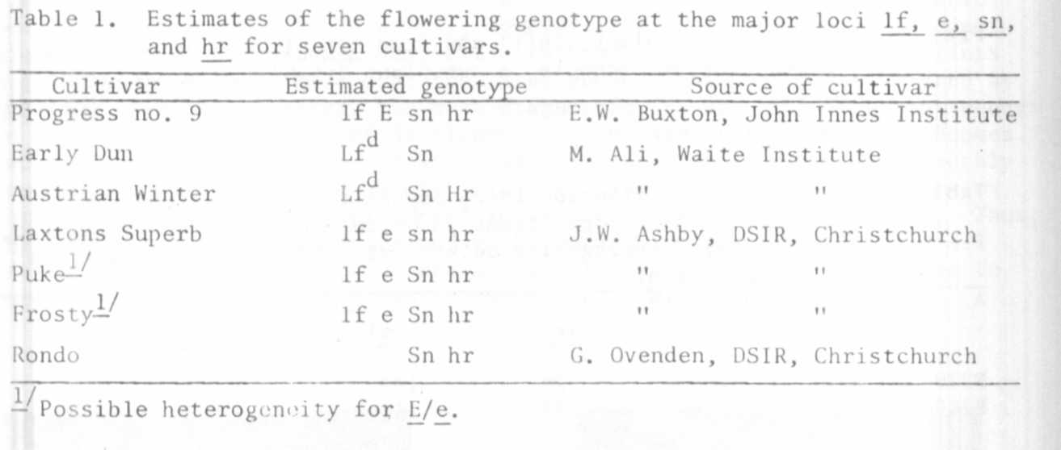

Useful estimates of the flowering genotype can often be made from quite
a small quantity of information. For example, 'Austrian Winter' flowered
at node 24 in an 18h photoperiod and in excess of node 70 in an 8h photoperiod
(temperature: night 17°C/day 23-27°C). The high flowering node in long days
indicates the presence of Lf^{d} and the very large response to photoperiod
indicates combination Sn Hr. 'Early Dun' also flowered at node 24 in an 18h
photoperiod and Lf^{d} is again indicated. However, the photoperiod response
of 18 nodes does not clearly indicate either Sn hr or Sn Hr and further
analysis would be required to resolve the genotype. [Berry and Aitken (1)
have estimated a genotype of Lf^{d} Sp_ Hr for the related cultivar 'Dun'.] 'Rondo
showed a 10 node response to photoperiod clearly indicating a genotype of
Sn hr. However, the flowering node of 16 in a 24h photoperiod is consistent
with either Lf or lf and further tests would be necessary to differentiate
the alternatives. 'Puke' and 'Frosty' also showed a limited, quantitative
response to photoperiod consistent with genotype Sp hr and in these varieties
tests using continuous light from the start of germination give a minimum
flowering node of 10 (lowest scale leaf counted as node 1) indicating genotype
lf (4,5). Puke and Frosty both gave a bimodal distribution of flowering node
under short days¹, segregating into two phenotypes EI and L (2). This behavior
is not necessarily indicative of heterogeneity since it can occur in genotype
If e Sn hr as a result of variable penetrance of gene Sn in terms of flowering
node [see Hobart line 61a (3,4)]. However, the unlikely possibility that
Puke and Frosty are heterogeneous for the E/e pair of alleles should not be
discounted.

'Progress no. 9' and 'Laxton's Superb', unlike the other varieties, showed
no response to photoperiod. They therefore carry sn. The cross Progress no. 9
x Hobart line 53 (If e Sn hr) gave an with a phenotype like Hobart line
60 (lf E Sn hr). The genotype of Progress no. 9 is therefore lf E sn hr.
The F1's of Laxtons Superb x Puke and Laxtons Superb x Frosty were late like
line 53. Laxtons Superb therefore appears to be lf e sn hr.
The reports by Sidorova et al (6,7) of certain induced flowering mutants
are of interest for at least two reasons. Firstly, one of the mutants appears
to be at the sn locus and all mutants so far tested (5) against the four locus
system have proved to be at the lf locus. Secondly, the reports provide data
on many characters including response to photoperiod, time to maturity, seed
yield, etc., and this allows an estimate to be made of the genotypes. Un-
fortunately, there is some uncertainty over the scoring system used and for
the purpose of this estimation I have assumed that nodes were counted from
the second scale leaf as one and that "flowering node" means node of first
open flower in this case (i.e. abortive flower initials were not counted as
flowers). Using these assumptions the mutation giving rise to 218 is almost
certainly of the type, or equivalent to, Sn to sn. This step is consistent
with the lower flowering node, earlier onset of flowering, reduced time from
the beginning to the end of flowering and from sowing to maturity, reduced
yield, and loss of sensitivity to photoperiod (2). Mutants 2 and 319 are
consistent with mutations from Lf_ to lfª and Lf to lf respectively. Note
these mutations promoted the onset of flowering but time to maturity was
brought forward only marginally in mutant 2 and actually delayed in mutant
319, the yield was not reduced, and there was no loss of photoperiod response.
As a tentative hypothesis we may estimate the genotype of the initial variety
•Torsdag' as Lf E Sn hr, mutant 2 as lfª E Sn hr, mutant 319 as lf E Sn hr,
and mutant 218 as Lf E sn hr. These estimates are also consistent with
the findings of Sidorova et al., that all three mutants are recessive, that
mutant 218 is not allelic with 2 and 319, and that 2 and 319 are allelic but
not identical.
Persons who would like us to estimate flowering genotypes for particular
varieties are invited to send samples to me (about 20 seeds per variety) care
of Chief Quarantine Officer (Plants), Dept. of Agriculture, P.O. Box 192B,
Hobart, Tasmania, 7001, Australia.
We would also like to receive seed of any flowering mutants (and their
initial lines) if and when they become available for release.

1. Berry, G. J. and Y. Aitken. 1979. Aust. J. Plant Physiol. 6:573-87.
2. Murfet, I. C. 1971. Heredity 26:243-57.
3. Murfet, I. C. 1973. Aust. J. Biol. Sci. 26:669-73.
4. Murfet, I. C. 1977. pp. 385-430 in The Physiology of the Garden Pea.
(Eds. J. F. Sutcliffe and J. S. Pate. Academic Press, London).
5. Murfet, I. C. 1978. PNL 10:48-52.
6. Sidorova, K. K., V. V. Khvostova, and L. P. Uzhintzeva. 1974. PNL (>:47.
7. Sidorova, K. K:, and L. P. Uzhintzeva. 1977. PNL 9:51.

