POLLEN PIGMENTATION AND THE ACTION OF MUTANT yp

Crowden, R, K. and 1. C. Murfet
Botany Department, University of Tasmania, Hobart, Australia

Murfet (1) identified a recessive gene, yp, determining yellow pollen
which had arisen as a spontaneous mutant in the cultivar 'Vinco' (Hobart
line 51). Chemical tests have now shown that the change in color from orange
in the wild type pollen (Yp) to yellow in the mutant is the result of a
quantitative rather than a qualitative effect on pigment (carotenoid) pro-
duction in the pollen. The yp pollen contains approximately 5% of the caro-
tenoid level occurring in Yp pollen.
For the interest of workers with Pisum we report here the results of
chemical analyses of the carotenoid pigments, made on our behalf by D. G.
Britton, Biochemistry Department, The University of Liverpool, U.K. (Table 1)
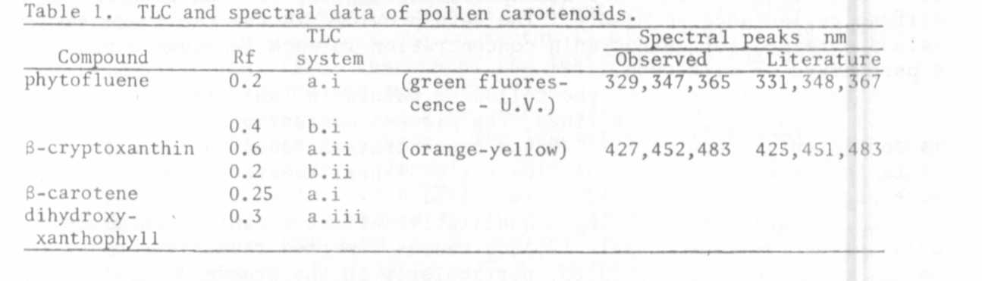
Isolation and analysis of pigments
Pollen was treated with 15% KOH in ethyl alcohol : water, 1:1, overnight,
at room temperature, in the dark under nitrogen. Diethyl ether and water
were added dropwise, alternately, to give two phases. The water layer was
re-extracted with ether, and the combined ether layers washed with water,
then evaporated to dryness under nitrogen. The residues so obtained were
examined by TLC on
a] Silica Gel G (incorporating 0.1% KOH) using the solvent systems
(i) petroleum ether (40°-60°)
(ii) 30% diethyl ether/petroleum ether
(iii) diethyl ether
h) MgO/Keiselguhr, 1/1 (incorporating 0.1% KOH) using solvent systems
(i) 5% benzene/petroleum ether
(ii) 20% acetone/petroleum ether
These treatments resolved the presence, in both Yp_ and yp_ pollen, of
two major carotenoids, phytofluene and B-cryptoxanthin. Two minor pigments.
B-carotene and an unidentified dihydroxyxanthophy11, were also present.
Confirmatory evidence of pigment identity was obtained by eluting spots from
TLC plates with acetone and determining absorption spectra.
The co-occurrence of phytofluene and B-cryptoxanthin as major carotenoid
constituents in a plant tissue is somewhat unusual. By comparison examination
of vegetative tissue (leaves) of Vinco showed a "normal" mixture of carotenoid
with 3-carotene; lutein, violaxanthin and neoxanthin occurring as major
pigments, together with a trace amount of a-carotene.
(1) Murfet, I. C. 1967. Heredity 22:602-607.

