THE LINKAGE RELATIONS OF A NEWLY ISOLATED nana MUTANT

Marx, G. A. NYS Agricultural Experiment Station, Geneva, NY USA

The mutant nana (na) was discovered and described by Wellensiek (8).
Later he reported its linkage relations on chromosome 6 (9). Murfet (5)
offered additional evidence in support of the location as to chromosome and
described the interaction with the Le locus; na was shown to be epistatic
to Le as well as to le.
In 1979 an extremely dwarf plant resembling Wellensiek's nana appeared
in one of my Arg progenies, an F4. All remaining plants in the progeny were
normal dwarfs (le/le). The line also was homozygous for b, sil, wlo, and
Pl (in addition to Arg). Progeny tests of this plant confirmed that the short
stature was genetic in origin and visual comparisons with Wellensiek's nana
(WL-1766) grown under the same conditions reaffirmed the phenotypic similari-
ties between the two lines.
WL-1766 was then crossed with the Geneva nana to test the genotypic
relationship. All F1 plants derived from crosses between the two lines ex-
pressed the nana phenotype indicating the na gene in my line represents a
reoccurrence of the original na but in this case the gene is combined with
le rather than with Le as is the case in WL-1766. A very small consisting
of 24 plants was grown from this cross for further confirmation that the two
genes were "identical". Although all the F2 plants apparently were pheno-
typically nana, three classes of height were evident: roughly speaking, (i)
very tiny and compact, (ii) slightly taller but clearly na, and (iii) taller
plants approaching the height of very short dwarf (le) plants. In another
context, the latter group of plants could easily have been mistaken for short
dwarfs. This observation together with the observation that na segregants
from the F2 and F3 populations discussed below were not all of equal height
(at least two distinct height classes), implied that other gene loci, perhaps
La and Cry, interact with na and influence internode length and final height.
Moreover, all populations studied showed rather clearly that the slightly
taller na segregants were consistently more vigorous and productive than the
shorter na segregants. It is tempting to speculate that plants with the
combination na/na Le/Le are shorter and less productive than those with the
combination na/na le/le. However, all crosses involving WL-1766 showed some
degree of semi-sterility whereas crosses with the Geneva na were fully fertile.
Two other crosses were analyzed more comprehensively. In these, tl>
two sources of na were again involved, the one isolated at Geneva being identi--
fied as na (Marx) and the na isolated by Wellensiek being designated na (Well.)
(WL-1766). However, the second parent in each of these crosses was Na.
The relevant genotypes of the first cross were:
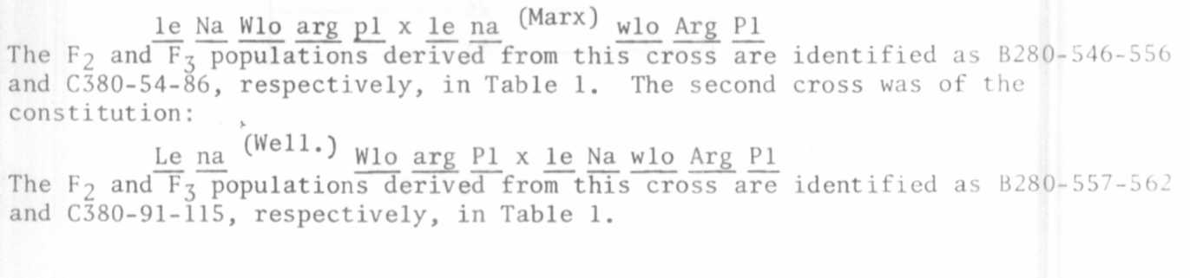

3 RESEARCH REPORTS
1981
PNL Volume 13

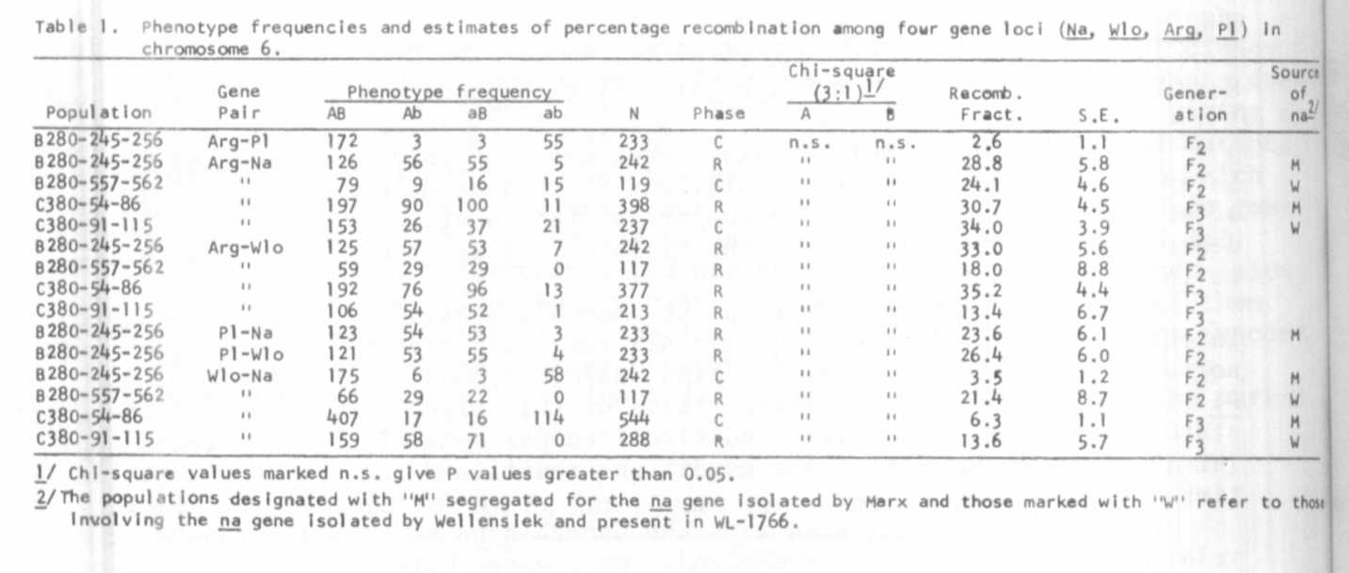

The F1's from the first cross were normal dwarfs (le) whereas F1's from
the second cross were tall (Le/-). Most of the linkage estimates are consis-
tent with each other within this study and with other published results.
The percentage recombination between Arg-Wlo was, however, uncharacteristically
low in the F₂ and F3 populations involving WL-1766 which, as mentioned, showed
evidence of partial sterility. The two sources of na appear to map to the
same site, thus supporting the results of the identity/allelism test. It
seems safe to conclude on the basis of all the evidence thus far collected
that Na, wlo, Arg, and Pl are all located in chromosome 6, with na being
situated at the wlo end of the chromosome. This suggests the following rough
and tentative map:
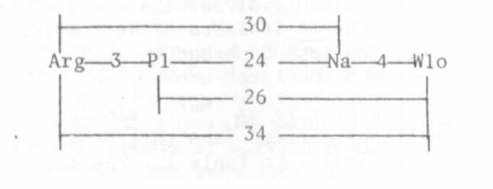

Wellensiek (9) reported a recombination value of 29.6% between na and f1,
the latter gene being situated close to Pl. Murfet found the dominant gene
for early flowering, E, to be linked with p_ (3) and with wlo (6), with CrO
values of 28 and 26.3, respectively. The recent finding (2) that art is
situated in chromosome 6 further brightens the linkage picture for this
chromosome.
A mutant controlling plant height and designated micro-dwarf (lm) by
Rasmusson (7) shows close linkage with p and wlo on chromosome 6 (1). This
raises the possibility that na and lm are identical or allelic. To test this
possibility, na(Marx), with its linked markers, has been crossed with WL-1329,
a line carrying lm in combination with cry^{s}.

1. Lindqvist, K. 1951. Hereditas 37:389-420.
2. Marx, G. A. 1981. PNL 13:38.
3. Murfet, I. C. 1971. Heredity 27:93-110.
4. Murfet, I. C. 1977. PNL 9:38.
5. Murfet, I. C. 1978. PNL 10:54-55.
6. Murfet, I. C. 1980. PNL 12:59.
7. Rasmusson, J. 1938. Hereditas 24:231-257.
8. Wellensiek, S. J. 1969. Z. Pflanzenphysiol. 60:388-402.
9. Wellensiek, S. J. 1972. PNL 4:60.

