A CHLOROPHYLL MUTANT WITH TWO SITES OF EXPRESSION

Marx, G. A. NYS Agricultural Experiment Station, Geneva, NY USA

In 1977 one F₂ population among several from the same cross contained
some abnormal plants with variegated or mottled leaves. Other plants in the
same population showed evidence of another, possibly different, disorder marked
by a diffuse paling of the leaves due to a reduction in chlorophyll, principally
in the central portion of the leaflets (Fig. 1). The affected leaves were
rarely, if ever, totally devoid of chlorophyll and not all leaves were affected, so
most mutant plants survived and produced seeds.
All surviving F2 plants were progeny tested. The F3 progenies were
variously composed of seedlings that were normal, those with variegation and
those with the reduction in chlorophyll. Reduced fertility was common.
Selection was practiced in these F3 progenies and eventually lines were de-
veloped which exhibited the chlorophyll condition without the variegation.
The selection process also led to improved fertility. It also became apparent
during the selection process (through Fg) that the expression of the chlorophyll
disorder varied considerably. Field-grown plants and those grown in silica
sand expressed symptoms early in the seedling stage and often a reduction in
chlorophyll was evident on all leaves produced thereafter. In one instance,
however, greenhouse-grown plants showed chlorosis of a single leaf borne at
the 5-6 node stage of development. Occasionally some inbred plants derived
from mutant plants failed to produce symptoms at all. Later in the course
of inbreeding and selection it was noted that affected plants expressed -a
second more consistent and characteristic symptom: the pods exhibited irregular
yellow stripes along the adaxial suture (Fig. 2).

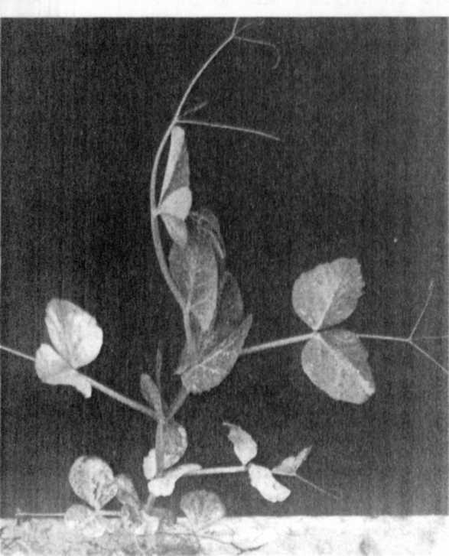
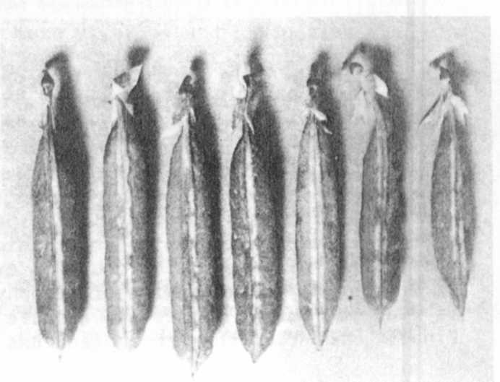
Fig. 1. Phenotypic expression
on leaves of plants
carrying a newly isolated
chlorophyll mutant.
Fig. 2. Phenotypic expression on
pods of plants carrying
same mutant shown in Fig. 1
(color photo converted to
black and white.

2 RESEARCH REPORTS
1981
PNL Volume 13

Once the lines had been selected for near normal fertility and consistent
mutant expression, they were used in exploratory crosses with other lines in
an attempt to localize the mutant. Table 1 presents the segregation of the
mutant in F2's in which no linkage was noted. There was a decided deficiency
of mutant plants in these populations. Twenty-one normal green segregants from
this F2 population were progeny tested. Twelve progenies segregated, giving a
collective ratio of 201 normal : 48 chlorotic. Again, a deficiency of mutants
was evident. This was not the case, however, in another population in which
the chlorophyll mutant showed linkage with wa on chromosome 2, the single gene
segregation ratios for the marker and mutant alike being very close to 3:1
(first pop., Table 2). The calculated percent recombination in the repulsion
phase cross was 18.7+/-6. The two CrO plants recovered from that F2 were then
grown in F3 and used as parents in coupling phase crosses. The results (second
pop., Table 2) verified the linkage between the chlorophyll mutant and wa,
but once again there was a significant deficiency of mutant plants. The marker
gene, wa, also showed a deficiency.

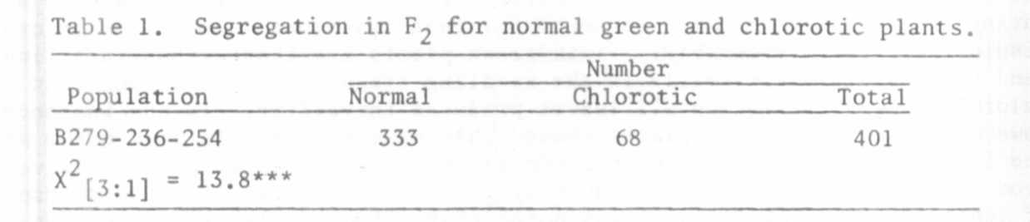

Table 2. Joint segregation for an unnamed chlorophyll mutant and wa in F₂ of two crosses, one
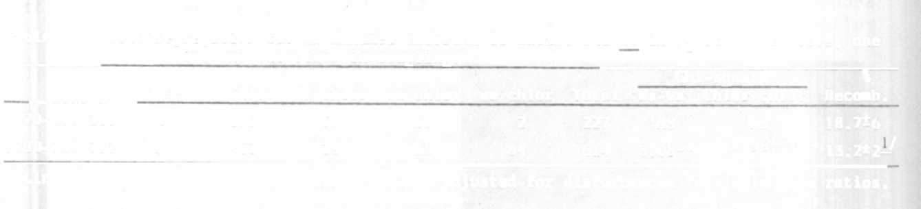
in repulsion and the other in coupling.
Chi-square \
Phase Wa Chlor Wa chlor wa Chlor wa chlor Total Wa-wa Chlor-chlor Recomb.
B279-219-235 R 115 57 53 2 227 NS NS 18.7*6
B280-769-792 C 462 29 39 84 614 8.08** 14.96*** ₁₃₋₂±2—
-^Linkage calculated by Product Method and not adjusted for disturbances in single gene ratios.

Naming of this mutant will be deferred until Dr. Blixt compares the pheno-
type with other chlorophyll mutants in his collection and completely excludes
the possibility that the mutant has not been previously isolated. Overall,
this mutant has a number of virtues from a genetic and physiological point
of view. The mutant shows rather clear-cut expression in the seedling stage
so it has value as a seedling marker. Mutant expression occurs during ontogeny
and expression is separated with respect to time, space, and tissue. Also,
mutant expression is subject to considerable environmental variation, suggesting
that phenotypic expression could be experimentally manipulated in the process
of seeking an understanding of its physiologic basis. Although chlorophyll
is reduced, mutant plants are capable of surviving and producing seeds.
Finally, the fact that the mutant has been localized adds to its value.

