1 RESEARCH REPORTS
PNL Volume 13
1981

ADDITIONAL EVIDENCE BEARING ON THE PLEIOTROPIC ACTION OF AM-1 AND AM-2

Marx, G. A.
NYS Agricultural Experiment Station, Geneva, NY USA

Past reports (1, 2) pointed to a direct (pleiotropic) relationship
between the genes am-1 or am-2 and one or the other of two associated seed
disorders. The association was interpreted as pleiotropy rather than linkage,
even though some am-1 or am-2 plants and lines do not express the seed dis-
order. The explanation offered was that the seed disorder fails to manifest
in the presence of one or more genes that counteract one aspect (the seed
disorder) but not the other aspect (flower color inhibition) of gene action.
The gene b_ was suggested as playing a role in the scheme.
To investigate the matter further, crosses were made between a wild-type
line (A, B, Am-1, Am-2, F/Fs) and several A/A lines with white flowers (due
to am-1 or am-2 or both) but not showing a seed disorder. The results of
one of these crosses are considered here (Table 1). It is evident from the
segregation pattern: (i) that the white-flowered parent carried only one flower
color inhibitor gene; (ii) that the gene in question was am-2 (distinguished
by the nature of the seed disorder found in F2); (iii) that since b_ segregated
in F2, b was present but masked in the white-flowered parent; and (iv) that
some but not all the white-flowered F2 plants showed a seed disorder. Further,
the relative number of white-flowered segregants with and without seed disorder
could be explained by assuming the segregation of a recessive gene pair that
blocked the pleiotropic action of am-2. The b gene was a likely candidate
in that role.
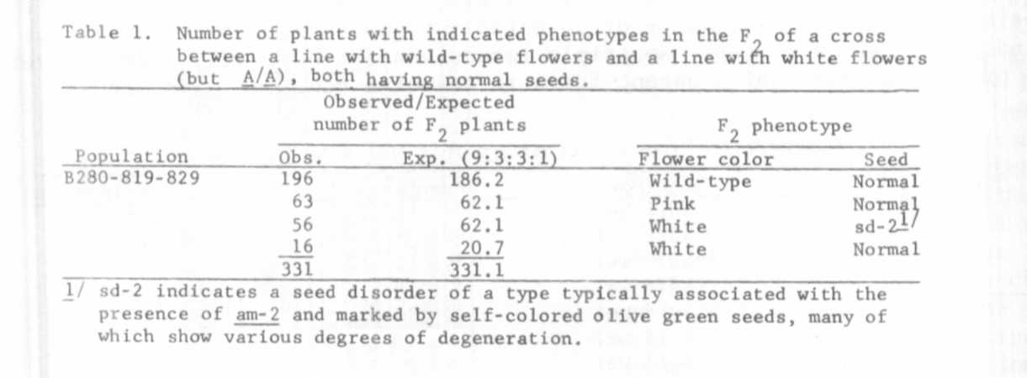

Ih< F2 results also implied that if b/b serves as the block, then some
of the white-flowered segregants with the seed disorder (presumably B/-)
should, when progeny tested, segregate for plants without the seed disorder
because some am-2/am-2 segregants were bound to be B/b (am-2 and b apparently
are not lmked). This prediction was tested by growing 20 F3 progenies from
selected white-flowered F2 plants. Two pink-flowered (b/b Am-2/-) F2 plants
were also progeny tested.
Each F3 progeny consisted of 12 plants. This is not enough to identify
all potentially heterozygous (B/b) entries but sufficient to detect heterozy-
gosity in most progenies and therefore to test the validity of the hypothesis.
The results of the FT analysis are given in Table 2. Of 12 plants that showed

PNL Volume 13 1981
RESEARCH REPORTS
3

seed disorder in F2, ten segregated for plants with normal seed (i.e. without
seed disorder) in F3, giving a combined ratio of 87 segregants with and 32
segregants without seed disorder (X²[3:1]=0.227). In three of the F3 pro-
genies, all 12 plants exhibited the seed disorder and therefore possibly were
homozygous B/B. Seven of the F2 plants tested were without the seed disorder
in the field. All 12 plants in each of the corresponding F3 progenies were
again without the seed disorder. Presumably, therefore, all seven progenies
were b/b_. The two b/b_ Am-2/- F₂ plants produced F3 progenies that were en-
tirely free of the seed disorder, including three am-2 plants that segregated
in one of the b entries.
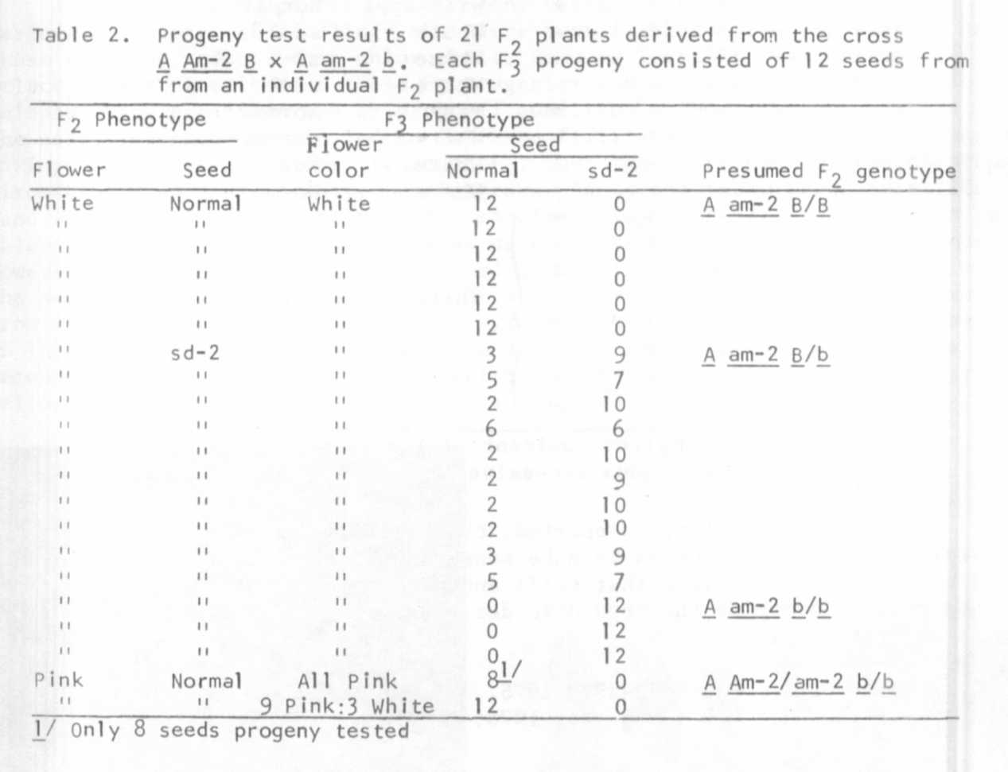
In a different but related experiment, it was shown that, after selfing
a line heterozygous for A (A/a) but homozygous for am-1, all the A/- segre-
gants showed the seed disorder which is associated with am-1 and all the
a/a segregants had normal seed. This same behavior was noted in three suc-
cessive generations, F4, F₅, and F₆. Thus a_ is epistatic to am-1 both in
terms of flower color and seed disorder.

5 RESEARCH REPORTS
1981
PNL Volume 13

It seems therefore that A and B are required for the seed disorders
associated with am-1 and am-2 to become phenotypically manifest. Once A
and B are present, then the specific type of seed disorder that is expressed
depends on whether am-1 or am-2 or both are present (2). A seemingly complex
pattern of dominance and interaction (epistasis) emerges from all this, a
situation perhaps made clearer by the following scheme:
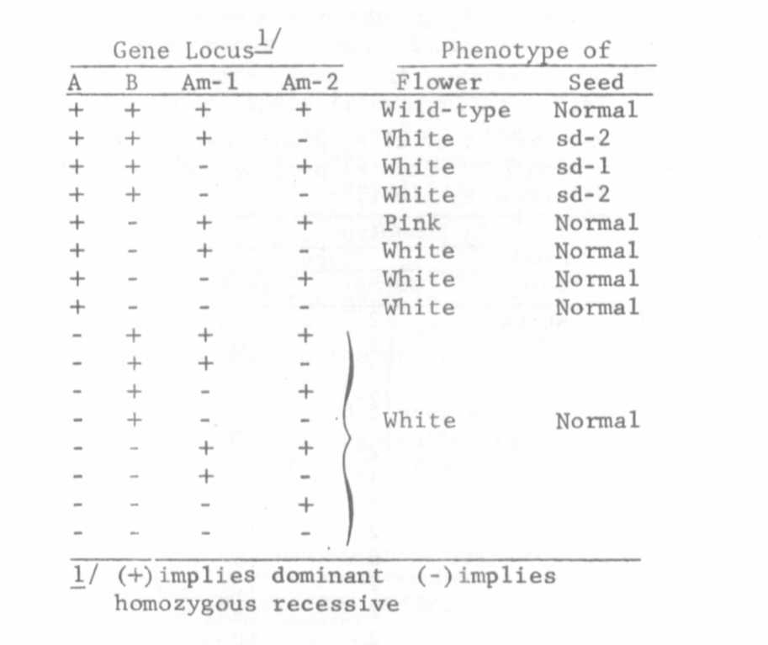
Many of my earlier, unreported, observations which initially defied
explanation have now begun to make sense in the light of this proposed scheme.
I have reason to believe that still another gene may interact with am-1
and am-2 to override the seed disorder phase of gene action but the analysis
is not yet complete.

1. Marx, G. A. PNL 7:28-29. 1975.
2. Marx, G. A. PNL 10:38-40. 1978.

