ADDITIONAL DATA FOR THE St-Bulf-Chi-6 LINKAGE

Marx, G. A.
NYS Agricultural Experiment Station, Geneva, NY USA

Evidence reported earlier (4) showed that bulf was linked with markers
on chromosome 3. The reported crosses were of the constitution
St-Bulf-chi-6 x st-bulf-Chi-6, so that only two of the three genes tested were
in the coupling phase. Results of a follow-up experiment involving a three-
point coupling phase cross (Table 1) confirm and strengthen the earlier findings,
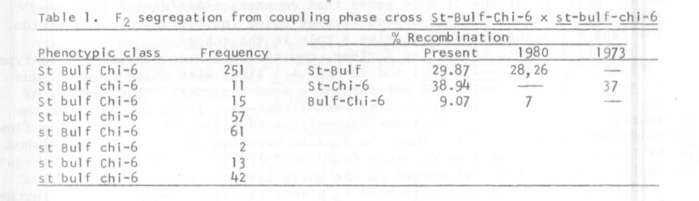
A small F2 from a three-point cross involving wel was also studied since
wel is also known to reside in chromosome 3 (1,2,3). In this cross st and
bulf were in coupling and Wel in repulsion viz. st_ bulf Wel x St Bulf wel.
Although the segregation data (Table 2) are too meager to give a reliable
estimate of linkage intensity or to establish gene order, they agree with other
findings obtained so far. No triple recessives (st-bulf-wel) were recovered
to provide a source of a parent for a three-point coupling phase cross.
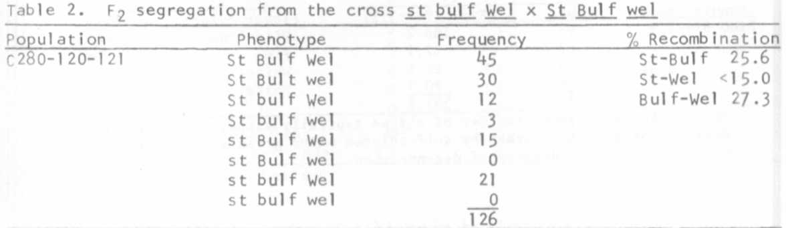

1. Marx, G. A. 1971. PNL 3:18-19.
2. Marx, G. A. 1972. PNL 4:30-31
3. Marx, G. A. 1974. PNL 6:30-31
4. Marx, G. A. 1980. PNL 12:47-48.

